**Case Vignette**

A 14 year old Roman Catholic female from Quezon City sought consult at the out patient department due to 2 week history of gum bleeding most noted on brushing her teeth. On further questioning, she shared that she had recurrent episodes of spontaneous nose bleeding that stops on application of pressure. This started approximately a year prior. She also had history of easy bruising after minor bumps. She has her monthly menstrual period that lasts for 7 days. First 3-5 days of her menses is characterized as moderate to heavy bleeding using 2-4 overnight pads per day. This is her first consult with a physician. She has no other symptoms including fever, jaundice, shortness of breath, weight loss, or urinary or bowel movement changes.

She had no previous illnesses, surgeries, hospitalizations or pregnancies. Family history was unremarkable. She denies illicit drug use, smoking or alcoholic beverage drinking.

PE on initial consult:

|  |  |
| --- | --- |
| General appearance | Awake, not in pain, not in distress |
| Vital Signs | BP 100/60, HR 90, RR 16, Temp: 36.0oC |
| HEENT | Anicteric sclerae, (+) pale palpebral conjunctivae, no palpable lymphadenopathies. (+) blood stains on teeth, (+) subconjunctival hemorrhage on left eye |
| Chest/Lungs | Symmetrical chest expansion, clear breath sounds |
| Cardiovascular | Adynamic precordium, regular rate and rhythm, distinct S1 and S2, no murmurs, PMI at 5th ICS left midclavicular line |
| Gastrointestinal | Flat abdomen, normoactive bowel sounds, tympanitic on percussion, soft and nontender abdomen. no palpable masses. |
| Extremities | Full and equal pulses. No bipedal edema. |

**Initial Labs done on consult**:

|  |  |
| --- | --- |
| CBC |  |
| Hgb | 80 g/L |
| Hct | 23% |
| RBC | 3.0 x1012/L |
| MCV | 76 fL |
| MCH | 26.6 pg |
| MCHC | 347 g/L |
| RDW | 18.0 % |
| WBC | 6.5 x109/L |
| Neutrophil | 73% |
| Lymphocyte | 24% |
| Monocyte | 2% |
| Eosinophil | 0% |
| Basophil | 1% |
| Platelet | 17 x109/L |

|  |  |
| --- | --- |
| **PT reference** | 12.6 secs |
| **PT reference** | 14.3 secs |
| **INR** | 1.14 |
| **PTT reference** | 30.38 secs |
| **PTT** | 33.9 secs |

|  |  |
| --- | --- |
| **Urinalysis** |  |
| **Color** | Yellow |
| **Character** | Clear |
| **pH** | 5.5 |
| **Sp. Gravity** | 1.009 |
| **Glucose** | (-) |
| **Albumin** | (-) |
| **RBC** | 0 |
| **WBC** | 0 |
| **Epith. cells** | 0 |
| **Bacteria** | 6 |
| **Mucus thread** | 5 |

|  |  |
| --- | --- |
| **LDH** | 167 U/L |
| **Crea** | 46 umol/L |
| **ALT** | 25 U/L |
| **AST** | 20 U/L |
| **Total Protein** | 6 g/dL |
| **Albumin** | 3.7 g/dL |
| **FBS** | 90 mg/dL |

**Subsequent Labs done**:

Peripheral Blood Smear:

Bone Marrow Aspirate Smear:

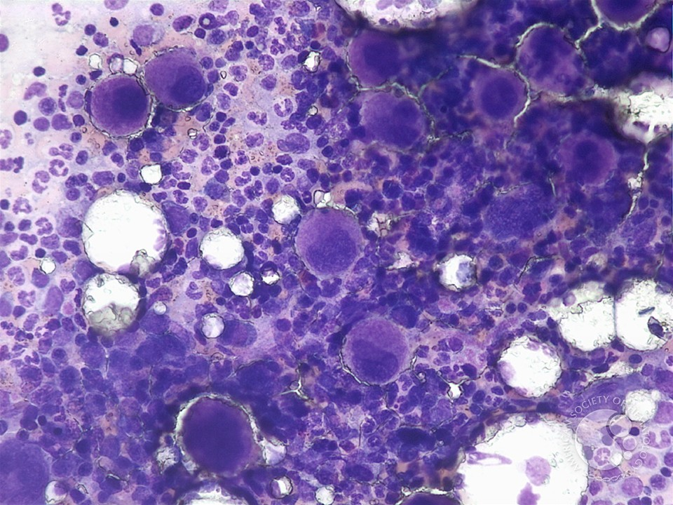

Bone Marrow Core Biopsy: No fibrosis on reticulin Staining

Flow Cytometry for basic leukemia panel (bone marrow aspirate): No abnormal blast population noted

Karyotyping (bone marrow aspirate): 46XX

ANA: negative

Hepatitis panel: positive for antiHBs but otherwise negative for other Hepatitis A, B and C markers

TSH: 3 miU/L

FT4: 1.5 mg/dL

Coomb’s test (direct and indirect): negative

Ferritin 2 mcg/L Iron 7.4 umol/L TIBC 100.45 umol/L

Whole abdomen ultrasound: unremarkable