**Case Vignette**

A 61-year-old female, Roman Catholic from Pasay City was brought in for persistent back pain. 6 months prior to consult patient experienced intermittent low back pain which was partially relived by self-medicating with Mefenamic Acid. After 1 month, the back pain became more bothersome for which she was brought to a general practitioner for evaluation. Laboratory tests were done and she was allegedly diagnosed with UTI and given unrecalled antibiotics. This only decreased pain severity. At around 4 months prior to consult, there was still persistent back pain now accompanied by exertional dyspnea, body malaise and occasional headache. She was brought to another physician and her tests allegedly showed she was only “anemic” hence she was given Ferrous Sulfate. In the interim, the symptoms persisted for which she would take pain relievers with partial relief of symptoms. Around 1 week prior to consult, patient had worsening back pain now accompanied by vomiting, abdominal pain and episodes of confusion. Persistence of symptoms prompted her to be admitted.

She is a known hypertensive for 5 years on Amlodipine 5 mg/tab once a day. There was no family history of hypertension, diabetes or asthma. There is a family history of breast cancer (sister), colon cancer (1st cousin) and lung cancer (nephew). She has a 20-pack year smoking history and quitted for around 10 years. She previously worked as a laundrywoman but has stopped for around 5 years. Her obstetric history is unremarkable at G5P5 (5-0-0-5)

Physical Examination upon initial consult

General survey: Conscious, coherent and follows commands, not in distress, requires assistance with ambulation

Vital Signs: BP 100/70, HR 110, RR 25, Temp 36.2, O2 sat 99% at room air

HEENT: Pale palpebral conjunctiva, anicteric sclerae, no palpable cervical lymph node, neck veins not engorged, thyroid not enlarged, dry oral mucosa, no oral ulcers, non-hyperemic pharyngeal wall, no tonsillar exudates

Chest/Lungs: Symmetrical chest expansion, clear and equal breath sounds bilaterally

Heart: Distinct heart sounds, apex beat left 5th ICS MCL, (-) heaves, thrills or lifts, (-) murmurs

Abdomen: Soft abdomen, normoactive bowel sounds, tympanitic to percussion, direct tenderness on the epigastric area, Traube’s space not obliterated

Extremities: Pulses full and equal, no edema, (+) palmar pallor

Musculoskeletal: No gross deformities, full range of motion on all extremites

Neurologic examination: Intact mental status, cranial nerves intact, no gross focal motor and sensory deficits, (+) resting tremor on both hands, hyporeflexia on both upper and lower extremities, (-) Babinski, (-) signs of meningeal irritation

**Labs done on admission**:

|  |  |
| --- | --- |
| Complete Blood Count | Result |
| Hgb | 88 g/L |
| Hct | 27% |
| MCV | 1. fl |
| MCH | 1. pg |
| MCHC | 335 g/L |
| WBC | 1. x 109/L |
| Neutrophils | 45% |
| Lymphocytes | 46% |
| Monocytes | 7% |
| Eosinophil | 2% |
| Platelet | 152 |
| RDW | 19.0% |

|  |  |
| --- | --- |
| Blood Chemistry | Result |
| Na | 129 mmol/l |
| K | 5.5 mmol/l |
| Ca | 13.04 mg/dL |
| Mg | 3.01 mg/dL |
| BUN | 32.75 mg/dL |
| Creatinine | 2.40 mg/dL |
| LDH | 310 U/L |
| Total Protein | 10.9 g /dL |
| Albumin | 3.0 g/dL |
| Globulin | 7.9 g/dL |

**Other Labs done during the course of admission**:

Whole Abdominal UTZ: There is no disparity in the renal sizes. Both kidneys are normal in size and exhibit normal parenchymal echogenicity with good corticomedullary differentiation. Liver, spleen, pancreas and gallbladder were unremarkable

Peripheral Blood Smear:

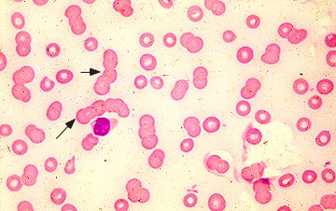

Serum Protein Electrophoresis:

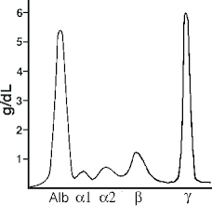

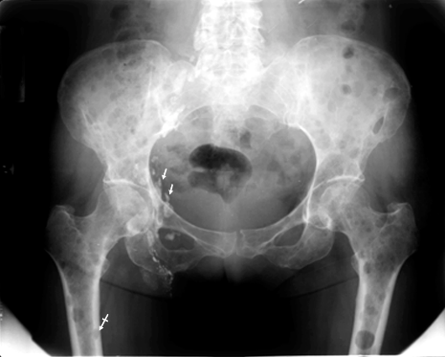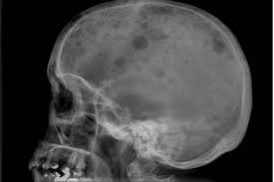Skeletal Survey:

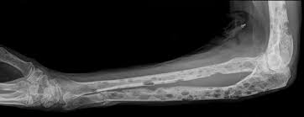

Bone Marrow Aspirate:

