**Case Vignette**

A 24-year-old female, Filipino, Christian, from Pampanga, is in the outpatient clinic due to history of gum bleeding. It started two months ago when she experienced light-headedness after her usual morning jog of 3km. The light-headedness was relieved by rest. Over the next two months, she noticed that she could no longer complete the 3km jog, now needing frequent breaks, and eventually could no longer jog for more than 500m at a time without feeling short of breath. She was still able to do chores around the house. One month ago, her boyfriend mentioned that she was looking pale. She self-medicated with iron supplementation. Two weeks ago, she noticed small red pinpoint macules on her arms and legs as well as gum bleeding after brushing her teeth. She was seen at a local hospital in Angeles where she was transfused with 3 units packed red blood cells and 8 units of random donor platelets. She was discharged after 5 days and advised to seek further consult.

` She has no known illnesses, no previous surgery, and no maintenance medications or supplements. Her father has hypertension. She does not smoke, drinks beer on occasion, and sells vegetables at a local market. She is a nulligravid. She has regular menses lasting 3-5 days consuming 3-4 pads per day with dysmenorrhea. She is presently on her 7th day of menses, consuming 6 pads per day.

Physical examination on consult

|  |  |
| --- | --- |
| General Appearance | Awake, oriented, not in cardiorespiratory distress |
| Vital Signs | BP 90/60 mmHg CR 128 bpm RR 22 bpm Temp 36.8C |
| HEENT | Anicteric sclerae, pale palpebral conjunctivae, no eye discharges, no nasal discharge, no cervical lymphadenopathies, no neck vein engorgement |
| Chest | Equal chest expansion, clear breath sounds |
| Heart | Adynamic precordium, tachycardic, regular rhythm, PMI at 5th ICS left midclavicular line, no murmurs, heaves or thrills |
| Abdomen | Abdomen soft, nontender, normoactive bowel sounds, no organomegaly |
| Extremities | Full and equal pulses, no edema, pale nail beds |

**Initial Labs done on consult:**

Complete blood count: Hemoglobin 92 g/L; Hematocrit 0.28; WBC 4.3 x 109/L; Neutrophils 0.29; Lymphocytes 0.61; Monocytes 0.06; Eosinophils 0.00; Basophils 0.00; Stabs 0.04; Platelet 16 x 109/L; MCV 91.3 fL; MCH 30.4 pg; MCHC 332 g/L

PT 14.1 sec/ control 12.6 INR 1.14

APTT 28.1 sec/control 30.38

RBS 5.1 mmol/L FBS 4.7 mmol/L BUN 5.8 mmol/L Crea 47 umol/L AST 18 U/L ALT 13 IU/L Alb 34 g/L Na 133 mmol/L K 4.7 mmol/L Cl 98 mmol/L Ca 2.23 mmol/L Mg 0.65 mmol/L

**Labs done on subsequent follow-up:**

Reticulocyte count: 0.5%

Peripheral Blood Smear:

Blood smear
Pancytopenia and reticulocytopenia
 

Bone marrow aspirate smear:

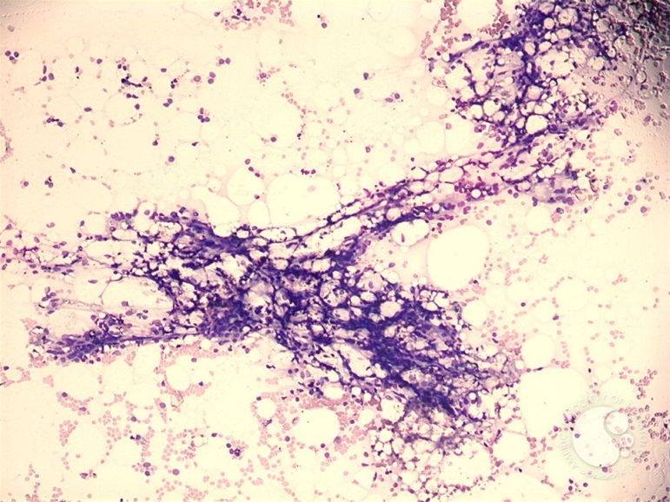

Bone marrow core biopsy: Only 5-10% cellularity. Hematopoietic areas are replaced by fatty tissue. No fibrosis seen on reticulin staining.

Flow Cytometry for Basic Leukemia Panel (bone marrow aspirate): no abnormal blast population seen.

Karyotyping (bone marrow aspirate): 46XX