**Case Vignette**

A.N., 48/M from Pasay who came in due to body malaise. Patient is a Born Again Christian, married with 2 children (8 year old female and 4 year old male), and presently unemployed. Patient had an onset of body malaise 1 week PTA not associated with fever, cough, colds, chest pain, dyspnea nor abdominal pain. 3 days PTA, malaise persisted but now associated with exertional dyspnea noted when climbing 2 flights of stairs. 1 day PTA the exertional dyspnea progressed, noted when walking less than 5 meters. The persistence of symptoms prompted consult and subsequent admission.

Patient has been having recurrent admissions since 2 years PTA (2-3 admissions/year) for blood transfusion due to anemia. He would be given 2-3 PRBCs per admission with usual admission hemoglobin of 60-70. It was also reported in his previous CBCs that his platelet count is also at the range of 80-90. However, further work-up was not pursued due to financial constraints. Six (6) months PTA patient was admitted at a nearby hospital due to numbness of his right upper extremity but was spontaneously relieved after less than 12 hours. He was advised to transfer to another hospital for CT scan at that time, but they went home against medical discharge. Blood pressure monitoring at the hospital was at the range of 140-150/70-80. In the Review of Systems, patient has no other complaints except for occasional light tea colored urine.

Patient has been taking Iron supplements 2x a day intermittently for his anemia, but he stopped 2 months PTA. No other medications were prescribed to the patient.

There was noted Hypertension in the family – Maternal grandfather, uncle, and cousins. There is also a history of Stroke – paternal aunt. Patient’s older brother has also been admitted several times for transfusion and was advised further work-up but not able to comply.

Patient was as a farmer prior to the onset of his illness. He denied history of smoking, illicit drug use, and only had occasional intake of alcoholic beverages.

Physical examination on admission

General survey: Conscious, coherent and not in distress, can ambulate without assistance

VS: BP 140/80 HR 105 RR 19 Temp 36.7 O2 sat 92% at room air, Ht 162cm, Wt 65 kg

HEENT: pale palpebral conjunctiva, anicteric sclerae, no tonsillo-pharyngeal congestion, trachea at midline, no neck vein distention, thyroid not enlarged, no palpable cervical/axillary lymph nodes, non-hyperemic posterior pharyngeal wall, no tonsillar exudates

Lungs: symmetrical chest expansion, clear and equal breath sounds bilaterally

Heart: Distinct heart sounds, apex beat left 5th ICS LMCL, regular rhythm, no murmurs

Abdomen: Soft abdomen, normoactive bowel sounds, tympanitic to percussion, no direct or rebound tenderness, spleen non-palpable, Traube’s space intact

Extremities: Pulses full and equal, no edema, pale nailbeds, no ecchymoses

Neuro: oriented to 3 spheres, cranial nerves intact, no deficit in sensory and motor strength, higher CNS function intact (no localizing signs)

**Initial Labs done on admission**:

|  |  |
| --- | --- |
| CBC | Admission |
| WBC | 1.9 |
| Hgb | 30 |
| Hct | 0.09 |
| MCV | 112.0 |
| MCH | 36.0 |
| MCHC | 322 |
| RDW | 33.8 |
| Platelet | 55 |
| Segmenters | 53 |
| Lymphocytes | 34 |
| Monocytes | 9 |
| Eosinophils | 3 |
| Basophils | 1 |

|  |  |  |  |
| --- | --- | --- | --- |
| Crea | 65 mmol/L | Na | 140 mmol/L |
| AST | 25 U/L | **K** | 3.5 mmol/L |
| ALT | 15 U/L | **Cl** | 105 mmol/L |
| Alb | 4.6g/dL | **Ca** | 4.46 mg/dL |
| TB | 1.5 mg/dL | **Mg** | 0.79 mmol/L |
| DB | 0.5 mg/dL | **LDH** | 1785 U/L |
| IB | 1.0 mg/dL |

**Whole abdomen ultrasound**: Normal ultrasound of the Liver, Spleen, Pancreas, Abdominal Aorta and Para-aortic areas and Kidneys

**Additional Labs done on Hematology Consult**:

Peripheral Blood Smear

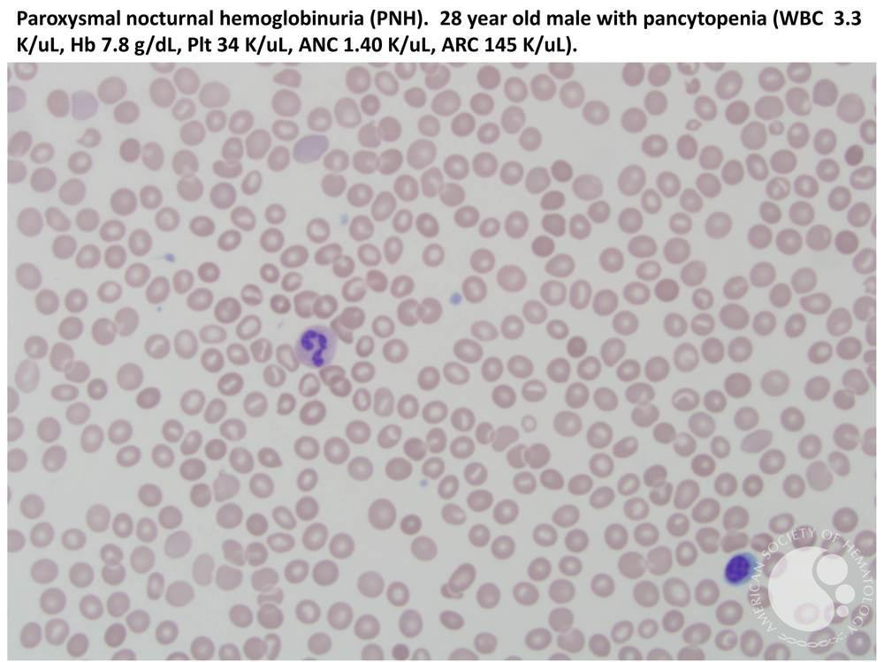

Bone Marrow Aspirate Smears:

Bone Marrow Core Biopsy: Hypocellular to normocellular marrow; no fibrosis on reticulin staining.

Basic Leukemia Panel Flow Cytometry (bone marrow aspirate): No abnormal blast population seen

Karyotyping (bone marrow aspirate): 46 XY

Reticulocyte Count: 1.5%

Coomb’s test (direct and indirect): negative

Ferritin 10 mcg/L Iron 9.4 umol/L TIBC 150 umol/L

PNH Panel with FLAER: PNH clone was demonstrated with rbcs (32.04% Type II), granulocytes (93.82% Type III and monocytes (95.11% Type III). PNH clone also shows a bimodal distribution, indicating Type II and Type III cells.

|  |  |  |
| --- | --- | --- |
| CBC (post transfusions) | HD2 | HD4 |
| WBC | 2.6 | 5.1 |
| Hgb | 67 | 82 |
| Hct | 20 | 24 |
| MCV | 94.4 | 92.4 |
| MCH | 32.1 | 31.2 |
| MCHC | 340 | 338 |
| RDW | 26.8 | 37 |
| Platelet | 59 | 57 |
| Segmenters | 52 | 83 |
| Lymphocytes | 27 | 14 |
| Monocytes | 19 | 2 |
| Eosinophils | 2 | 0 |
| Basophils | 0 | 1 |