**Case Vignette**

A 21-year-old female student from Navotas presented at the emergency room with complaints of progressive shortness of breath, chest pain, and lower extremity edema over the past month. She has no known comorbidities or previous hospitalizations. Additional complaints include alopecia, painful oral sores, generalized joint pains, and fatigue. No previous consults have been done. Patient has been self-medicating with Paracetamol and this would somewhat relieve the chest pain but would have no effect on shortness of breath or edema. On day of consult patient noted severe shortness of breath after walking to the bathroom. Persistence despite rest prompted consult.

She has no other known co-morbids and has no prior hospitaizations. She has no significant claims in her family history. She occasionally smokes and drinks alcoholic beverages with her friends on night-outs. She has never been pregnant but uses OCPs for protected sexual encounters.

Physical examination on consult

General survey: Conscious, coherent and not in distress, can ambulate without assistance

VS: BP 150/90 HR 91 RR 22 Temp 37.6 O2 sat 95% at room air

HEENT: pale palpebral conjunctiva, anicteric sclerae, JVP was measured at 10-11 cm, thyroid not enlarged, no palpable cervical/axillary lymph nodes, non-hyperemic posterior pharyngeal wall, no tonsillar exudates, thin brittle hair, (+) erythematous, scaly, nonpruritic patch with distinct borders over her cheeks crossing the bridge of her nose, (+) oral ulcers, dry oral mucosa, (+) dental caries

Lungs: mild chest retractions, symmetrical chest expansion, decreased breath sounds bilaterally on lung bases, no rales or wheezes

Heart: Distinct heart sounds, apex beat left 6th ICS AAL, (+) grade 3/6 decrescendo diastolic murmur over the left parasternal area radiating to the apex

Abdomen: Soft abdomen, normoactive bowel sounds, tympanitic to percussion, no direct or rebound tenderness, (+) fluid wave

Extremities: Pale and dry skin, Pulses full and equal, no edema, (+) anasarca

**Initial Labs on admission**:

|  |
| --- |
| **CBC:**  Hgb 8.0 g/dL, Hct 24% MCV 89 fL MCH 29 pg RDW 16% WBC 2.9 x109/L (N90% L5% M4% E1% B0%) Platelet 337 x109/L |
|  |
| **ABG on room air:** pH 7.49 pO2 100 pCO2 17 HCO3 21 BE -6 O2Sat 94% |
|  |
| **ECG:** regular sinus rhythm with right axis deviation |
|  |
| PT 16 sec (12.9 control) PTT 26.8 sec (30.38 control) |
|  |
| **Serum chemistry:**  RBS 107 mg/dL Na 131 mmol/L K 4.4 mmol/L BUN 12 mg/dL Crea 2.68 mg/dL AST 49 U/L ALT 37 U/L Ca 2.2 mg/dL Mg 2.16 mmol/L |
|  |
| CRP >12 Ferritin 2000  TB 1.5 mg/dL DB 0.4 mg/dL IB 1.1 mg/dL, ALB 3,6 g/dL LDH 1041 U/L |
|  |
| **Urinalysis:**  yellow, hazy, (-) bilirubin, normal urobilinogen, negative ketone, albumin 3+, blood 3+, pH 6.9, (-) nitrite and leukocyte esterase, SpG 1.009, per high-power field: RBC 4620, WBC 4, EC 79, bacteria 75 |
|  |
| Negative fecal immunochemical test, reticulocyte count 3.5%, direct antiglobulin test (DAT) +2 IgG only |
|  |
| **Hepatitis profile:** reactive Anti-HBs but nonreactive across the rest of the panels |

**Additional Labs done on admission**:

Peripheral Blood Smear

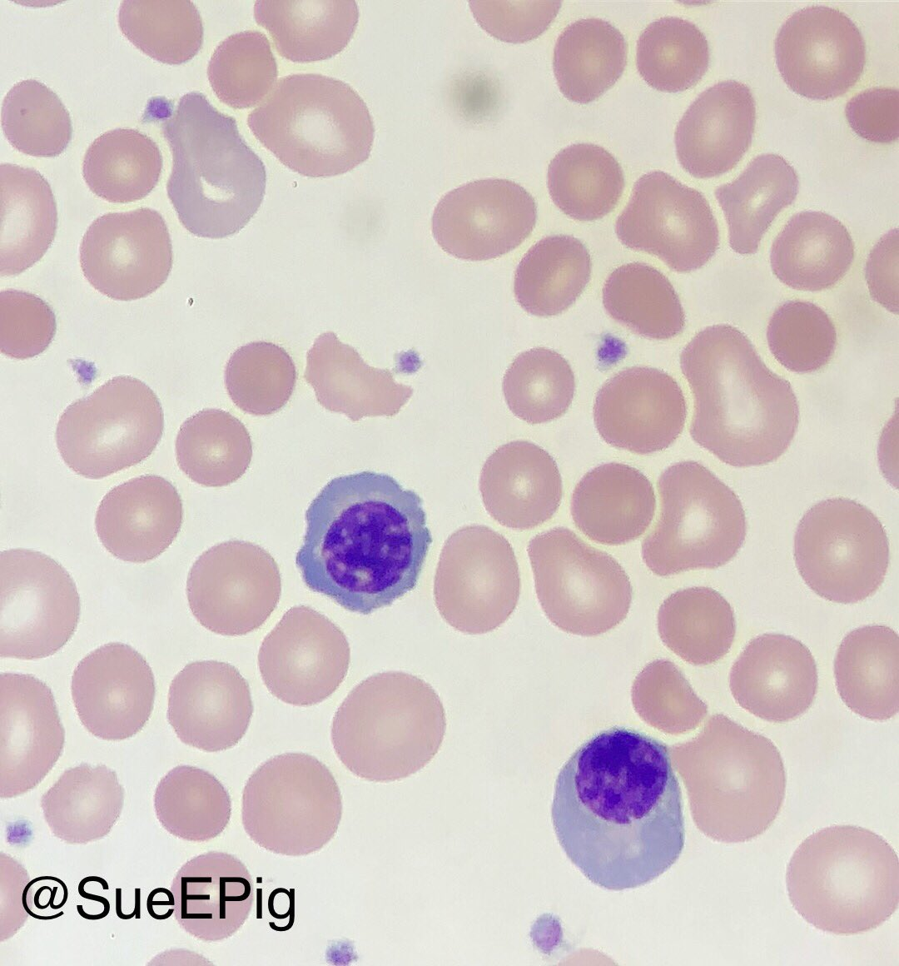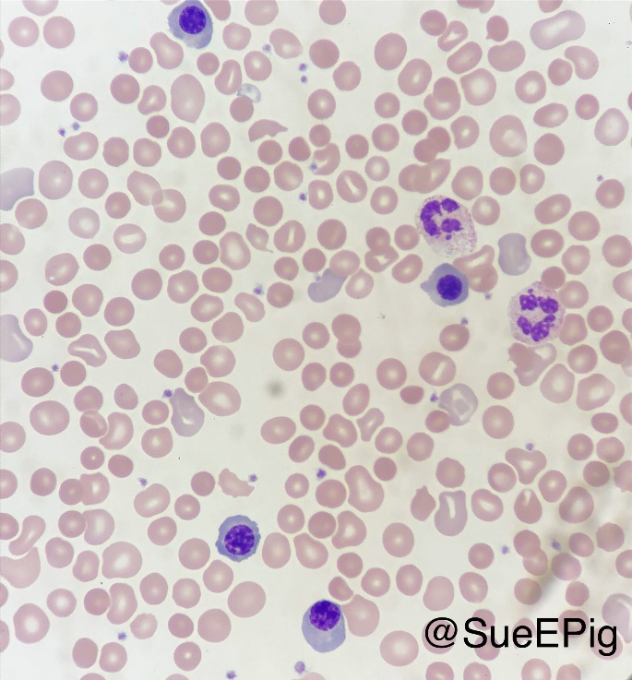

Bone Marrow Aspirate Smear:

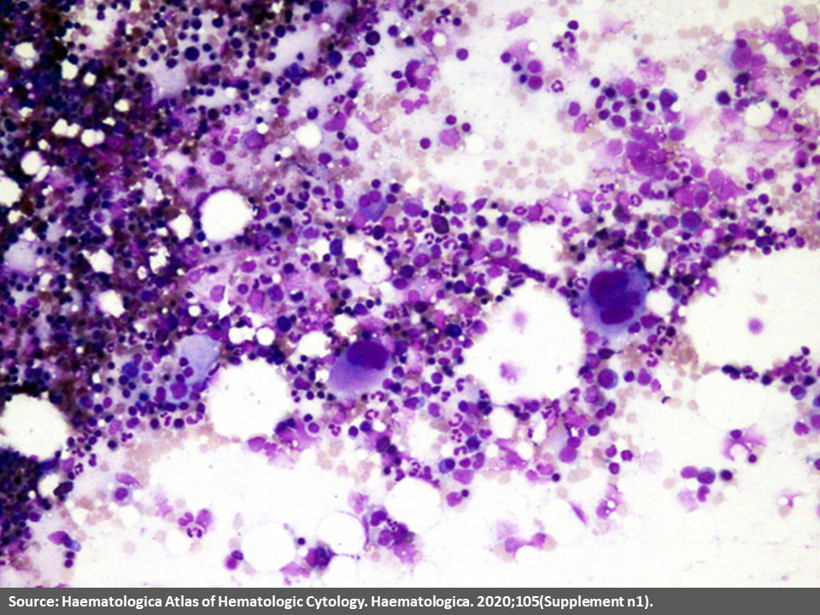

|  |
| --- |
| 24-hour urine protein 6.2g |
| ANA 1:2560 homogenous pattern; Anti-dsDNA antibody titer >1000IU/ml; Anti-Smith antibody 142units; Complement C3: 36 |
| Coombs test direct and indirect: positive |
| **Renal biopsy:**  diffuse proliferative glomerulonephritis with active crescents involving 7 out of 24 glomeruli on light microscopy |