**Case Vignette**

A 67-year-old male, Filipino, Christian, from Bulacan, is in the outpatient clinic due to easy fatigability. Two months prior to consult, he had an episode of light-headedness but was relieved by rest. He used to go walking with his neighbors every morning for 1 hour but he could only tolerate walking for a twenty minute stretch. At home, he could still clean his room and care for himself. One month prior to consult, he mentioned that he stopped walking every day because he could no longer keep up. He prefers to sit down at home and noticed that he was looking pale. Two weeks ago, he went to a local hospital and his CBC allegedly revealed low blood counts. He was admitted and transfused with 2 units packed red blood cells and 4 units platelet concentrate. He was then advised consult with a hematologist.

He has no known illnesses, no previous surgery, and is maintained on Losartan 50 mg once daily for hypertension. His brother also has hypertension. He does not smoke or drink. He is a widower with two children. He owns and manages a small store that sells car parts. H recently switched to a vegetarian diet 2 years ago.

Physical Exam on Consult:

|  |  |
| --- | --- |
| General Appearance | Awake, oriented, not in cardiorespiratory distress |
| Vital Signs | BP 100/60 mmHg CR 88 bpm RR 20 bpm Temp 36.8C |
| HEENT | Anicteric sclerae, pale palpebral conjunctivae, no eye discharges, no nasal discharge, no cervical lymphadenopathies, no neck vein engorgement |
| Chest | Equal chest expansion, clear breath sounds |
| Heart | Adynamic precordium, tachycardic, regular rhythm, PMI at 5th ICS left midclavicular line, no murmurs, heaves or thrills |
| Abdomen | Abdomen soft, nontender, normoactive bowel sounds, no organomegaly |
| Extremities | Full and equal pulses, no edema, pale nail beds |

**Initial Labs done on admission**:

Complete blood count: Hemoglobin 68 g/L; Hematocrit 0.20; WBC 3.6 x 109/L; Neutrophils 0.70; Lymphocytes 0.13; Monocytes 0.14; Eosinophils 0.03; Basophils 0.00; Platelet 115 x 109/L; MCV 114.3 fL; MCH 37.9 pg; MCHC 332 g/L

Reticulocyte count 1.5%

PT 18.1 sec/ control 12.6

APTT 36.6 sec/control 30.38

BUN 12.7 mmol/L Crea 204 umol/L AST 49 U/L ALT 33 IU/L Alb 32 g/L Na 137 mmol/L K 3.6 mmol/L Ca 1.83 mmol/L Mg 0.68 mmol/L

Ferritin 722 ng/mL Iron 7.4 umol/L dTIBC 18.44 umol/L

**Additional Labs done on Subsequent Follow-up**:

Peripheral Blood Smear:

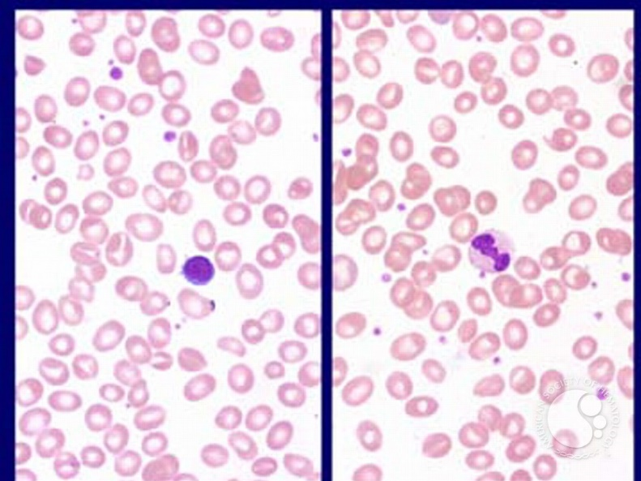

Bone Marrow Aspirate Smear:

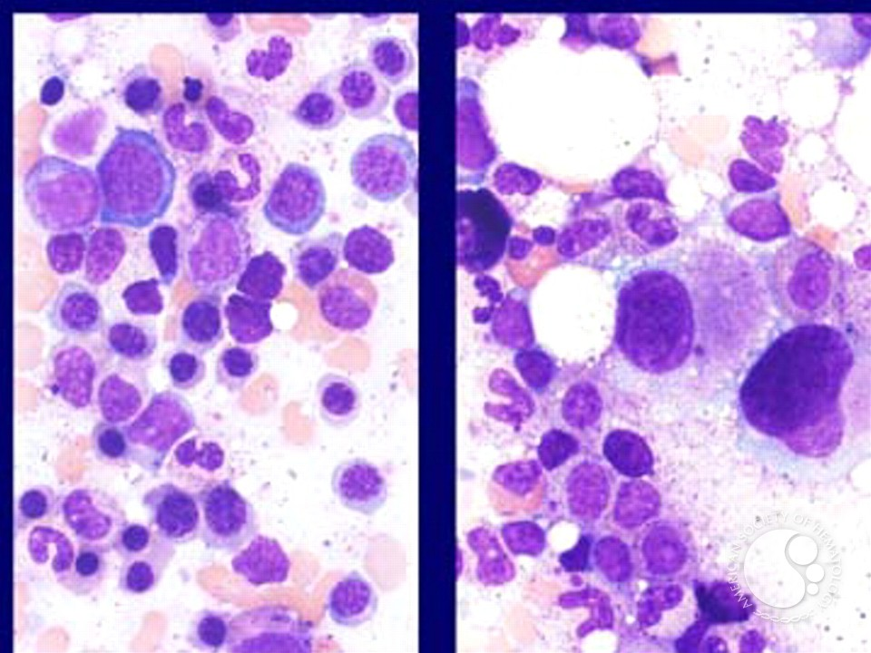

Bone Marrow Core Biopsy: 60% cellularity. Grade 1 fibrosis seen on reticulin staining.

Karyotyping (bone marrow aspirate): 46,XY,del(5)(q13q33)

Flow Cytometry for Basic Leukemia Panel (bone marrow aspirate): no abnormal blast population detected