Case Vignette

A 14 year-old female from Laguna was brought in for consult at the outpatient department due to incidental finding of decreased hemoglobin on her CBC. She denies any history of bleeding, easy bruisability, headache, dizziness, chest pain, palpitations, or abdominal pain. She claims she would sometimes feel easy fatigability. ROS was unremarkable. Past medical history was unremarkable other than a history of UTI 2 years ago and was given unrecalled antibiotics. Patient does not smoke, or drink alcohol and denies use of illicit drug use. She prefers eating meat but claims to eat vegetables at least 3x a week. She has no history of transfusion or prior hospitalizations. She had menarche at age 11 with regular monthly menses lasting 3 days consuming 2-3 pads per day. Denies any sexual contact and has no history of prior pregnancies.
She is currently attending school and claims to be able to participate in all school activities including her PE classes. Patient is a member of the dance club and has dance practices at least once a week.
Her father has a history of hypertension and her mother has Diabetes mellitus. Allegedly her relatives on the father side have a history of anemia with paternal grandmother requiring regular transfusions but they could not recall the indication for transfusions.

Physical examination on consult
General survey: Conscious, coherent and not in distress, can ambulate without assistance
VS: BP 100/70 HR 78 RR 17 Temp 36.7 O2 sat 97% at room air
HEENT: pale palpebral conjunctiva, anicteric sclerae, no tonsillo-pharyngeal congestion, trachea at midline, no neck vein distention, thyroid not enlarged, no palpable cervical/axillary lymph nodes, non-hyperemic posterior pharyngeal wall, no tonsillar exudates
Lungs: symmetrical chest expansion, clear and equal breath sounds bilaterally
Heart: Distinct heart sounds, apex beat left 5th ICS LMCL, regular rhythm, no murmurs
Abdomen: Soft abdomen, normoactive bowel sounds, tympanitic to percussion, no direct or rebound tenderness, spleen non-palpable, Traube’s space intact
Extremities: Pulses full and equal, no edema, pale nailbeds, no ecchymoses

Initial Labs done on consult:

CBC
WBC | 7.8 x10⁹/L
RBC | 5.5 x10¹²/L
Hgb | 92 g/L
Hct | 32%
MCV | 68 fl
MCH | 20 pg
MCHC | 280 g/L
RDW | 19%
Platelet | 400 x10⁹/L
Segmenters | 75%
Lymphocytes | 20%
Monocytes | 4%
Eosinophils | 1%
Basophils | 0%

Crea | 60 umol/L | Na | 140 mmol/L
AST | 30 U/L | K | 3.5 mmol/L
ALT | 27 U/L | Cl | 110 mmol/L
Alb | 3.8 g/dL | Ca | 4.2 mg/dL
TB | 1.5 mg/dL | Mg | 0.81 mmol/L
DB | 0.5 mg/dL | LDH | 200 U/L
IB | 1.0 mg/dL

Urinalysis: unremarkable

Stool FIT: negative

Pregnancy test: negative

12L ECG normal sinus rhythm, normal axis, No ST elevation

Hepatitis profile all were non-reactive

Whole abdomen ultrasound: Splenomegaly with splenic index of 550. Normal ultrasound of the Liver, Pancreas, Abdominal Aorta and Para-aortic areas and Kidneys

Subsequent Labs done:

Reticulocytes: 2%

Ferritin 550 mcg/L Iron 25 umol/L TIBC 75umol/L

Peripheral Blood Smear
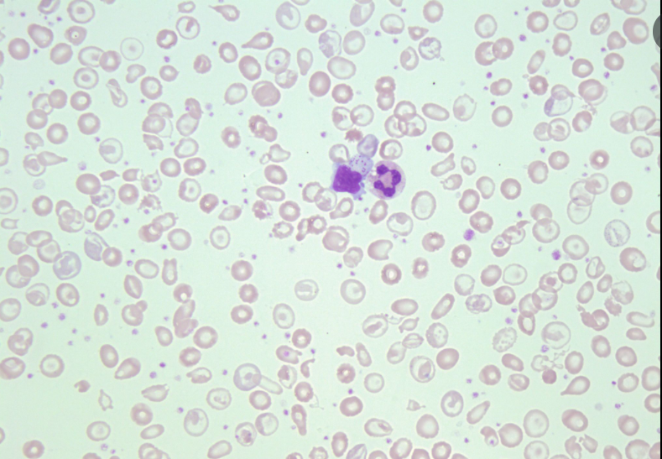

Hemoglobin Electrophoresis
