**Case Vignette**

A 57 year old male Roman Catholic from Camarines Norte was referred for evaluation of abdominal pain. 6 months prior to consult the patient experienced vague left upper quadrant abdominal pain noted to be aggravated by sudden positional changes. This was also accompanied by early satiety, unintentional weight loss, joint pains and occasional pruritus. Patient did not seek any consult at this time. 2 months prior to consult noted increased severity and frequency of abdominal pain with persistence of the early satiety. The patient also noted occasional ringing in both ears as well as exertional dyspnea when climbing two flights of stairs. He consulted at a provincial hospital and was told to have an elevated white blood cell count. He was referred to an internist who recommended hematology evaluation. The patient’s son who works in Manila brought his father to the outpatient department of PGH for consult and second opinion.

The patient is a known hypertensive for 5 years on Losartan 50 mg/tab OD, diabetic for 3 years on Metformin 500 mg/tab BID. He allegedly had a “heart condition” diagnosed 1 year ago when he presented with intermittent chest pain however he was unable to follow-up with his physician. He has a family history of hypertension and diabetes. He also disclosed that he has a sister and brother who both developed “liver disease”. He works as a farmer in a plantation field. He does not smoke but regularly drinks alcoholic beverages, averaging at least 2-3 bottles of beer in a week.

Physical examination on consult

General survey: Conscious, coherent and not in distress, can ambulate without assistance

VS: BP 150/80 HR 80 RR 20 Temp 36.5 O2 sat 97% at room air

HEENT: Pink palpebral conjunctiva, anicteric sclerae, no neck vein distention, thyroid not enlarged, no palpable cervical/axillary lymph nodes, non-hyperemic posterior pharyngeal wall, no tonsillar exudates

Lungs: symmetrical chest expansion, clear and equal breath sounds bilaterally

Heart: Distinct heart sounds, apex beat left 6th ICS AAL, (+) grade 3/6 systolic murmur over the left parasternal area radiating to the apex

Abdomen: Soft abdomen, normoactive bowel sounds, tympanitic to percussion, no direct or rebound tenderness, spleen palpable up to 6 cm below the left subcostal margin

Extremities: Pulses full and equal, no edema, no jaundice

**Initial Labs done at the Provincial Hospital**:

|  |  |
| --- | --- |
| Complete Blood Count | Result |
| Hgb | 89 g/L |
| Hct | 30% |
| MCV | 1. fl |
| MCH | 1. pg |
| MCHC | 335 g/L |
| WBC | 153.0 x109/L |
| Neutrophils | 38% |
| Lymphocytes | 34% |
| Monocytes | 4% |
| Eosinophil | 1% |
| Basophil | 3% |
| Promyelocytes | 3% |
| Metamyelocytes | 8% |
| Bands | 7% |
| Platelet | 152 x109/L |
| RDW | 19.0% |

|  |  |
| --- | --- |
| Blood Chemistry | Result |
| Na | 137 mmol/l |
| K | 3.8 mmol/l |
| Ca | 2,2 mg/dL |
| Mg | 0.82 mmol’L |
| BUN | 32.75 mg/dL |
| Creatinine | 112 umol/L |
| Uric Acid | 7.2 mg/dL |
| AST | 90 U/L |
| ALT | 118 U/L |
| Albumin | 3.4 g/dL |
| FBS | 5.0 mmol/L |

HbA1c 6.2%

Lipid profile: within normal

Hepa profile: nonreactive

12 L ECG: Sinus rhythym, Left ventricular hypertrophy, lateral wall ischemia, occasional skip beats

2Decho: EF 42%, left ventricular dilatation with mild hypokinesia, severe mitral regurgitation

UTZ WA: liver enlarged with signs of portal hypertension, splenomegaly (1800 splenic index), both kidneys normal in size with increased cortical thickness, without nephrolithiasis. GB, pancreas, urinary bladder, ureters unremarkable.

**Additional Labs done on Hematology Consult**:

CBC WBC 175 Hb 99 Hct 33 MCV 94 Neutro 36 Lympho 30 Monocytes 6 Eosinophil 4 Basophil 5 Promyelocytes 3 Metamye 10 Myelocytes 5 Bands 7 Platelet count 512

Peripheral blood smear

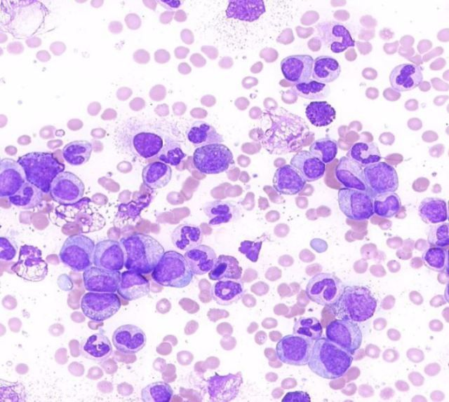

Bone marrow aspirate smear:

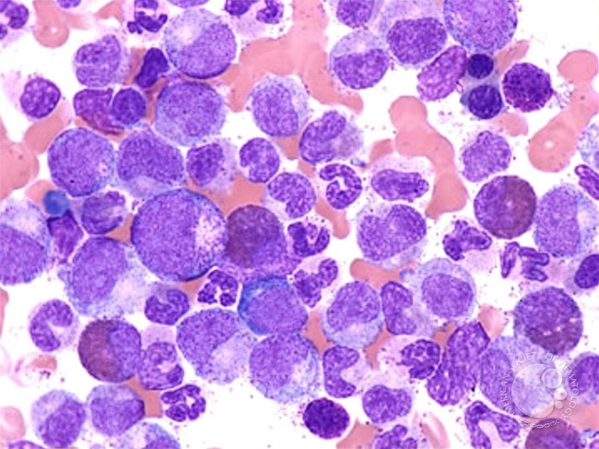

FISH for BCR ABL (marrow aspirate): 98% cells positive for BCR-ABL

Karyotyping (marrow aspirate): 46 XY, t(9;22)(q34;q11.2)