**Module 9: Sustaining living systems**

* 1. **Introduction**

Global population is expected to reach eight billion by 2025. Like all other living species, “humanity depends on nature for food and water, materials for survival, and safety from environmental threats, such as epidemics and natural catastrophes”. However, humanity is also not so good in managing the resources that are the basis of our survival (Sachs 2015).

Natural resources embody land, air, water, forests, fisheries, minerals and wildlife provided by nature, which together produce the ecosystem services critical to human existence and welfare. These natural resources are components in the biosphere illustrated in Module 9. Humans derive many benefits from nature and from protection or conservation of living systems. One example is guaranteed persistence of endemic species and delivery of clean water derived from conservation of native forests (Manhaes et al 2018). However, natural resources are subjected to increasing pressures and threats, as discussed in Modules 8 & 9. Thus, there is a need to understand the perspectives and approaches to sustaining living systems.

* 1. **Learning Outcomes**

After completing the module, students are expected to:

* + 1. Discuss biological conservation as an approach to sustaining living systems; and
    2. Differentiate the various approaches to natural resource management in sustaining living systems.
  1. **Biodiversity conservation**

**Activity 1** (Study time: 150 minutes)

Read the following materials:

Asaad, I., Lundquist, C. J., Erdmann, M. V., Costello, M. J. 2017. Ecological criteria to identify areas for biodiversity conservation. *Biological Conservation*, 213: 309-316.

Congress of the Philippines. 1992. Republic Act No. 7586, An act providing for the establishment and management of national integrated areas system, defining its scope and coverage, ang for other purposes (Section 1 to Section 4).

UNEP-WCMC and IUCN. 2016. Protected Planet Report 2016. UNEP-WCMC and IUCN: Cambridge UK and Gland, Switzerland (pages 1-50)

**Study questions**

1. Why is it important to conserve and manage biodiversity? **G1**
2. What are the possible ways of reducing direct pressures on biodiversity? **G1**
3. What are the international initiatives for prioritization of areas for biodiversity conservation? **G2**
4. What is a protected area? **G2**
5. What are the global categories of protected areas? **G3**
6. What are the categories of protected areas in the Philippines? **G3**
7. What are the challenges to biodiversity conservation in protected areas? **G4**
8. How can the establishment of protected areas facilitate resource management and sustain living systems? **G4**

**Discussion**

The various aspects of biodiversity are discussed in Module 8, including the benefits from and threats to biodiversity. Thus, the discussions in Module 8 highlights the importance of sustaining living systems.

The Philippines is committed to manage and conserve the country’s biodiversity. Our country is a signatory to a number of international agreements intended for this purpose, the most notable of which is 1992 United Nations’ Convention on Biological Diversity (CBD). The CBD is the first global initiative to address biological diversity. The main objectives of the CBD are conservation of biological diversity, sustainable use of its components, and fair and equitable sharing of the benefits arising out of utilization of genetic resources (Muralikrishna and Manickam, 2017).

Globally, biodiversity conservation has been done through the establishment of protected areas. As defined by the International Union for the Conservation of Nature (IUCN) defines a protected area as “a clearly defined geographical space, recognized, dedicated and managed, through legal or other effective means, to achieve the long-term conservation of nature with associated ecosystem services and cultural values” (Day et al 2012, p. 9). Thus, it should be noted that the benefits of protected areas extend beyond biodiversity conservation. As reiterated by IUCN, “protected areas are critical for maintaining a healthy environment for people and nature. They are essential for biodiversity conservation and vital to the cultures and livelihoods of indigenous peoples and local communities. They also deliver clean air and water, bring benefits to millions of people through tourism, and provide protection from climate change and natural disasters” (UNEP-WCMC and IUCN 2016, p. 1)

In 2011, the global protected area network included more than 150,000 sites with a total land area of at least 24 million square kilometers that covers more that 15% of the earth’s total land surface (IUCN and UNEP-WCMC 2012). As of December 2016, the global coverage was 14.8% of terrestrial and inland water areas, 5.1% of oceans and 12.7% of the coastal and marine areas (IUCN 2016). The target for 2020 is to conserve at least 17% of terrestrial areas and 10% of coastal and marine areas (Aichi Target 11 of the Conservation of Biological Diversity).

In the Philippines, the national framework for the establishment of protected areas is Republic Act 7586, known as the “National Integrated Protected Areas Systems (NIPAS) Act”, which was signed on June 1, 1992. However, the first known legislation intended for establishment of national parks was signed in 1932, known as “Act No. 3915: An Act Providing for the Establishment of National Parks”. Mount Arayat became the first national park under Act No. 3915.

The NIPAS Act defines a protected area as identified portions of land and water set aside by reason of their unique physical and biological significance, managed to enhance biological diversity and protected against destructive human exploitation (Section 4, par. 2). Under the NIPAS Act, the specific categories of protected areas are strict nature reserve, natural park, natural monument, wildlife sanctuary, protected landscape and seascapes, resource reserve and natural biotic areas. The Act also provides for the establishment of other categories of protected areas (Section 3).

As of 2016, the Philippines had 559 protected areas composed of 45,762 square kilometers of protected areas (15.32% of total land area) and 21,269 square kilometers (1.16% of total marine area)(<https://www.protectedplanet.net/country/PH)>.

In the Philippines, the overall management of the protected areas in the country is under the general supervision of the Department of Environment and Natural Resources (DENR). The effectiveness of protected areas in conserving biodiversity, other living systems and ecosystem services require active management. This may include onsite conservation, restoration activities, monitoring and enforcement. In some case, it may also be necessary to compensate local communities to forego certain land uses to improve effectiveness of protected area management.

Activities in protected area management include demarcation and patrolling of boundaries, capacity building of staff, purchase of necessary equipment, and information and education campaign. Activities that relate directly to the ecosystem services provided by protected areas can include reforestation for biodiversity conservation, watershed protection and carbon sequestration, monitoring and protection of species and, in case of nature-based recreation, visitor monitoring and trail maintenances (Gomez 2015).

Effective management of protected areas require sufficient funding and community support. Typically, funding comes from government allocations and private donations or grants from international funding agencies. These sources provide about 80% of total funds for protected area management in the Philippines. However, there is an estimated funding shortfall of about 70% (DENR-PAWB 2012).

Local communities are usually primary stakeholders of protected areas and their support can be critical to the sustainability of protected areas. Lack of community support or conflict with protected area managers can arise when any or a combination of these scenarios occur: communities lack awareness about biodiversity, they are neglected in decision-making, or the establishment of protected areas is perceived to result in inequitable distribution of benefits or disadvantage the community by curtailing their resource utilization or source of livelihood (Gomez 2015).

* 1. **Other approaches to natural resource management**

**Activity 2** (Study time: 120 minutes)

Read the following materials:

Ambal, R.G.R., Duya, M.V., Cruz, M.A., et al. 2012. Key biodiversity areas in the Philippines: priorities for conservation. *Journal of Threatened Taxa*, 4(8): 2788-2796.

Hooland, R.A., Darwall, W.R.T, Smith, K.G. 2012. Conservation priorities for freshwater biodiversity: The key biodiversity area approach refined and tested for continental Africa. *Biological conservation*, 148: 167-179.

Stucki, V., Smith, M. 2011. Integrated approaches to natural resources management in practice: The catalyzing role of national adaptation programmes for action. *Ambio*, 40:351-360.

**Study questions**

1. What is natural resource management? **G1**
2. Why is there a need to protect natural resources? **G1**
3. What are examples of integrated natural resources management approaches? **G2**
4. What is a key biodiversity area? **G3**
5. What are some criteria for delineation of key biodiversity area? **G3**
6. What are some of key biodiversity areas in the Philippines? **G4**
7. What is community-based natural resource management? **G4**

**Discussion**

According to Muralikrishna and Manickam (2017) “natural resource management broadly refers to the sustainable utilization of major natural resources, such as land, water, air, minerals, forests, fisheries, and wild flora and fauna” (p. 23). Collectively, these resources provide ecosystem services essential to human life. Thus, it is essential that natural resources be properly managed and effectively conserved.

The establishment of protected areas remain as the major approach for biodiversity conservation worldwide. This is an approach that restricts human use and access to designated areas (Persha, Fisher, Chhatre, et al. 2010). Protected areas are likely to remain the cornerstone of biodiversity conservation. However, many areas with abundant and important natural resources, including biodiversity, are also inhabited by humans or are in the fringes of human settlements. This reality gives rise to other approaches to natural resource management. This reality also highlights the importance of balancing nature conservation with the socio-economic realities of the human population that directly or indirectly benefits from living systems. This requires conservation and management scenarios that take into account social and economic goals of the human communities (Manhães, Loyola, Mazzochini, et al. 2018).

One approach to conservation of living systems is the establishment of key biodiversity areas (KBAs), sites that has significant global contribution. They are identified by national constituencies using globally standardized criteria and quantitative thresholds which can be applied to species and ecosystems in terrestrial, inland water, and marine environments. There are more than 15,000 KBAs identified to date globally (Langhammer, Butchart & Brooks, 2018). In the Philippines, the initiation of definition of KBAs was a collaborative initiative by Conservation International Philippines (CIP), Haribon Foundation and the Protected Areas and Wildlife Bureau (PAWB) of the DENR, following standard criteria. Most of the Philippine KBAs are terrestrial areas, while there are also KBAs that cover both terrestrial and marine areas. They are at various levels of protection, as shown in Figure 1. The country’s KBAs represent the “known habitat of 855 species, 396 globally threatened, 398 restricted-range species of plants and animals and 61 species of congregatory birds (Ambal, et al., 2012).

KBAs guide the strategic expansion of protected area networks by governments and civil society. They also providing growing recognition for and investment in site conservation efforts by local and indigenous communities (Langhammer, Butchart & Brooks, 2018).

.

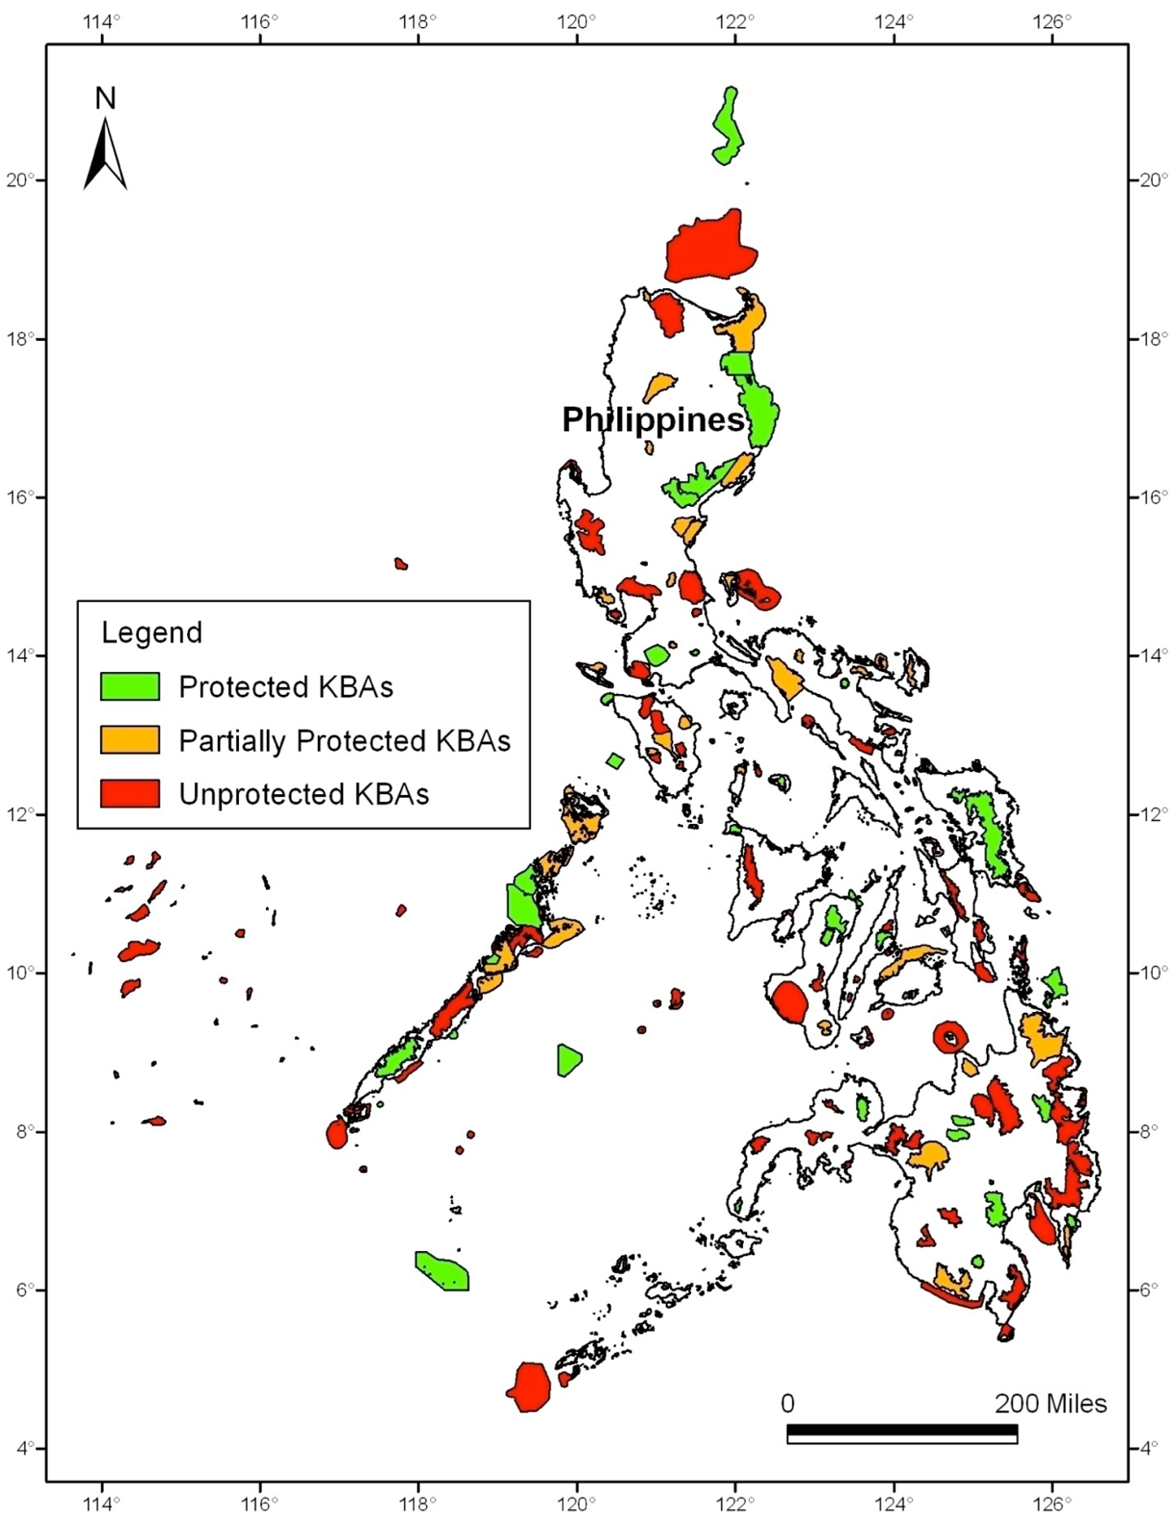

Figure 1. Philippine map showing delineated KBA boundaries, with various levels of protection (Source: Ambal, et al. 2012)

Another approach to conservation of living systems is community-based natural resource management. This is probably one of the oldest approach in natural resource management, wherein a group of people (usually in rural areas) manage the use of resources in their defined area, using communal facilities. According to the US Agency for International Development, “CBNRM promotes conservation through the sustainable use of natural resources, enables communities to generate income that can be used for rural development, and promotes democracy and good governance in local institutions”

Another approach to conservation and management of living systems can be collectively referred to as integrated natural resources approaches. These include integrated water resource management, ecosystems approach, integrated coastal zone management, integrated natural resources management, and forest landscape restoration (Stucki and Smith, 2011). Table 1 shows details about these approaches.

Table 1. Definition and spatial scale of sample integrated natural resources approaches.

|  |  |  |
| --- | --- | --- |
| **Approach** | **Definition** | **Spatial scale** |
| Integrated water resource management | A process which promotes the coordinated development and management of water, land, and related resources, to maximize the resultant economic and social welfare in an equitable manner without compromising the sustainability of vital ecosystems | Basin (river, lake, groundwater) |
| Ecosystem approach | A strategy for the integrated management of land, water, and living resources that promotes conservation and sustainable use in an equitable way | Within the limits of ecosystem functioning |
| Integrated coastal zone management (ICZM) | The process of combining all aspects of human, physical, and biological aspects of the coastal zone within a single management framework | All coastal and upland areas, the uses of which can affect coastal waters and the resources therein, and extends seaward to include that part of the coastal ocean that can affect the land of the coastal zone |

Table 1. Continued

|  |  |  |
| --- | --- | --- |
| **Approach** | **Definition** | **Spatial scale** |
| Integrated natural resources management | Responsible and broad-based management of the land, water, forest, and biological resources base—including genes—needed to sustain agricultural productivity and avert degradation of potential productivity | Landscape |
| Forest landscape restoration | A process that aims to regain ecological integrity and enhance human well-being in deforested or degraded forest landscapes | Landscape |

Source: Stucki and Smith (2011, p. 354)

**Possible formative activities (in class, can choose one only)**

1) What is your favorite food and how it may affect living systems?

Mechanics:

1.1) Divide the class into groups of four or five students;

1.2) The group will decide on one member’s favorite food;

1.3) The group will discuss how the processes involved in the production of that food;

1.4) The group will illustrate how the production of the food may impact living systems; and

1.5) The group will discuss possible ways to minimize any negative impact of production on living systems

2) What is your favorite nature-based tourist destination and how that destination may impact living systems?

Mechanics:

2.1) Divide the class into groups of four or five students;

2.2) The group will decide on one member’s favorite nature-based tourist destination;

2.3) The group will discuss why it is a favorite destination (may be affected by entrance fee, attractions or activities, etc);

2.4) The group will illustrate how the attractions and what people do may impact living systems; and

2.5) The group will discuss what tourists and management may do to minimize any negative impact on living systems.

* 1. **Summary**

Living systems or natural resources are critical to human well-being. However, natural and man-made pressures pose serious threats to natural resources. Thus, there is a need to properly manage and conserve those resources. Establishment of protected areas has been the cornerstone of management and conservation of natural resources. However, effective protected area management requires substantial funds and concerted efforts of various stakeholders including government agencies, local communities, and beneficiaries of the protected area. It is also important to remember that “the use and enjoyment of these protected areas must be consistent with the principles of biological diversity and sustainable development” (NIPAS Act, Section 2).

* 1. **Possible summative assessment (All groups 1-4)**

**Identification of benefits of the protected area, challenges for protected area management, and potential contribution of nearby communities and students in sustaining living systems in protected areas** (outside class, study time: 240 minutes)**.**

Mechanics:

1. Divide the class into groups of four or five students
2. Choose a protected area from your region (if students come from different regions, they will decide which region will be chosen)
3. Identify the benefits derived from living systems protected area or potential benefits that can be derived from living systems in the protected area
4. Identify potential challenges to sustaining living systems in the protected area
5. Use the following format:

|  |  |
| --- | --- |
| Region |  |
| Name of protected area |  |
| Category of protected area |  |
| Natural resources present |  |
| Existing benefits from the living systems in the protected area |  |
| Potential benefits from living systems in the protected area |  |
| Who are currently involved in managing the protected area? |  |
| Existing challenge/s to sustaining the living systems in the protected area |  |
| Potential challenge/s to sustaining the living systems in the protected area |  |
| Potential community participation in sustaining living systems in the protected area |  |
| How can we (students) contribute in sustaining the living systems in the protected area? |  |

* 1. **References**

McLaughlin, D., and W. Kinzelbach

(2015), Food security and sustainable

resource management, Water Resour.

Res., 51, 4966–4985, doi:10.1002/

2015WR017053

McLaughlin, D., and W. Kinzelbach

(2015), Food security and sustainable

resource management, Water Resour.

Res., 51, 4966–4985, doi:10.1002/

2015WR017053

McLaughlin, D., and W. Kinzelbach

(2015), Food security and sustainable

resource management, Water Resour.

Res., 51, 4966–4985, doi:10.1002/

2015WR017053

McLaughlin, D., and W. Kinzelbach

(2015), Food security and sustainable

resource management, Water Resource.

Res., 51, 4966–4985, doi:10.1002/

2015WR017053

McLaughlin, D., and W. Kinzelbach

(2015), Food security and sustainable

resource management, Water Resource.

Res., 51, 4966–4985, doi:10.1002/

2015WR017053

McLaughlin, D., and W. Kinzelbach

(2015), Food security and sustainable

resource management, Water Resour.

Res., 51, 4966–4985, doi:10.1002/

2015WR017053

McLaughlin, D., and W. Kinzelbach

(2015)

Food security and sustainable resource management

Dennis McLaughlin

1

and Wolfgang Kinzelbach

Dennis McLaughlin

1

and Wolfgang Kinzelbach

Ambal, R.G.R., Duya, M.V., Cruz, M.A., et al. 2012. Key biodiversity areas in the Philippines: priorities for conservation. Journal of Threatened Taxa, 4(8): 2788-2796.

Asaad, I., Lundquist, C. J., Erdmann, M. V., Costello, M. J. 2017. Ecological criteria to identify areas for biodiversity conservation. *Biological Conservation*, 213: 309-316.

Congress of the Philippines. 1992. Republic Act No. 7586, An act providing for the establishment and management of national integrated areas system, defining its scope and coverage, ang for other purposes (Section 1 to Section 4).

Day, J, Dudley, N, Hockings, M, Holmes, G, Laffoley, D, Stolton, S & Wells, S 2012, *Guidelines for applying the IUCN protected area management categories to marine protected areas*, IUCN, Gland, Switzerland, viewed 23 June 2013, <[http://cmsdata.iucn.org/downloads/iucn_categoriesmpa_eng.pdf>](http://cmsdata.iucn.org/downloads/iucn_categoriesmpa_eng.pdf%3e).

Gomez, A.L.V. 2015. Identification and valuation of ecosystem services in the Mount Apo Natural Park, the Philippines, as a basis for exploring the potential of ‘payments for environmental services’ for protected area management. PhD Thesis, Charles Darwin University, Australia. Available at <http://espace.cdu.edu.au/view/cdu:53511>

IUCN. 2016. Annual Report 2016. IUCN: Gland, Switzerland.

IUCN and UNEP-WCMC 2012, *The world database on protected areas (WDPA)*, UNEP-WCMC, Cambridge, UK, 18 June 2013, <[http://www.wdpa.org/Statistics.aspx>](http://www.wdpa.org/Statistics.aspx%3e).

## Langhammer, P.F., Butchart, S.H.M., Brooks, T.M. 2018 Key biodiversity areas. Encyclopedia of Anthropocene, 3: 341-345. <https://doi.org/10.1016/B978-0-12-809665-9.09829-3>

Manhães, A.P., Loyola, R., Mazzochini, G.G., Ganade, G., Oliveira-Filho, A.T. and Carvalho, A.T. 2018. Low-cost strategies for protecting ecosystem services and biodiversity. Biological Conservation, Vol. 217, pp. 187–194.

Muralikrishna, I.V., Manickam, V. 2017. Environmental management: Science and engineering for industry, Chapter 3: Natural resources management and conservation. Kidlington, Oxford, UK: Butterworth-Heinemann.

Persha, L., Fischer, H., Chhatre, A., Agrawal, A., Benson, C. Biodiversity conservation and livelihoods in human-dominated landscape: Forest commons in South Asia. *Biological Conservation*, 143: 2918-2925.

Sachs, Jeffrey D. 2015. The age of sustainable development. New York: Columbia University Press.

Stucki, V., Smith, M. 2011. Integrated approaches to natural resources management in practice: The catalyzing role of national adaptation programmes for action. *Ambio*, 40:351-360.

Ullah, R. 2017. Methodological approaches in natural resource management. *Redefining Diversity and Dynamics of Natural Resources Management in Asia*, 4:11-18. <http://dx.doi.org/10.1016/B978-0-12-805451-2.00002-8>.

UNEP-WCMC and IUCN. 2016. Protected Planet Report 2016. UNEP-WCMC and IUCN: Cambridge UK and Gland, Switzerland.