**Module 5: Population Dynamics**

Aimee Lynn A. Barrion-Dupo

**5.1 INTRODUCTION**

The innate dynamism of living systems is typified through patterns and cycles explained in Modules 3 and 4, modification of components, adaptations to physiological environments, genetic regulation, and population dynamics. This module focuses on the latter; providing an understanding of how populations grow and decline.

It is important to relate population growth to resource use as biogeochemical cycles through ecosystems influence the rates at which populations of organisms reproduce. In the same manner, the size and pattern of distribution of populations of organisms influences biogeochemical cycles. Microorganisms, for instance, are known to be key drivers of global biogeochemical cycles (Madsen, 2011).

The human population, meanwhile, contributes to global change by altering biogeochemical cycles. Such modifications are partially a function of the growth in size and productivity of the human population. Population size and productivity are intricately connected through both technologies and socio-cultural activities that allow us to harness energy as well as feed us (Suarez and Sajise, 2010; Wright, 2005).

By the end of Module 5, you are expected to accomplish the following: 1) study the resources in this module, and 2) accomplish module’s learning tasks.

**5.2 LEARNING OUTCOMES**

After studying the resources and accomplishing the activities given in this module, you should be able to:

1. identify demographic processes affecting population growth;
2. differentiate factors limiting population growth; and
3. interpret constructed graphs and tables on population dynamics;

**5.3 LEARNING ACTIVITIES**

It was through Thomas Malthus’ *Essay on the Principle of Population* in 1798 that the first theoretical treatment of population dynamics was proposed. At that time, Malthus described populations to grow logistically under ideal environmental conditions. However, he also mentioned that growth of populations depended on constant resource supply. The mathematical translation of this concept was made by Pierre François Verhulst in 1838, forming what is now known as the *logistic equation* : dN/dt = rN(1-N/K). In this equation, N represents the population size while r represents the intrinsic rate of increase in a given time period (t). Meanwhile, K represents the carrying capacity, the total number of individuals of a population that the finite environment can support (Berryman, 1992).

Alfred Lotka and Vito Volterra upgraded Verhulst’s linear single-species population dynamics equation to include the effect of another population, i.e. predator interaction. This cycling effect of predator-prey interaction is illustrated in their dynamics (Figure 5.1).

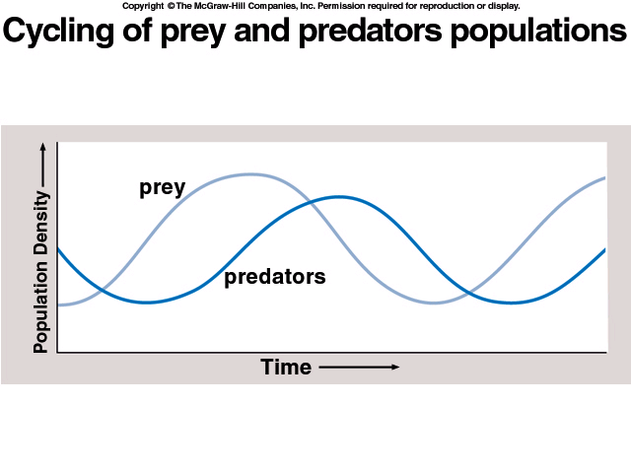

Figure 5.1. Cycling of predator-prey populations.

(lifted without permission Mc Graw Hill Companies)

**5.3.1** **Demographic Factors**

Core to the study of population dynamics is understanding how demographic factors influence population size. These demographic factors are namely: **birth**, **death**, i**mmigration,** and **emigration**. Members of a population enter this system in two ways. One is through birth and the other through immigration. Hence, birth and immigration cause increase in population size. In contrast, members of this living system exit it either through death or emigration. Both demographic processes eventually lead to the decline in population size.

How demographic factors affect population expansion and shrinking rates can be visualized through life tables, survivorship curves, and age structures. **Life tables** are a record of the birth and death rates for organisms at different life stages. A simplified graphical presentation of elements of the life table is called a **survivorship curve**. Lastly, the **age structure** is literally a “groufie” of a population at a specific moment in time. Members of this population are clustered according to age and sex categories. Data provided by these visual records provide useful information on the state of the population.

**5.3.2** **Population Growth**

As with life tables, survivorship curves, and age structures, ecologists think

of ways to show or model how population size changes in size and composition

over of time. Modelling population dynamics mathematically helps to quantify changes occurring in a population and, importantly, to predict future changes. Describing and predicting future population changes becomes all the more important with the human population, as the dynamics of our population directly and indirectly exert pressure on other living systems in the biosphere (Molles, 2010).

The first population growth model represents growth of a population without environmental resistance factors. These **environmental resistance factors** are limits to population growth (e.g. predators, food, mates etc.). This continuous population increase in an unlimited environment is called the **exponential growth model**. This pattern of population growth yields a J-shaped curved. However, Module 2 has demonstrated that resources are limited and can be depleted. This causes population growth to eventually slow down and stop. The part where population growth stops is what is termed as the carrying capacity of the environment. **Carrying capacity** is the total number of individuals that the environment can support. A **logistic growth model** shows that when resources get diminished, population growth rate will ultimately plateau (Molles, 2009; Stiling, 2002). And this model produces an S-shaped population growth curve.

**5.3.2** **Population Regulation**

According to Molles (2010), environmental checks affect population growth by altering demographic processes such as birth and death rates. These limits are classified into two types: density-dependent factors and density-independent factors. Biotic factors like disease and predation which limit population growth are **density-dependent factors**. The effects of these factors on birth and death intensifies as population increases in size. In contrast, **density-independent** factors are abiotic factors (e.g. temperature, weather, light intensity etc.) that exert the same influence on the population regardless if the population is large or small.

**Activity 1: Mind Mapping Population Dynamics Concept**

**Estimated Time to Finish Task 1: 90 minutes**

The following resources discuss population demographics and population growth. Resource [**1**](http://tvup.ph/?p=3935) presents the four demographic processes affecting population size (i.e. birth, death, immigration, and emigration). Furthermore, Resource [**1**](http://tvup.ph/?p=3935) tackles how populations growth is predicted through two models: exponential and logistic.

On the other hand, Resource [**2**](https://www.khanacademy.org/science/biology/ecology/population-ecology/a/life-tables-survivorship-age-sex-structure) complements Resource [**1**](http://tvup.ph/?p=3935) by depicting how populations grow and decline through life tables, survivorship curves and age structures. elate to age structure

Resource [**3**](http://tvup.ph/?p=3934) elaborates on these using the Philippine population growth as an example.

Meanwhile, Resource **4** will help you differentiate the density-independent and density-dependent limiting factors to population growth.

Take note of your answers to these study questions as you study the learning resources. You will have to go back to these again at the last part of Activities 2 and 3.

1. How do demographic factors affect population size?
2. Are the effects of these factors mutually exclusive?
3. How is population growth depicted?
4. What are applications of knowing limits to population growth?
5. Describe a density-independent factor and explain why its effect on population growth is independent of population density.
6. How do density-dependent factors limit population growth?

Click the links below to access or download all resources and study them carefully.

**Resource 1:** [**Population Dynamics**](http://tvup.ph/?p=3935)

**Link:** http://tvup.ph/?p=3935

**Estimated Time Required to View and Study: 15 minutes**

**Resource 2:** [**Life Tables, Survivorship, & Age- Structure**](https://www.khanacademy.org/science/biology/ecology/population-ecology/a/life-tables-survivorship-age-sex-structure)

**Link:** https://www.khanacademy.org/science/biology/ecology/population-ecology/a/life-tables-survivorship-age-sex-structure

**Estimated Time Required to Read: 5 minutes**

**Resource 3.** [**Philippine Population Growth**](http://tvup.ph/?p=3934)

**Link:** http://tvup.ph/?p=3934

**Estimated Time Required to View and Study: 30 minutes**

**Resource 4:** [**Population Regulation**](https://www.khanacademy.org/science/biology/ecology/population-growth-and-regulation/a/mechanisms-of-population-regulation)

**Link:** https://www.khanacademy.org/science/biology/ecology/population-growth-and-regulation/a/mechanisms-of-population-regulation

**Estimated Time Required to Read: 5 minutes**

Visually organize what you have learned from Resources 1-4 into a [**mind map**](https://www.youtube.com/watch?v=YRKyWp6TSm8).

First identify a central idea from the resources you studied. Next, create links or associations to this central idea by adding branches to your central idea. When you are done with your mind map, partner with someone in class and discuss your mind map.

**Resource 5:** [**How to make a mind map Study Tip # 6**](https://www.youtube.com/watch?v=YRKyWp6TSm8)

**Link:** https://www.youtube.com/watch?v=YRKyWp6TSm8

**Estimated Time Required to View: 1:40 minutes**

**Activity 2: Think Pair Share (bridge with Resources 1-4 application)**

**Estimated Time to Finish Task 1: 30 minutes**

Read the following population cases:

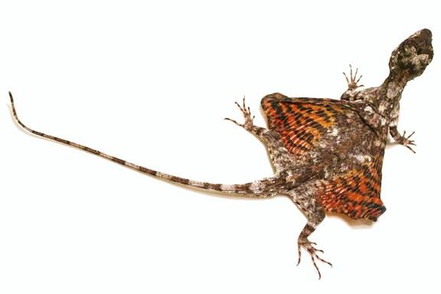

**Case 1.** You happened to observe a population of

the Philippine flying lizards, *Draco volans* thriving in the mulberry trees. One day, you noticed that the number of adults has increased and is higher than previously observed. What could explain this?

**Case 2.** It is the start of the rainy season. The 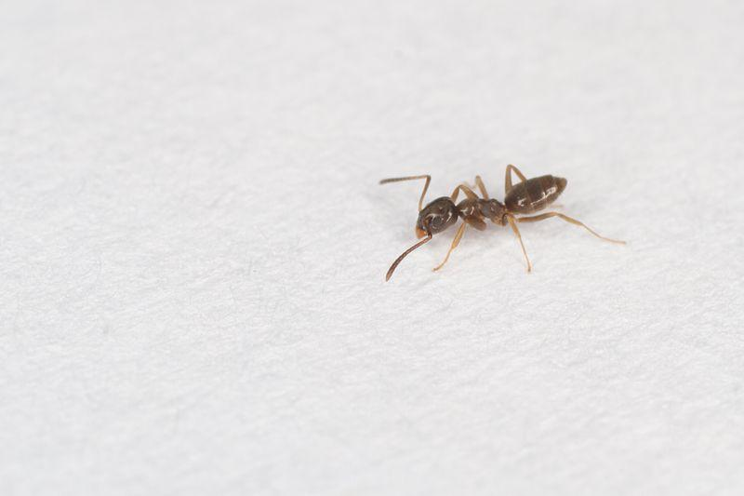

grassy areas near your dorm have been flooded

and odorous ants (*Tapinoma sessile*) living there

started to take refuge inside dorms—including

yours. In sheer panic, you try setting up sticky

traps. After some, time, you noticed that nothing

was happening. You tried plotting the population 

growth curve of this ant species to determine if the

traps are working. You ended up with the

exponential phase of a logistic curve. What can

you infer from your graph?

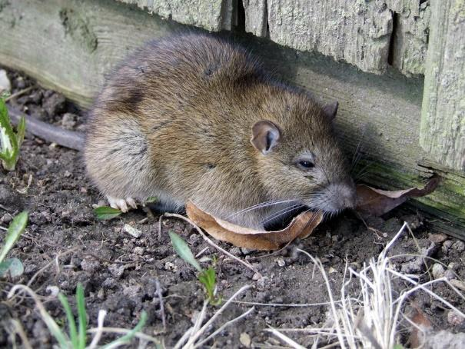

**Case 3.** During sembreak, you observed rats (*Rattus norvegicus*) living in the field near your home. You noticed that while there are many rats, you rarely observed any reproductive females. What can you infer from this observation?



Write down your explanation on each case topic prior to the discussions. Next, pair up with a partner. You may also work with your initial partner whom you have discussed your mind map with. Discuss and share your ideas on these cases with your partner.

**Activity 3: *Figure* It Out**

**Estimated Time to Finish Task 1: 50 minutes**

After studying Resources 1-4, check your understanding of the text and

videos by doing the following with your assigned group:

1. Construct a graph of the population growth of the Philippines. Make use of the data found in: <https://web.archive.org/web/20120704171010/http://www.nscb.gov.ph/secstat/d_popn.asp>
2. Next, plot the survivorship curve of Filipinos in 2000 using the life-table data of the Philippines. This information can be accessed through the link below: <http://apps.who.int/gho/data/view.main.LT62150?lang=en>.

Your may also request your professor for an excel file of this.

1. If you need a guide on constructing a survivorship curve, you can access this link for a step-by-step guide : <http://www.afrc.uamont.edu/whited/Life%20tables,%20survivorship%20curves,%20and%20popuation%20growth.pdf>

**NOTE:** If you do not have access to the internet, your professor can

provide you with electronic and hard copies of these materials.

4. The following meeting, your group will present properly-labelled

graphs keeping in mind the guide questions listed below:

* 1. Is your graph of the Philippine population showing exponential or logistic growth?
  2. What type of survivorship curve does the Philippine population show?
  3. What do you think are demographic factors influencing the population growth of Filipinos?
  4. Cite some examples of density-dependent and density independent factors that could influence (or has influenced) Philippine population growth.
  5. When do you think will a population collapse?

**Scoring Rubric for Task 1: *Figure* It Out**

|  |  |  |  |  |
| --- | --- | --- | --- | --- |
| **Categories** | **Yes**  **(2 pts)** | **Partly**  **(1 pt)** | **No**  **(0 pt)** | **Remarks** |
| **Comprehension** | | | | |
| 1. Discussion reflects a good perception of key  ideas from the module and resources |  |  |  |  |
| 2. Discussion connects the topic to related ideas  and concepts |  |  |  |  |
| **Presentation of Graphs** | | | | |
| 1. Graphs are clearly, concisely presented |  |  |  |  |
| 2. Graphs are neat and properly labelled |  |  |  |  |
| Interpretation of Graphs | | | | |
| 1. Related data to module concept clearly |  |  |  |  |
| 2. Described and evaluated trends observed  from the data plotted |  |  |  |  |
| **Etiquette** | | | | |
| 1. The group responds to their peers' questions  courteously |  |  |  |  |
| 2. The group displays a openess to consider  novel and even contradictory ideas |  |  |  |  |
| **Communication Skills** | | | | |
| 1. Data presentation and discussion is presented in correct, academic language |  |  |  |  |
| 2. Data presentation display minimal grammar,  spelling errors |  |  |  |  |
| **Sub-total** |  |  |  |  |

**SYNTHESIS**

From this module, you should be able to realize the importance and applications of knowing why and how populations grow and shrink. Such knowledge and understanding can help you relate the complex interwoven connections between population dynamics and the sustainable use of biological resources. However, keep in mind that with appreciation comes action too, hence you were asked to address some incendiary questions.

**SELF-ASSESSMENT:**

**Estimated Time to Finish Self-Assessment: 5 minutes**

After studying the module resources and accomplishing all the learning tasks for this module, check whether you were able to do the following:

* + - identify demographic processes influencing population dynamics
    - discuss how population size increases and decreases
    - distinguish factors limiting population growth
    - explain the relationship population dynamics with resource use

**Multimedia Resources:**

Below are multimedia resources (videos, slide presentations, etc.) to help reinforce your learning on Population Dynamics.

[**Demographic Transition**](https://www.youtube.com/watch?v=6P2bsPWCRvM)

(Khan Academy (2014, April 28). Demographic Transition [Video file].)

https://www.youtube.com/watch?v=6P2bsPWCRvM

[**Manila- 20 Million and Rising**](https://www.youtube.com/watch?v=KuDDvYhmCTE)

(LeeLee (2012, October 12). Manila 20 Million and Rising [Video file].)

<https://www.youtube.com/watch?v=KuDDvYhmCTE>

[**Population Dynamics**](https://www.youtube.com/watch?v=4CAQN-nc8Ac)

(Khan Academy (2014, April 27). Population Dynamics [Video file].)

<https://www.youtube.com/watch?v=4CAQN-nc8Ac>

[**Population Ecology**](https://www.youtube.com/watch?v=PQ-CQ3CQE3g)

(Bozeman Science (2015, October 1). Population Ecology [Video file].)

<https://www.youtube.com/watch?v=PQ-CQ3CQE3g>

**Links:**

Resource 1: Population Dynamics

Link: <http://tvup.ph/?p=3935>

Resource 2: Life Tables, Survivorship, & Age- Structure

Link: <https://www.khanacademy.org/science/biology/ecology/population-ecology/a/life-tables-survivorship-age-sex-structure>

Resource 3. Philippine Population Growth

Link: <http://tvup.ph/?p=3934>

Resource 4: Population Regulation

Link: <https://www.khanacademy.org/science/biology/ecology/population-growth-and-regulation/a/mechanisms-of-population-regulation>

Resource 5: How to make a mind map Study Tip # 6

Link:<https://www.youtube.com/watch?v=YRKyWp6TSm8>

Human Population Growth and the Demographic Transition

Link: <https://www.ncbi.nlm.nih.gov/pmc/articles/PMC2781829/>

**References:**

1. Albertin,W., P. Marullo,M. Aigle,C. Dillmann,D, de Vienne,M. Bely, and D.Sicard.

2011. Population Size Drives Industrial *Saccharomyces cerevisiae* Alcoholic

Fermentation and Is under Genetic Control. Applied and Environmental

Microbiology: 2772–2784.

1. Berryman, AA. 1992. The origins and evolution of predator-prey theory. Ecology.

73(5): 1530-1535.

1. Barrion-Dupo ALA, Banaay CGB, Lambio IAF, Maranan FS, Rabena MAF, Flores

RJD, Deyto RC, Fajardo AM, Lit ILJr. 2013. Effect of population density on

larval dispersion and pit construction of the antlion, *Myrmeleon angustipennis*

Banks (Neuroptera: Myrmeleontidae). Asian Journal of Biological

Sciences.vol.6(2): 31-137.

1. Bongaarts, J. 2009. Human population growth and the demographic transition. Phil.

Trans. R. Soc. B (2009) 364, 2985–2990. doi:10.1098/rstb.2009.0137.

1. Madsen, E.L. 2011. Microorganisms and their roles in fundamental biogeochemical

cycles. Current Opinion in Biotechnology. 22:456–464.

1. Molles, M. C. Jr. 2010. Ecology: Concepts and Applications. 5th edition. Boston:

WCB/McGraw-Hill. 230-261.

1. Stiling, P. 2002. Ecology. Upper Saddle River, NJ: Prentice Hall, pp.66-88.
2. Suarez, R.K. and P.E. Sajise. 2010. Deforestation, Swidden Agriculture and Philippine

Biodiversity. Philip Sci Letters . 3(1):91-99.

1. Wright, R.T. 2005. Environmental Science. Upper Saddle River, N.J.:

Pearson/Prentice Hall, pp.76-78.