A 74-year-old male, Filipino, Catholic, from Quezon City, is in the outpatient clinic due to easy fatigability. Six months ago, he started having intermittent low back pain which he self-medicated with ibuprofen with relief. Two weeks ago, he started feeling short of breath after doing gardening around his house. He attributed it to the summer heat but the feeling has persisted so he had laboratory tests done. He also complains of anorexia, early satiety, and polyuria and nocturia.

He has had type 2 diabetes mellitus for the past ten years and takes metformin and empagliflozin. His siblings also have diabetes mellitus and one has undergone bypass surgery for three-vessel coronary artery disease. He is a retired engineer, is married and has three children. He is a twenty-pack year smoker and presently uses vape as he has tried to stop smoking cigarettes. He is a heavy alcoholic beverage drinker, drinking 4 shots of whisky every night, and more during occasion.

General Appearance | Awake, oriented, not in cardiorespiratory distress
Vital Signs | BP 110/60 mmHg CR 92 bpm RR 22 bpm Temp 36.8C
HEENT | Anicteric sclerae, pale palpebral conjunctivae, no eye discharges, no nasal discharge, no cervical lymphadenopathies, no neck vein engorgement
Chest | Equal chest expansion, clear breath sounds
Heart | Adynamic precordium, tachycardic, regular rhythm, PMI at 5th ICS left midclavicular line, no murmurs, heaves or thrills
Abdomen | Abdomen soft, nontender, normoactive bowel sounds, splenic tip palpable at the left subcostal margin
Extremities | Full and equal pulses, no edema, pale nail beds

Laboratories
Complete blood count | Hemoglobin 92 g/L Hematocrit 0.28  WBC 12.3 x 10⁹/L  Neutrophils 0.72 Lymphocytes 0.21 Monocytes 0.03  Eosinophils 0.00 Basophils 0.00 Myelocytes 0.03  Nucleated RBCs 4/100 RDW 22  Platelet 270 x 10⁹/L  MCV 91.3 fL MCH 30.4 pg MCHC 320 g/L  Reticulocyte count 1.3%
Coagulation | PT 16.8 sec/ control 12.6 INR 1.21  APTT 32.3 sec/control 30.38
Chemistry | BUN 10.1 mmol/L Crea 164 umol/L AST 62 U/L ALT 73 IU/L Alb 30 g/L Na 137 mmol/L K 4.7 mmol/L Cl 104 mmol/L Ca 1.99 mmol/L Mg 0.85 mmol/L
Whole abdominal ultrasound | Bilaterally small kidneys with signs of renal parenchymal disease  Liver is bright in echogenicity and spans 10cm. No focal lesions or intrahepatic biliary dilation seen. Splenic index is 450.
Peripheral blood smear | Normocytic normochromic RBC, anisopoikilocytosis grade 3 (dacryocytes, elliptocytes, and polychromatic RBCs seen), nucleated RBCs seen  WBC 5-7/hpf predominantly segmenters with note of myelocytes and suspicious mononuclear myeloid cells, probably blasts  Platelet 13-15/OIF mostly small granular, few medium hypogranular forms seen  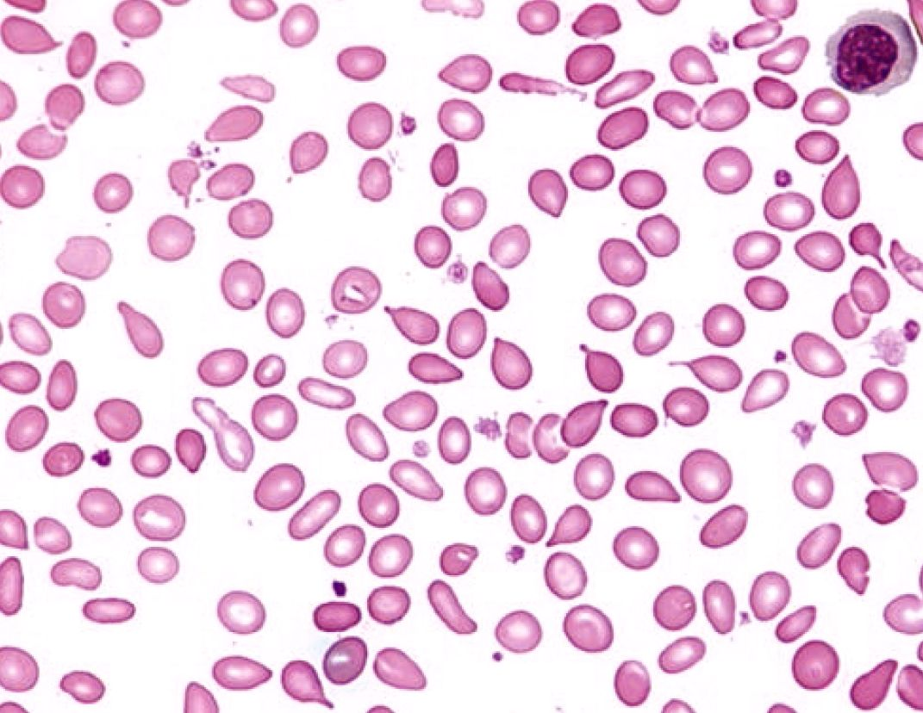  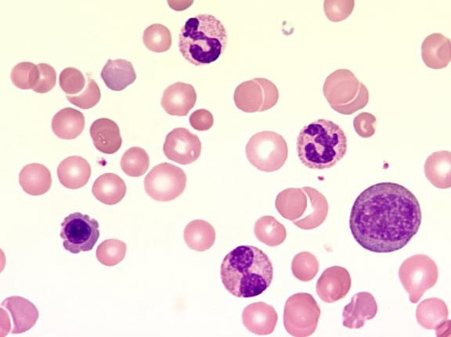
Bone marrow aspiration and biopsy | - Cellular marrow with trilineage hematopoiesis  - The bone marrow is hypercellular for age, with intact trilineage hematopoiesis seen. Megakaryocytes seen, 3-5 per low power field, with normal size and lobation.  - The bone marrow smears are particulate, with intact erythrogranulopoiesis with adequate maturation. Clusters of mononuclear cells with basophilic scant cytoplasm seen interspersed throughout the bone marrow sample.  