BIO166 – Ecosystem Health

Activity 1: Habitat Suitability Assessment

Our environment is made up of complex ecosystems that serve as important habitats for a wide array of organisms. These particular habitats do not just possess ecosystem structures but they provide us with numerous ecosystem services. Hence, they need to be protected and safeguarded from possible stressors induced by man or by nature. Applying an assessment procedure in looking into these habitats are important as the process can quantitatively predict the extent of damage to the general environment. This tool also provides us a perspective to quantitatively identify the environmental value of an ecosystem in terms of its size and habitat quality, which may bring about an influence whether directly or indirectly on the survival of an individual species.

The Habitat suitability assessment is a method that accounts target species on a particular habitat. It is a measure of the suitability of a particular habitat for a given species or group of species based on the habitat attributes assessed in a given area. Indices can be used to calculate areas that conform to the target species’ habitat within its distribution. Indices can be combined with many variables to form a single composite measure. The method provides numerous benefits like providing a complete picture of a species distribution, predicting future changes in the species distribution, and helping identify sites where particularly important species can be found.

The purpose of this activity is to enable students in exploring the method as an effective quantitative assessment in evaluating or even predicting impacts on the area’s ecosystem from certain stressors emanating in the environment. This assessment can be conducted by using data-driven methods like an ecological niche modelling and by ‘expert’ methods where a panel of experts are convened and asked to describe a species’ habitat preferences. This particular activity will focus on the data-driven method where students will be asked to go about a statistical analysis of data on a species’ current distribution and relate it to the habitat’s attributes (e.g. soil quality, air quality, water quality, human developments, etc.).

Methodology:

In constructing a habitat suitability assessment report, each group will have to use the following data sets obtained from the following researches that will be provided. Maps and data of species distribution are provided in the journal articles. Environmental attributes of the habitats have to be searched in the internet through the websites of government agencies. Each group will only select a particular topic on the given data set (like for example, fish surrounding the Las Pinas Paranaque ecotourism area; birds in the Las Pinas Paranaque ecotourism area; plants in Metro Manila). Using the data generated in the process, a logistic regression model is to be formed. The logistic regression is a specialist form of statistical regression analysis where the presence/absence of data are to be inputted. This activity involves investigating the relationship between the abundance of certain species or group of species in a particular habitat.

The following analytical methods and index may also be used to go about the process of doing a habitat evaluation procedure theory where the habitat of a target species and the quality of the species’ habitat can assess the value of the habitat (Table 1).

Table 1. Analytical Methods and Index for Habitat Evaluation Procedure

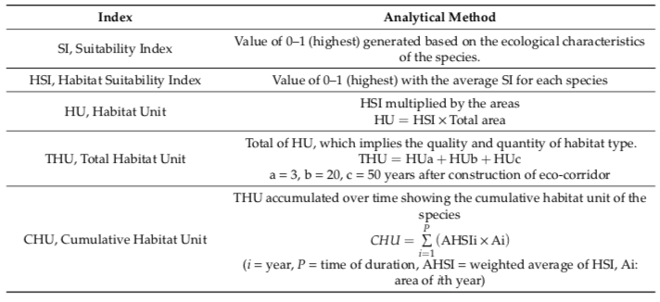

The suitability index (SI) involves the collection of the environmental factors to the species in order to generate a suitability index. The habitat suitability index (HSI) uses an arithmetic mean method where all the SI are averaged. The Habitat unit (HU) is generated from the HIS values obtained for all the study regions multiplied by the HU values from each study area and Total Habitat Unit (THU) is the cumulative HU value for each study region. The cumulative habitat unit (CMU) is generated by integrating the obtained THU with the target time selected and calculating the graphical area of the portion surrounded by the time axis and line graph indicating the variation in the THU.

At the end, a written habitat suitability assessment report is required from each group.

Reference Materials will be provided with the activity.