**Biology 181**

**Exercise 6**

**Data Presentation and Analysis**

**Instructions:**

1. **Read the abstract, statement of the problem, research objectives and hypothesis of the study assigned to your group.**
2. **Critique the research objectives. Do they address the problem identified in the study? Were they written following the guidelines for objectives formulation (i.e., SMART)?**
3. **Based on the objectives, list down the variables and classify them according to:**
   1. **Type of data (qualitative or quantitative)**
   2. **Level of measurement (nominal, ordinal, interval, ratio)**
4. **Based on the objectives, what study design would be most appropriate to employ?**
5. **Does the study need hypothesis testing? Why or why not? Critique how the hypotheses were formulated. Do they follow the guidelines for hypothesis framing?**
6. **Refer to the raw data of the study assigned to your group.** 
   1. **Present summarized data in whichever form you think is most appropriate.**
   2. **What statistical tests should be employed? Provide a brief justification for your decision on which statistical test to use.**
   3. **Attach the SPSS output and interpret the results.**

## **Abstract**

Glutathione is popularly known for its anti-melanogenic properties despite not

having been approved by the Food and Drug Administration as a skin-whitening agent. But

it is endorsed as a supplement which acts as an antioxidant in the body. This study aimed

to assess anti-melanogenic properties; effects on liver histology; and effects on fecundity

of a branded and a generic glutathione supplement. There were three set-ups, control,

branded, and generic groups. The control group were fed with untreated TetraMin™ fish

flakes while the branded and generic groups were fed with TetraMin™ fish flakes mixed

in with the equivalent amount of branded and generic glutathione, respectively, based on

weight equal to the human dose of 1000 mg/day. Results showed that branded and generic

glutathione had significant lower mean absorbance compared to the control group at 350

nm and 450 nm, branded being more effective than generic, except no significant difference

between control and generic groups at 350 nm; no significant difference based on the

NAFLD scoring was observed between liver sections of the three groups; and no significant

difference was observed in terms of fecundity as well as no obvious difference in larval

pigmentation at 72 hpf among the three groups. This investigation provides evidences of

anti-melanogenic properties of branded and generic glutathione.

Keywords: antioxidant, anti-melanogenic, fecundity, glutathione, melanin, liver histology

## **Statement of the problem**

Glutathione is an antioxidant and detoxifying agent incorporated in many health

and commercial products (Wu et al., 2004). Branded and generic glutathione capsules are

available in drug stores and commonly bought by Filipinos interested in achieving fairer

skin. This study aimed to shed light on the effectiveness of branded and generic glutathione

as a whitening agent as well as investigate other side effects to the liver and fecundity of

adult female zebrafishes.

## **Research objectives**

This study aimed to compare the effects of branded and generic glutathione as

whitening agents, specifically:

1. To compare the effects of the branded and generic glutathione capsules

on the melanin content of adult female zebrafish.

2. To analyze the histological effects of orally administered branded and

generic glutathione capsules on the liver tissues of the control, branded

and generic glutathione-fed female zebrafish.

3. To compare the number of eggs spawned by the control, branded and

generic glutathione-fed female zebrafish.

## **Hypothesis**

H o :There is no significant difference in the melanin content, liver histology, and

fecundity between branded and generic glutathione treatment groups of adult female

zebrafish.

H a :There is a significant difference in the melanin content, liver histology, and

fecundity between branded and generic glutathione treatment groups of adult female

zebrafish.

## **Raw data**

# **Study 2**

## **Abstract**

Extended-spectrum beta-lactamase (ESBL)-producing bacteria have increasingly

been reported to be widespread in various environments. In the Philippines, limited studies

have been made on the presence of ESBL-producers particularly on bacteria isolated from

caves. This study screened ESBL production and genotyped the beta-lactamase genes of

28 bacterial strains from bat guano in Cabalyorisa Cave, Mabini, Pangasinan, Philippines.

The strains were found to belong to the family Enterobacteriaceae and were identified to

be either Enterobacter cloacae, Enterobacter xiangfengensis, Escherichia coli, and

Salmonella spp. Antimicrobial susceptibility testing of these strains against four 3

generation cephalosporins and a monobactam showed that 18 (64%) out of the 28 strains

were found to be resistant to at least one of four antibiotics. ESBL-production was then

confirmed using the Phenotypic Confirmatory Disk Diffusion Test (PCDDT) and 15 (83%)

out of 18 strains that were initially tested antibiotic resistant were also positive for ESBL

production. Lastly, the type of beta-lactamase genes that the phenotypically identified

ESBL-producing strains possessed was determined by the amplification and sequencing of

the blaCTX-M, blaOXA, blaAmpC genes through Polymerase Chain Reaction (PCR). Results

showed that 12 (80%) and 14 (93%) out of the 15 strains were detected to harbor the blaOXA

and blaAmpC genes, respectively. Meanwhile, the blaCTX-M gene was detected in all of the

strains tested making it the most predominant bla gene present among the strains.

Alarmingly, 11 (73%) of the strains harbored all the three bla genes tested which may

indicate higher resistance to antibiotics. This study therefore confirmed presence of ESBL-

producers with multiple genes indicative of the spread of antibiotic resistant bacteria in the

Philippine wildlife and other isolated environments. Further studies therefore are necessary

to determine the distribution and prevalence of ESBL-producers in various environments.

## **Statement of the problem**

Are extended-spectrum beta-lactamase (ESBL)-producing bacteria present in bat

guano collected from Cabalyorisa Cave, Mabini, Pangasinan? If present, what ESBL genes

do they possess?

## **Research objectives**

In order to detect the presence of the (ESBL)-producing bacteria and beta-lactamase

genes present in the bacterial isolates from bat guano of Cabalyorisa Cave, Mabini,

Pangasinan, the following objectives must be met:

Specifically, the study plans to:

1. profile the antibiotic resistance of the Enterobacteriaceae isolates against different

3rd generation cephalosporins and monobactam;

2. confirm the production of ESBL enzymes through the Phenotypic Confirmatory

Disk Diffusion Test (PCDDT); and

3. type the genes harbored by the ESBL-positive isolates through amplification of the

blaCTX-M, blaOXA, blaAmpC using Polymerase Chain Reaction (PCR).

## **Raw data**

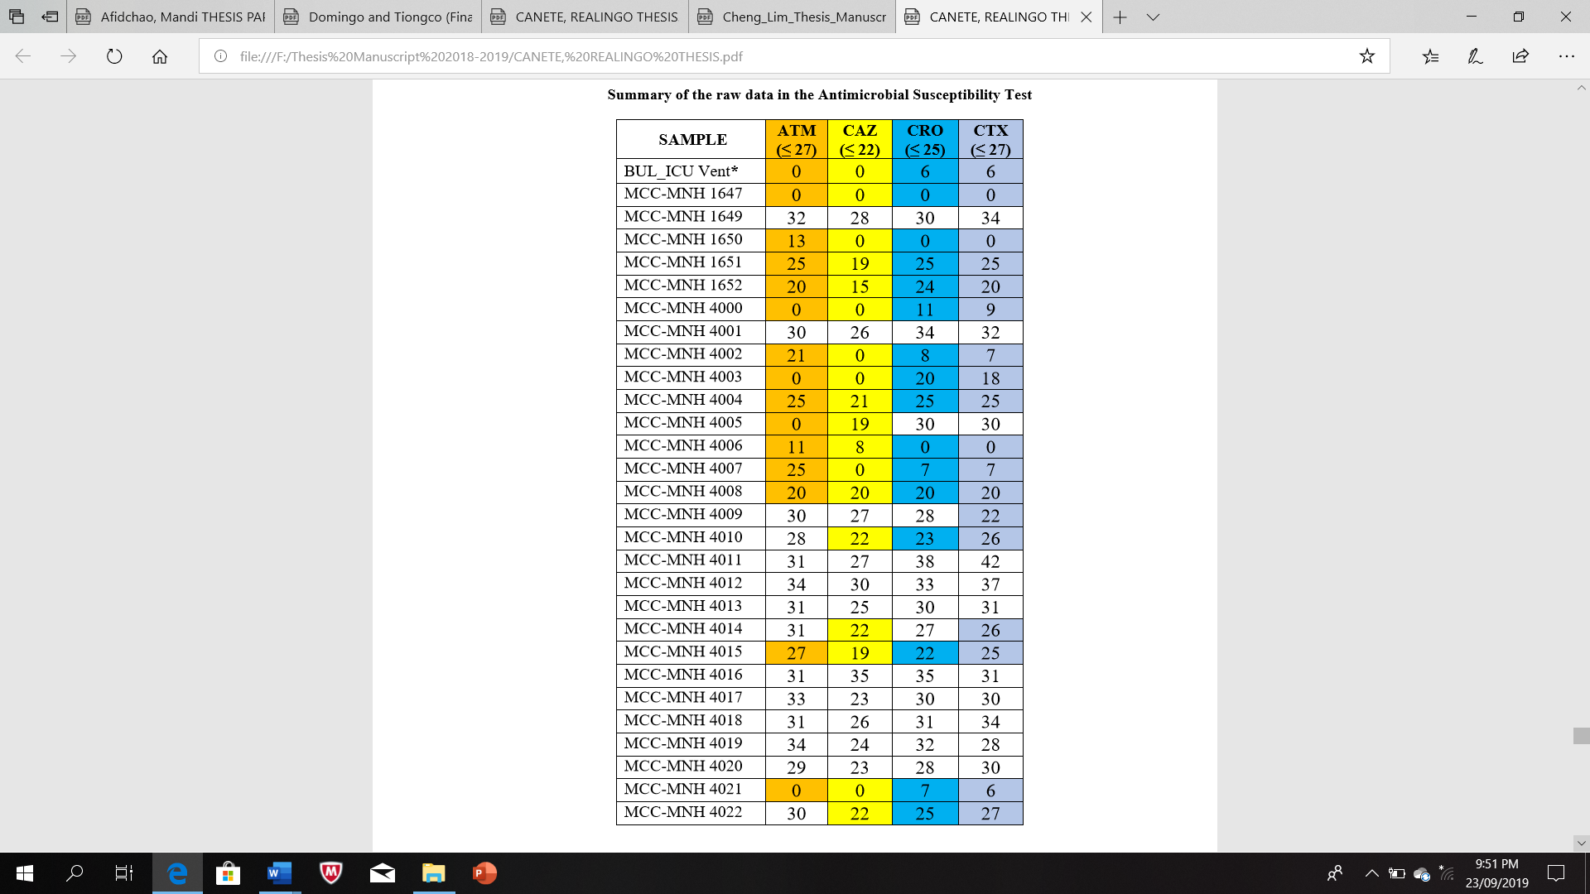

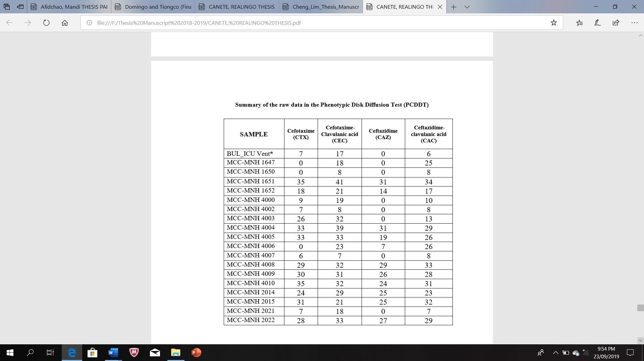

# **Study 3**

## **Abstract**

The essential oil extract from the leaves of Blumea balsamifera L. was tested for its

larvicidal activity against third and fourth instar larvae of Aedes aegypti, the primary vector of the

dengue virus. The essential oil was obtained via hydrodistillation using a Clevenger-type

apparatus. Essential oil concentrations used for the larvicidal assay were 100, 125, 150, 225, and

300 ppm. Larval mortality was observed after 24 hours of treatment. The LC50 values of B.

balsamifera essential oil against third and fourth instar larvae of Ae. aegypti after 24 hours of

exposure were 148.10 ppm and 140.53 ppm, respectively while the LC90 values for third and fourth

instar larvae were 275.67 ppm and 212.35 ppm, respectively. No mortality was observed in the

negative control with DMSO. The LC50 values of Abate 1SG against third and fourth instar larvae

were 0.218 ppm and 0.252 ppm, respectively while LC90 values for third and fourth instar were

0.417 ppm and 0.398 ppm, respectively. These findings suggested that the commercial larvicide

was still more potent in comparison to the essential oil as its aforementioned LC50 and LC90 values

were lower by 99.8% as compared to the values observed from the essential oil. Thus, the sambong

leaf essential oil exhibited good larvicidal activity and may be utilized to lessen the frequency of

synthetic larvicide usage, which could delay the rapidly evolving resistance of mosquitos against

synthetic larvicides due to the over dependence and repeated use of these products.

## **Statement of the problem**

Is *Blumea balsamifera* essential oil an effective larvicide against the third instar and fourth

instar larvae of *Aedes aegypti*?

## **Research objectives**

The overall objective of this study was to test for the larvicidal activity of *B. balsamifera*

leaf essential oil against third instar and fourth instar *Aedes aegypti* larvae. This was accomplished

firstly by estimating the 24-hour LC50 and LC90 values of B. balsamifera essential oil against Aedes

aegypti third instar and fourth instar larvae through probit analysis. The experiment also aimed to

compare the larvicidal effect of sambong essential with the effect of a commercial larvicide such

as Abate 1SG through comparison of their lethal concentration values.

## **Hypothesis**

## **Raw data**

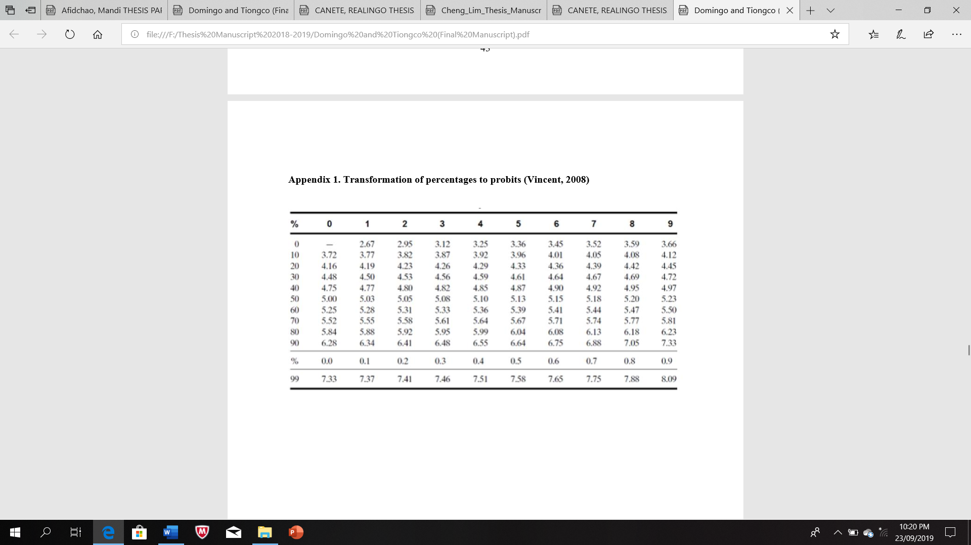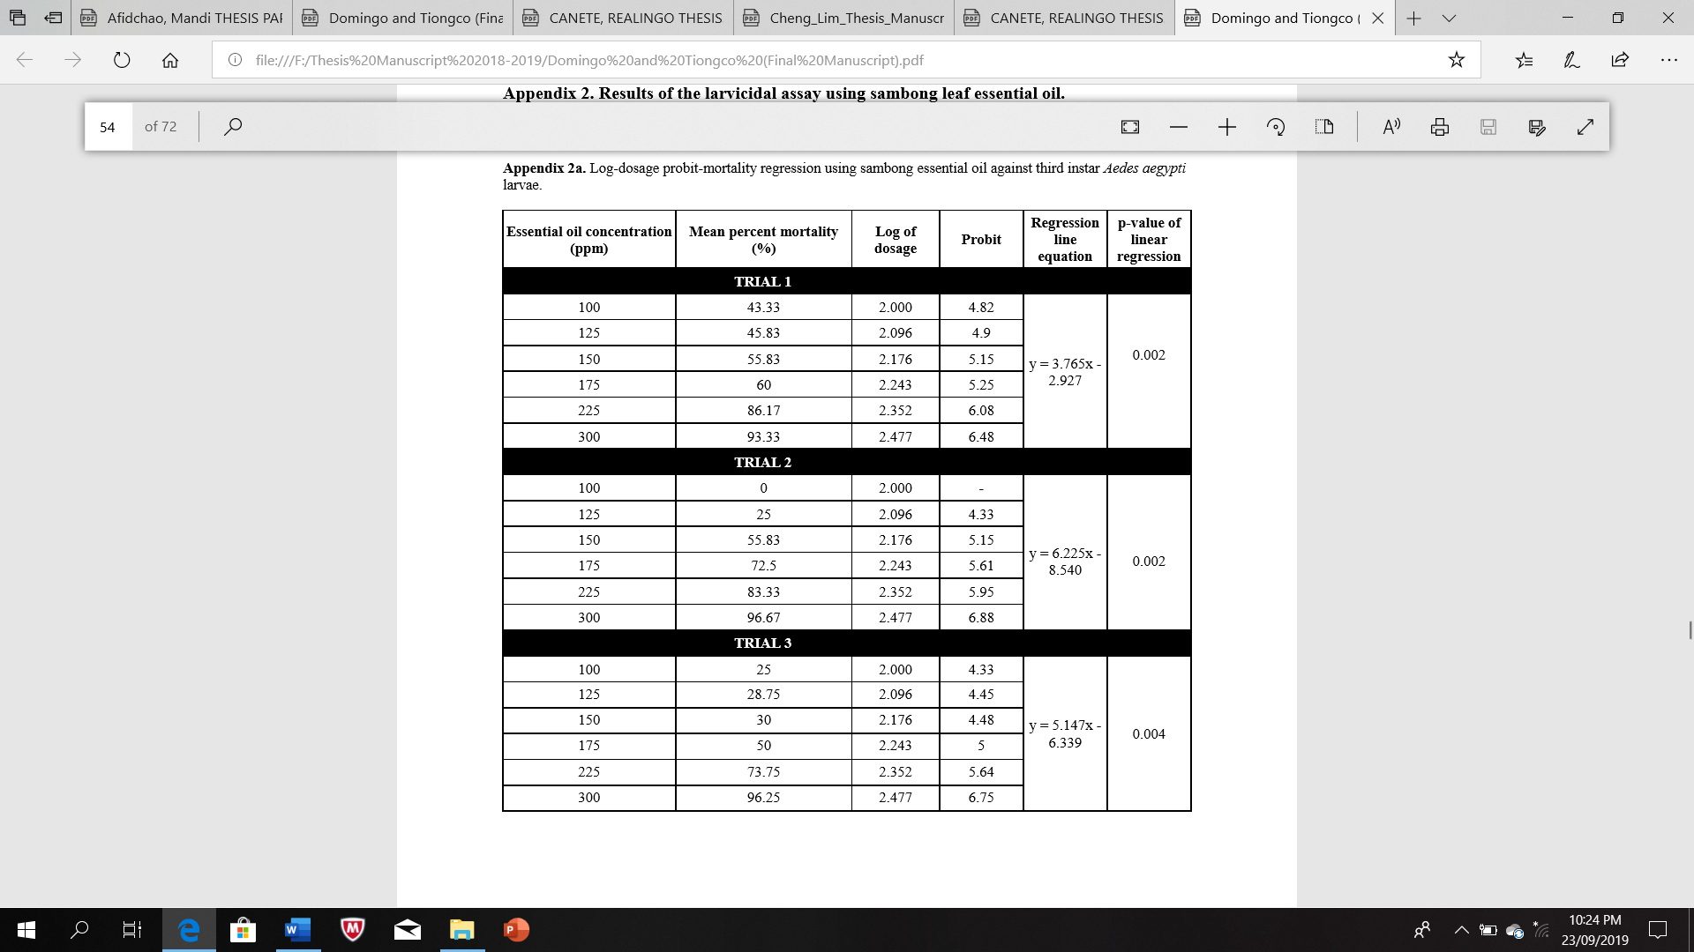

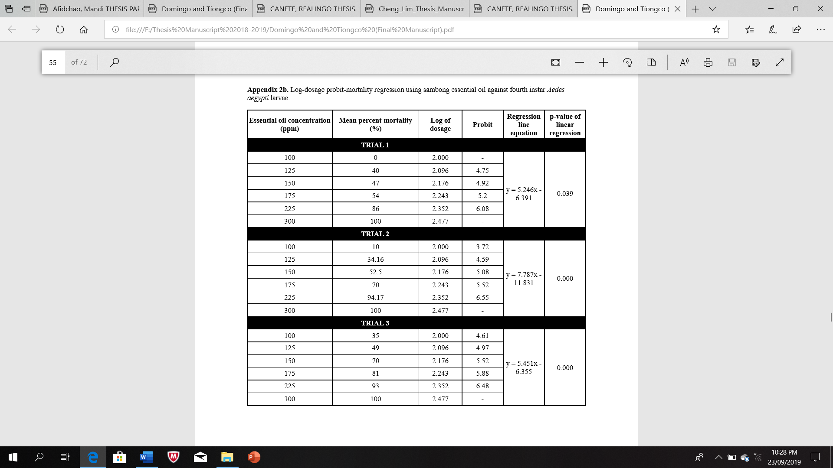



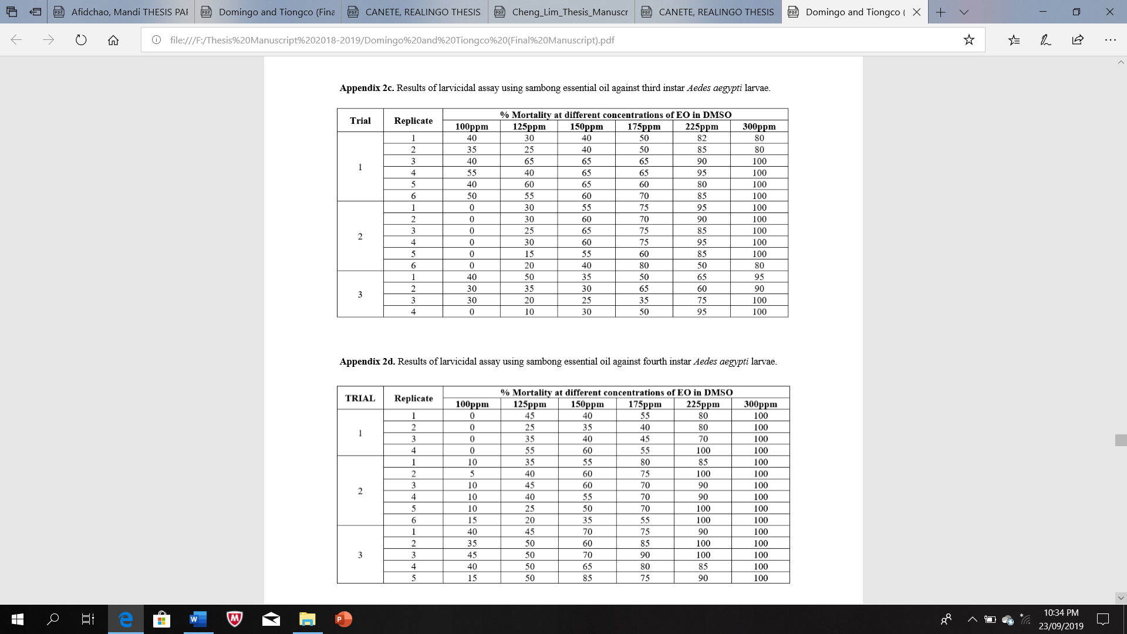



# **Study 4**

## **Abstract**

Mosquito borne diseases are responsible for causing numerous morbidities and

mortalities worldwide. The need to control these mosquitoes is a must to help curb the

problem brought about by these mosquitoes. Chemical insecticides and commercial

larvicides are used to control these mosquito populations, however, the use of these

chemicals bring about detrimental effects to other organisms and the environment.

Hence, there is a need to find natural products that can act as an alternative in controlling

mosquito populations. This study aims to determine whether the crude methanolic extract

of *Pleurotus florida* (white oyster mushroom) is able to kill *A. aegypti* mosquito larvae

and to elucidate the presence of bioactive compounds through qualitative phytochemical

screening. The mushroom samples were collected, air-dried, and crude methanolic

extracted and screened for the presence of secondary metabolites namely flavonoids,

alkaloids, tannins, phytosterols, anthraquinone, glycosides, saponins, resins, reducing

sugars, carbohydrates, and proteins. Larvicidal activity was assessed using a modified

larvicide bioassay using three concentrations (v/v): 5%, 2%, and 1%. Results show that

only flavonoids, carbohydrates, alkaloids, glycosides, saponins, and phytosterols are

present. Complete larval mortality at 5% concentration v/v after 24 and 48 hours post-

exposure. Gradual larval mortality was observed in both the 1% and 2% concentrations

from 24 to 48 hours. All concentrations exhibited higher larval mortality relative to the

positive control (*Piper nigrum*), which had a 43.33% larval mortality. The *P. florida*

crude methanolic extract can be a potential larvicide against *A. aegypti* larvae.

Keywords: *Pleurotus florida*, *Aedes aegypti*, dengue virus, larvicide, phytochemical

## **Statement of the problem**

Does the crude methanolic extract of *Pleurotus florida* exhibit a larvicidal

activity?

## **Research objectives**

The study aims to determine the potential larvicidal activity of the crude

methanolic extract of *Pleurotus florida* mushroom on the *Aedes aegypti* mosquito larvae.

Specifically, it aims to (1) assess whether the *P. florida* extracts will be able to

kill the *A. aegypti mosquito* larvae; and (2) determine the presence of certain bioactive

compounds through qualitative phytochemical screening.

## **Hypothesis**

## **Raw data**





