**Name:**

**Age:**

**GROWTH CHARTS FOR GIRLS (0-5 YRS. OLD)**

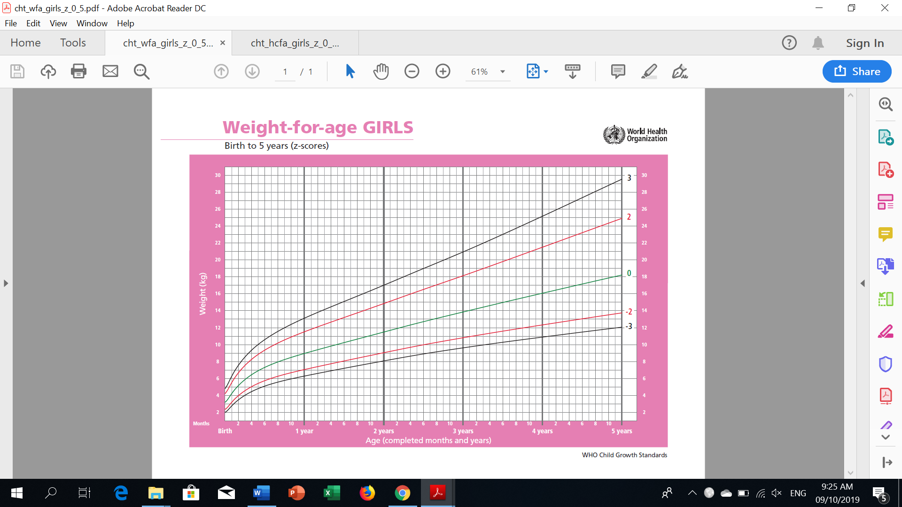

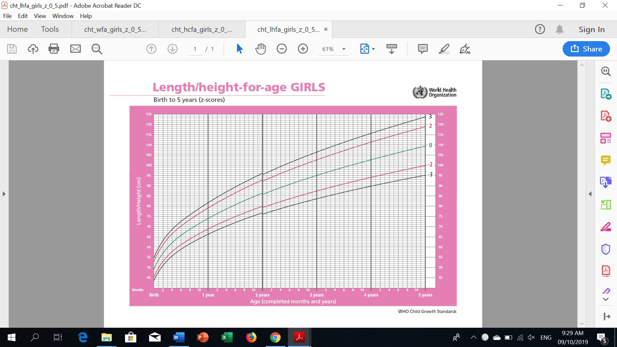

**Name:**

**Age:**

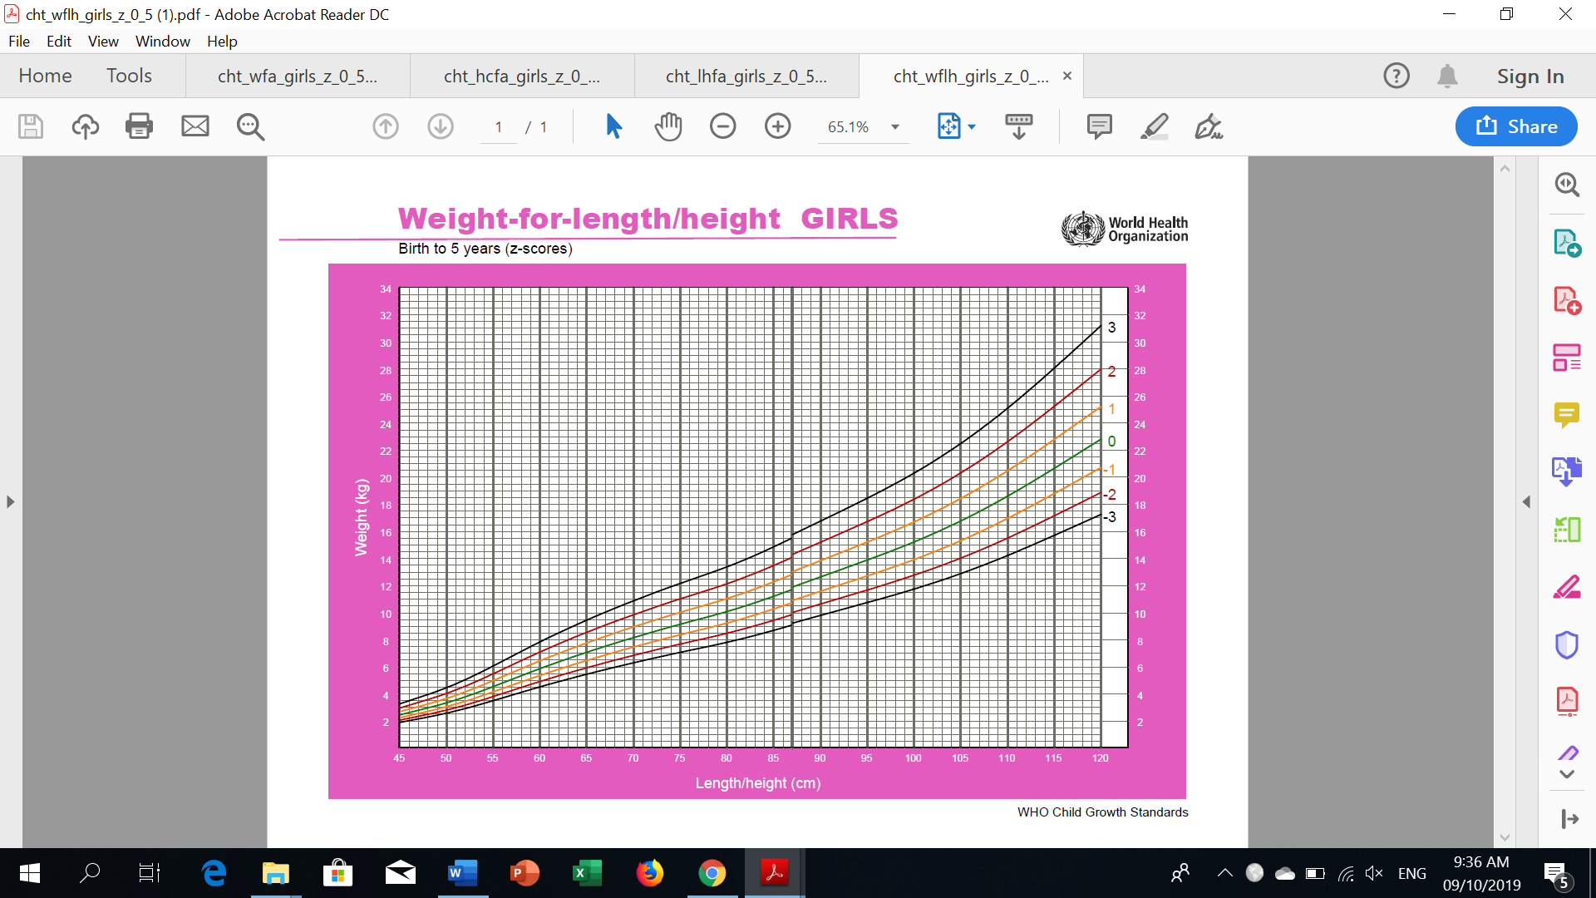**GROWTH CHARTS FOR GIRLS (0-5 YRS. OLD)**

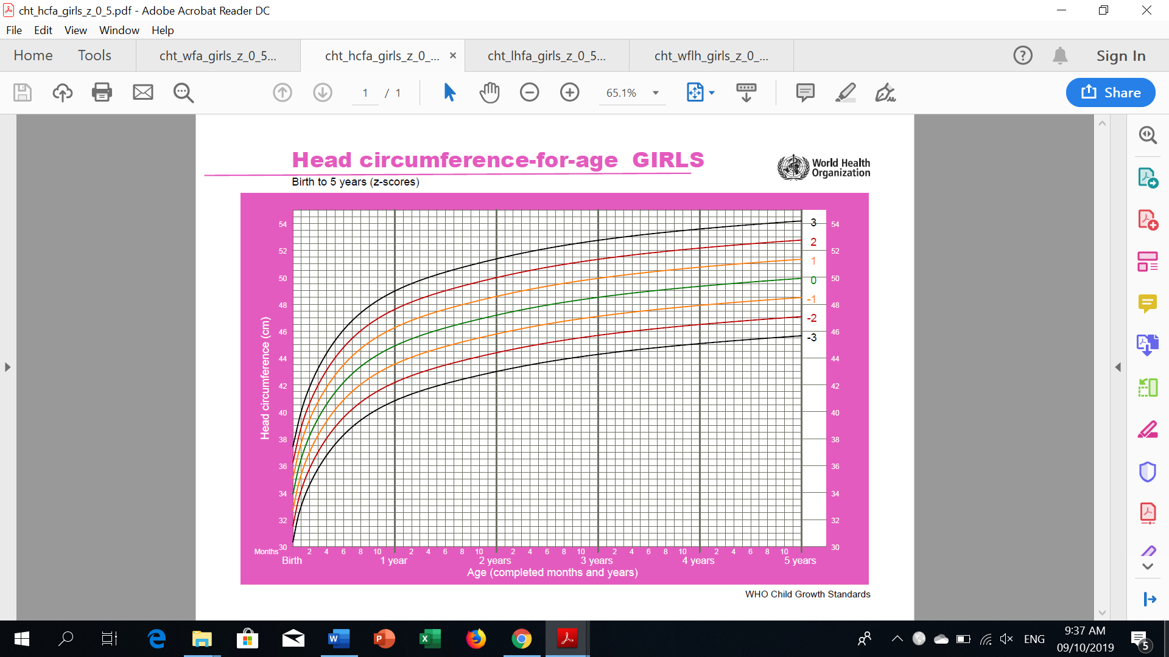

**Name:**

**Age:**

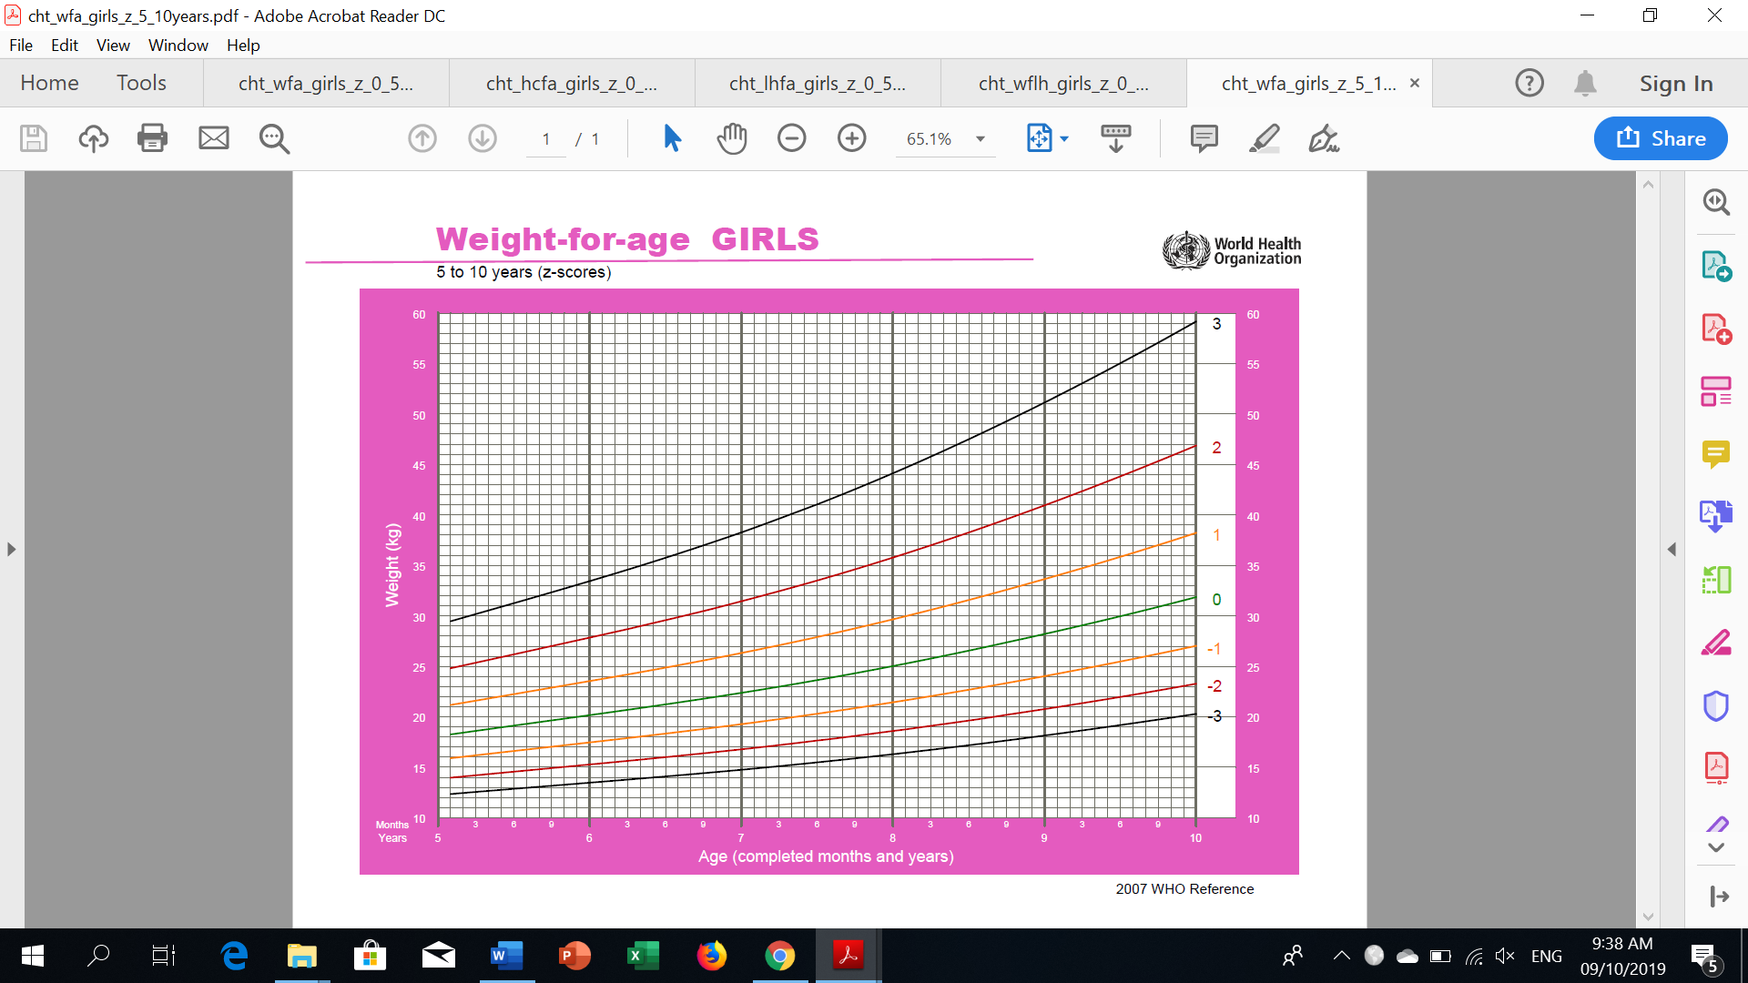**GROWTH CHARTS FOR GIRLS (5-19 YRS. OLD)**

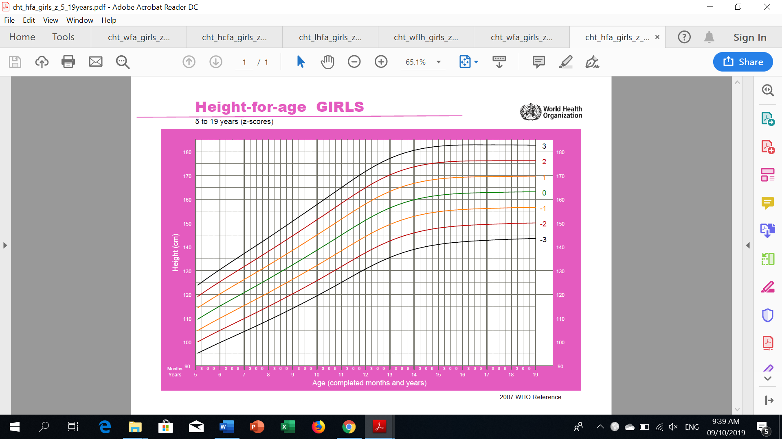

**Name:**

**Age:**

**GROWTH CHARTS FOR GIRLS (5-19 YRS. OLD)**

