**Name:**

**Age:**

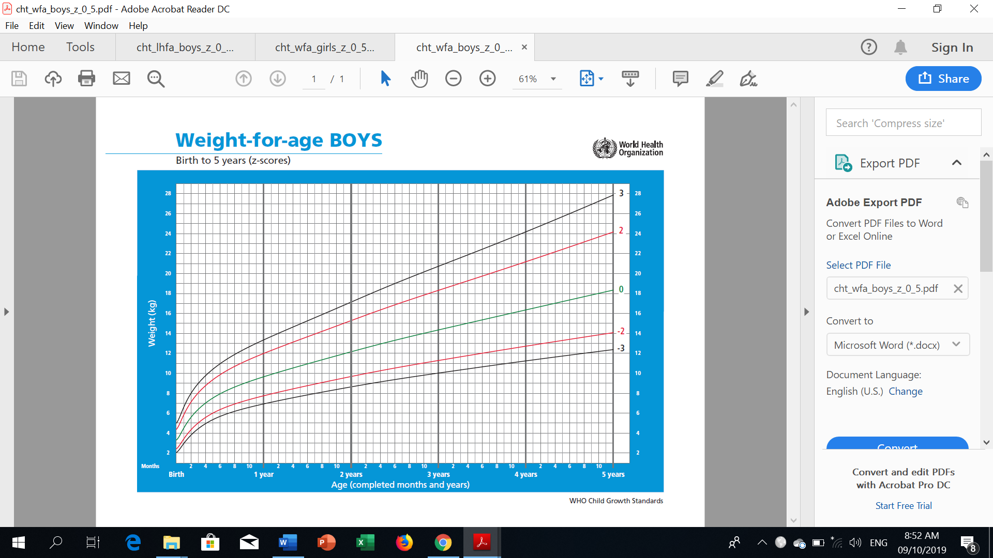**GROWTH CHARTS FOR BOYS (0-5 YRS. OLD)**

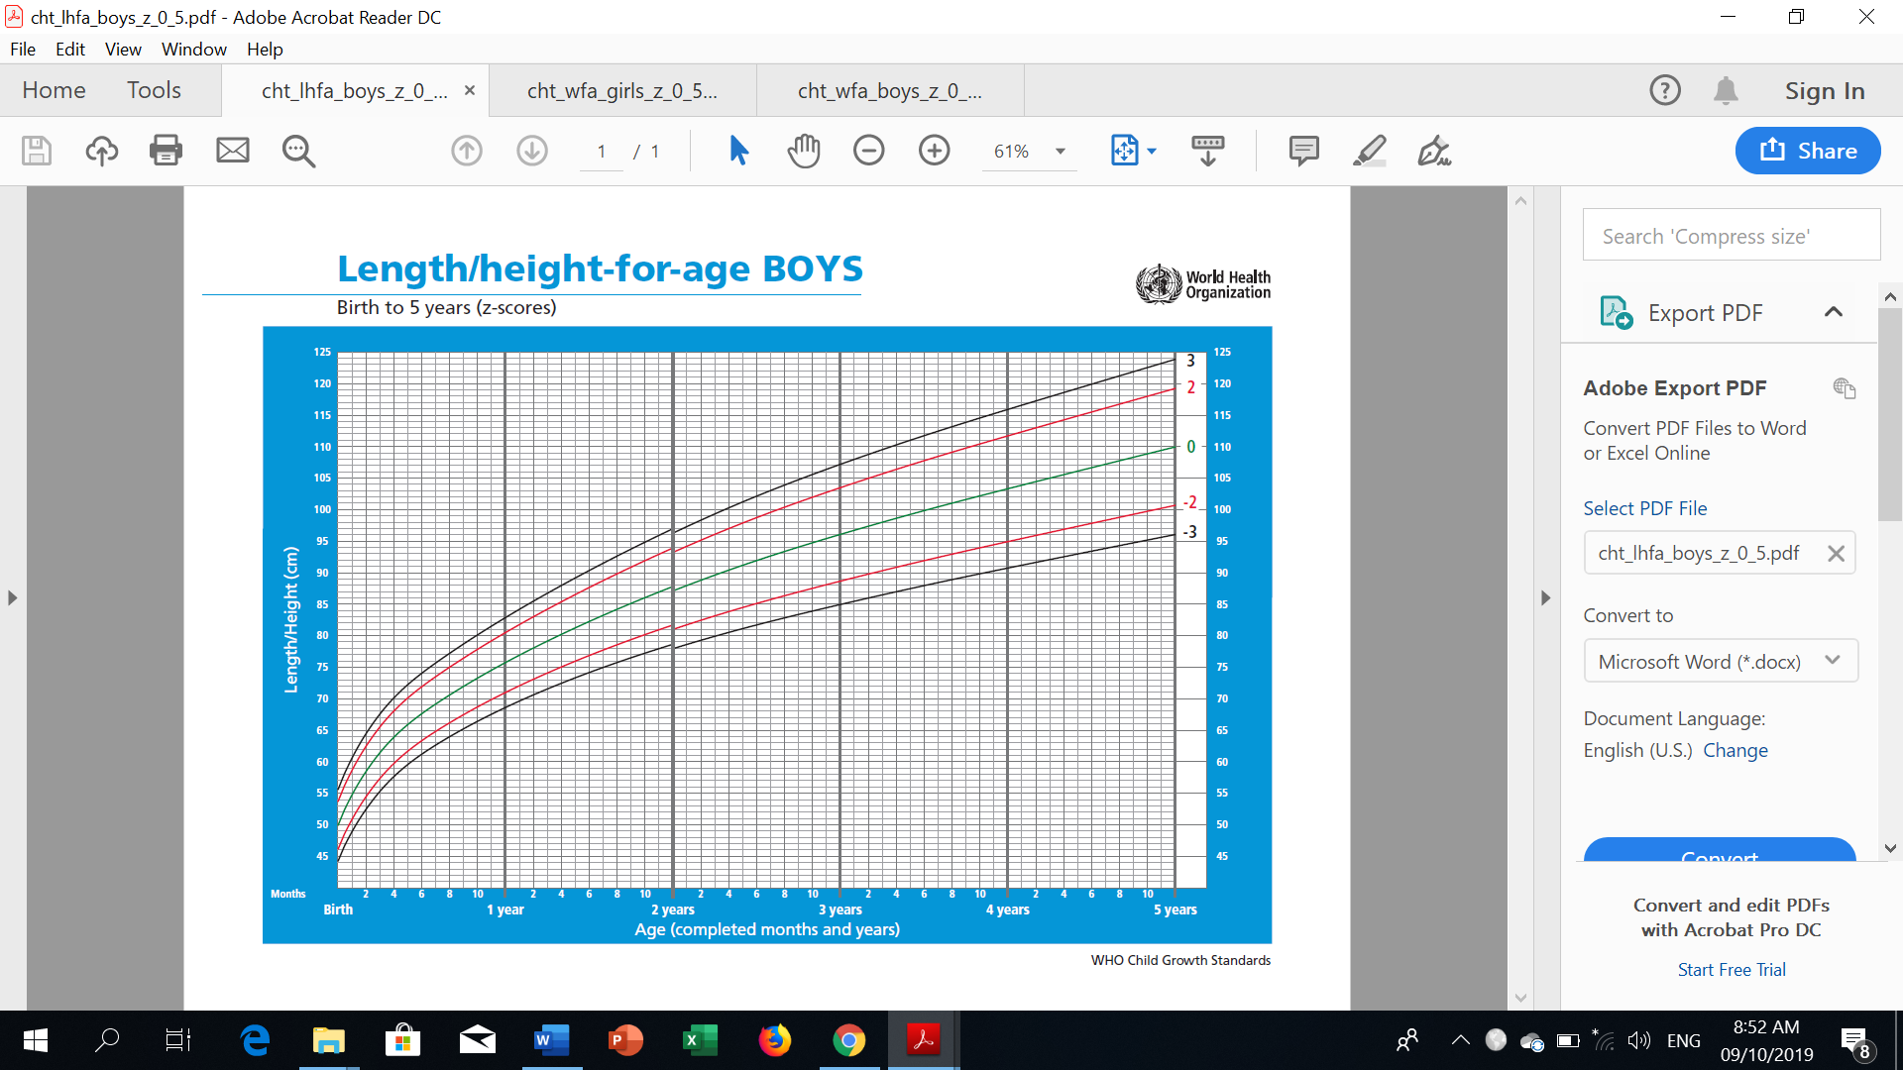

**Name:**

**Age:**

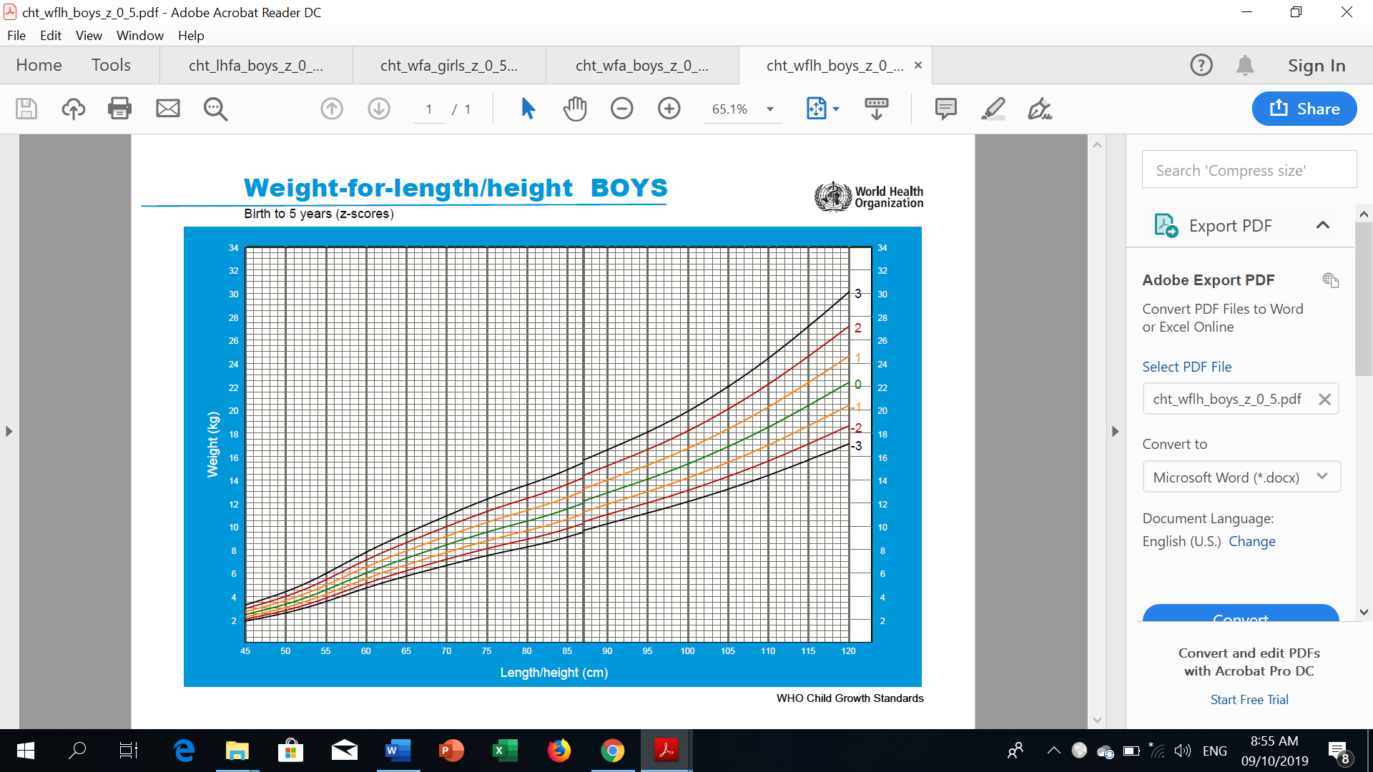**GROWTH CHARTS FOR BOYS (0-5 YRS. OLD)**

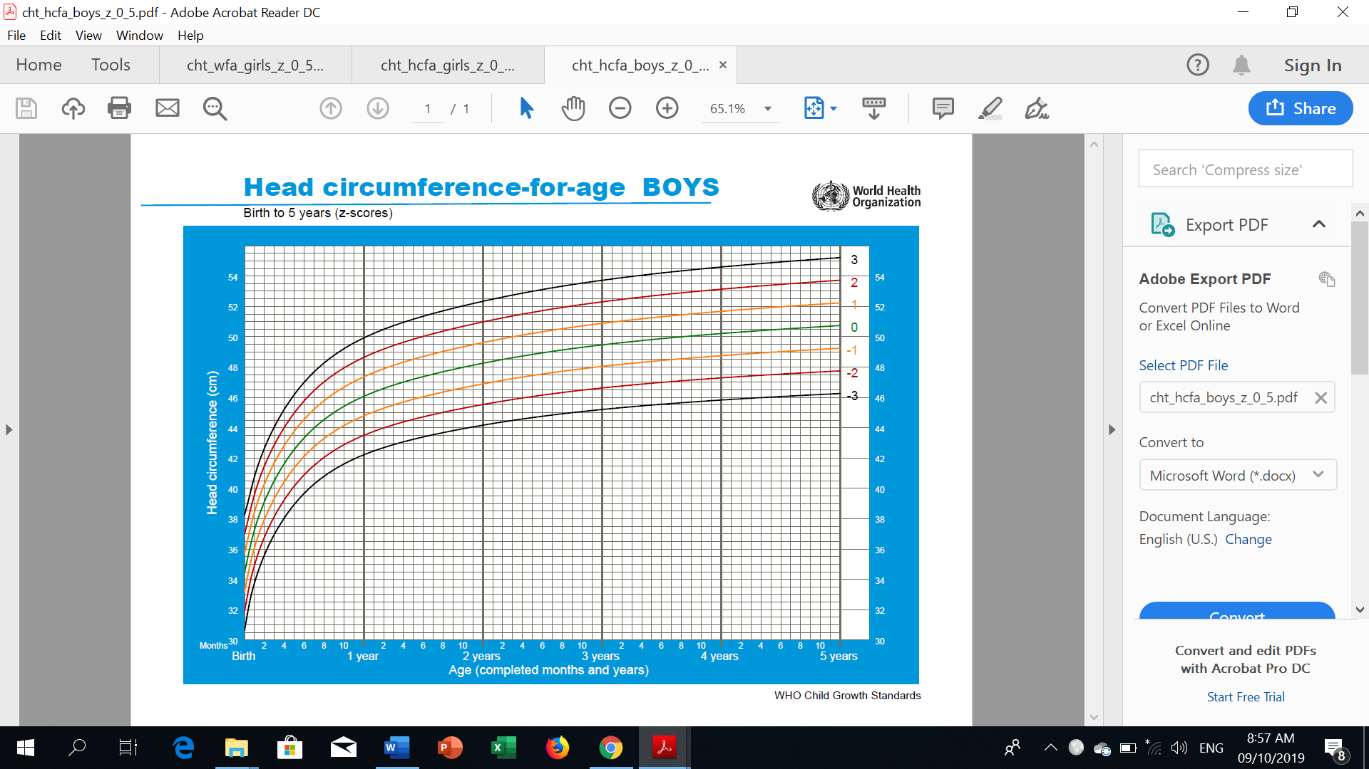

**Name:**

**Age:**

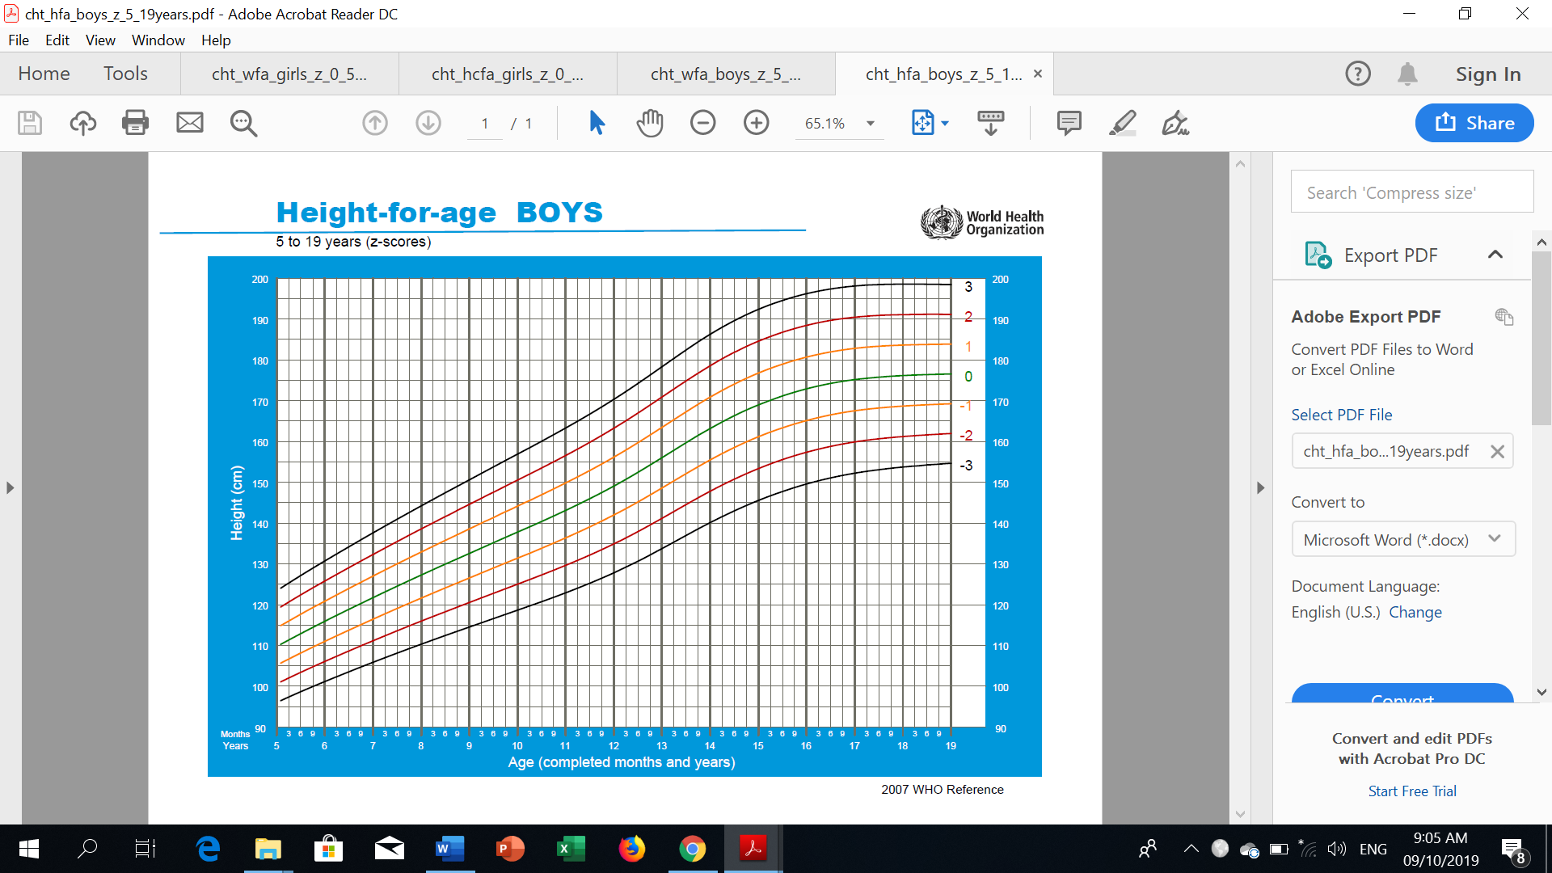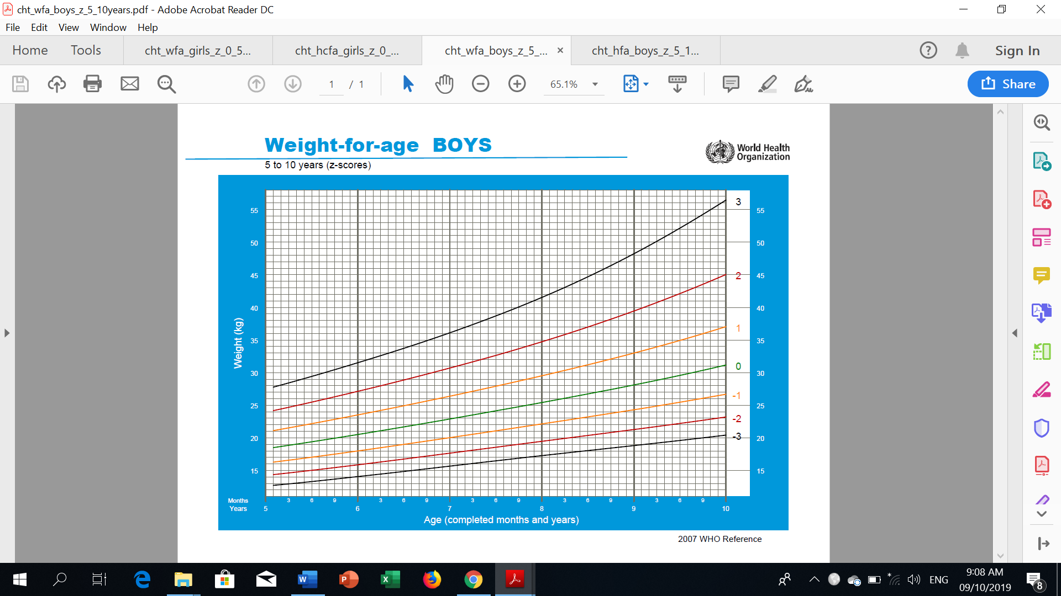**GROWTH CHARTS FOR BOYS (5-19 YRS. OLD)**

**Name:**

**Age:**

**GROWTH CHARTS FOR BOYS (5-19 YRS. OLD)**

