OS 217 ONCOLOGY MODULE – Breast Cancer
CASE

FG, 64 year-old female from Daet, Camarines Norte

Chief complaint: difficulty breathing

History of Present Illness

One year prior to admission, the patient noted a gradually enlarging non-painful mass on her left breast. The mass initially had darkening of the overlying skin. She consulted at a local hospital where a biopsy of the mass was done which revealed breast adenocarcinoma, with IHC ERPR negative HER2 negative. She was then referred for consultation at the PGH Breast Clinic. Her mass at time of initial consult was 6.0cm x 7.4cm by clinical examination. One lymph node, nontender, movable was palpable in the L axillary area measuring 2.0cm x 2.5cm. Initial imaging of Bone scan, Chest X-ray and Liver ultrasound was done revealing no evident distant metastases. She was eventually assessed to have breast cancer stage IIIB cT4N1M0. She was then advised chemotherapy for 4 cycles of unrecalled agents prior to possible surgical intervention. She was then lost to follow-up due to financial constraints.

3 days prior to admission, the patient followed-up at the PGH Breast Clinic, this time with her left breast converted to a large 13.7cm x 15.0cm fungating mass with foul-smelling odor. She also complained of generalized weakness of 2 weeks duration, difficulty of breathing, easy fatigability and 2-pillow orthopnea. Condition was associated with occasional productive cough with whitish sputum; however, no febrile episodes were documented. She was advised admission but the patient opted to go home against advice.

Few hours prior to admission, the patient was noted to have further increase in her shortness of breath at even the smallest of movements and developing sitting orthopnea. She was then brought to the PGH ER.

Review of Systems

(-) seizures, loss of consciousness, headaches, fever
(-) abdominal pain, changes in bowel habits, GI bleeding
(+) low back pains, R hip pain

Past Medical History

Patient has no known co-morbidities, no previous hospitalizations or surgeries. She has taken OCPs for the past 14 years.

Family Medical History

Patient’s sister was also diagnosed with breast cancer in 1998 when she was 35 years old. She died of complications of pneumonia. Patient’s father died of complications of lung cancer in 2002. Denies exposure to known COVID19 cases, at home or in community.

Personal and Social History

Patient is a non-smoker. Patient reports moderate alcohol intake. She previously worked in an abaca plantation. Patient is single with no children. She finished grade school. She lives with the family of her elder sister.

Obstetric and Gynecologic History
Patient is nulligravid. Menarche at age 13. Menopause at age 58. no history of any post-menopausal spotting/bleeding. Coitarche at Age 18. Claims to have had three sexual partners.

Physical Examination

At the Emergency Department, the patient was received emaciated, weak looking, awake, coherent, but in not in CP distress at rest, speaks in complete sentences.

The vital signs and physical findings were:
BP 100/60 HR 110 RR 24 Temp 36.8 C
Wt 37kg Ht 147cm

Pale conjuctivae, anicteric sclerae, no palpable neck lymphadenopathy, engorged neck veins
Left chest lag, decreased breath sounds on the left, mid to base, dull to percussion
Distinct heart sounds, tachycardic, regular rhythm, point of maximal impulse 5th ICS, LPSB
(+) left breast converted to a 13.7cm x 15.0cm fixed fungating mass with yellowish foul-smelling discharge
(+) 3x3 cm movable lymph node at left axilla
(-) supraclavicular lymph nodes, and right axillary lymph nodes palpated
No mass palpated in the right breast
Abdomen flat, soft, non-tender, no palpable mass. No hepatosplenomegaly noted.
Full and equal peripheral pulses, no edema. Pale nail beds, no jaundice.
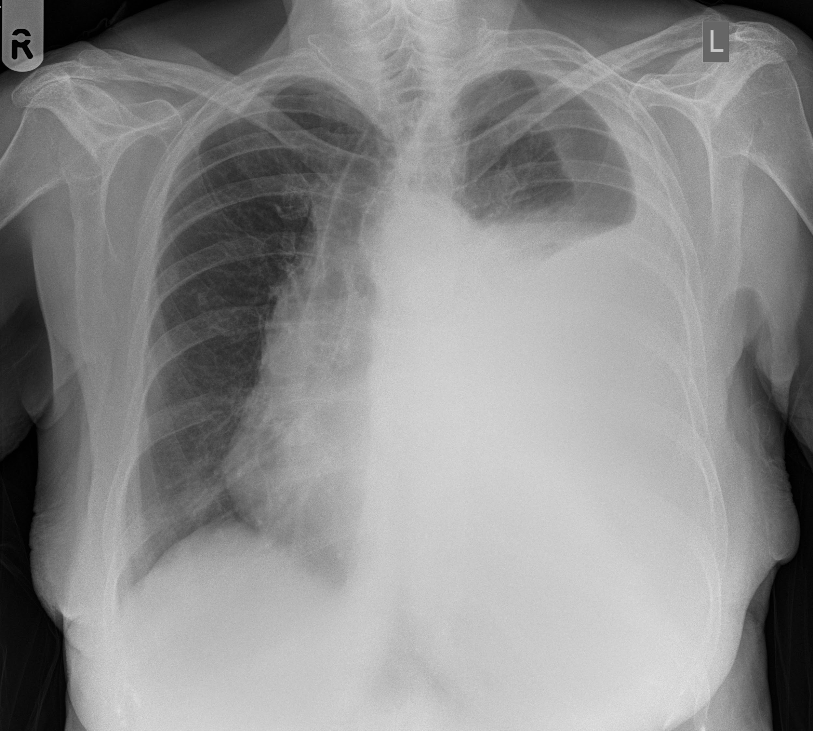
Neurological PE unremarkable

Laboratory Examinations at ER

CBC: Hgb 76 (L) Hct 0.21 (L) WBC 11.03 (N 68 L26 B5 E1) Plt 333
Na 140 K 3.2 (L) Alb 14 (L) Ca 2.35 mmol/L Crea 89 ALT 24 AST 23 ALP 245 (H)
PT 99% activity INR 1.34 PTT normal
Chest Xray: Homogenous opacification of the L lung field, mid-base, soft tissue mass overlying L lung field
12-L ECG: sinus tachycardia

Old Diagnostics retrieved from PGH Breast Clinic (1y PTA)

Incisional biopsy: invasive ductal carcinoma
IHC: ER negative PR negative HER2 negative
Mammogram, right: BI-RADS 0
Bone Scan, Chest X-ray and Liver ultrasound: no evidence of metastasis

(Sample Case courtesy of Dr Ian Bickle, Radiopaedia.org, rID: 26730)

