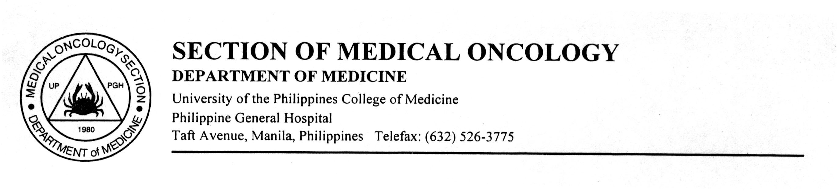**SECTION OF MEDICAL ONCOLOGY**

Department of Internal Medicine

University of the Philippines College of Medicine

Philippine General Hospital

Taft Ave., Manila, Philippines Telefax: (632) 526-3775

**Division of Medical Oncology**

LU 5 Case

**General Data:**

33/M

Married, with 2 children

Automobile Mechanic, from Dasmarinas, Cavite

**Chief Complaint**: Bilateral neck masses

**History of Present Illness**:

3 years prior to consult, the patient noted gradually enlarging bilateral multiple neck masses which initially started on the left lateral neck then eventually involving the right with no associated skin involvement, episodes of dyspnea, dysphagia or compressive symptoms.

No consults done before since patient did not feel any pain nor discomfort from the masses.

1 year PTC, consult was done at DLSUMC where incision biopsy of lateral neck mass showed lymphoproliferative fibrous tissue and was recommended for excision biopsy. The patient was then lost to follow-up due to the pandemic.

In the interim, patient noted progression of neck masses with skin discoloration and changes, also now noting presence of left axillary nodes thus prompting consult.

**Review of systems:**

(+) Undocumented febrile episodes

No dyspnea, chest pain, dysphagia, colds, abdominal pain,

*no weight loss, night sweats*

**Past Medical History:**

s/p PTB Category 1 treatment 6 months (2016)

Cutaneous viral infection (2020)

**Family Medical History**:

(+) unrecalled malignancy, paternal uncle

**Personal and Social History**:

Previous casual smoker stopped 5 years ago, ~3pack-years

Occasional alcoholic beverage drinker last intake was Sept 2020

Denies illicit drug use

Denies occupational exposure to chemicals and radiation

**Physical Examination**

General survey: Awake, alert, comfortable at room air

Head and Neck: Anicteric sclerae, pink palpebral conjunctivae, (+) conglomerated, hard fixed lateral neck masses on the left and right sides, largest in dimensions at 9x7x4 cm on the right; (+) 3x3 cm left axillary lymph node

Chest: Equal chest expansion, Clear breath sounds

Cardiac: Adynamic precordium, Distinct S1 and S2, no S3, regular rhythm, no murmur

Abomen: Flabby abdomen, normoactive bowel sounds, soft, nontender no guarding

Extremities: Full and equal pulses, CRT<2s, no bipedal edema

**Review of Diagnostics**

6/25/2021 ATYPICAL ROUND CELL PROLIFERATION

7/5/21 IMMUNOHISTOCHEMISTRY RESULTS:

Positive: CD15, CD30, PAX5

NEGATIVE: LCA, CD3, CD20, ALK, PANCYTOKERATIN

**PET-CT SCAN 6/15/21**

Hypermetabolic confluent lymphadenopathy in the mediastinum, left axillary, and bilateral cervical areas, consistent with lymphoma.

Hypermetabolic foci in the spleen are also most likely lymphoma

Diffuse marrow activity is still most likely reactive than lymphomatous involvement

WBC 20.6, N 80, L 10, M 0.06, E 0.03, B 0.01

Hgb 117, normocytic, normochromic, PC 472

Uric acid 4.67 mg/dL N, alb 3.8