OS 217 ONCOLOGY MODULE: Breast Cancer

AM, 58 year-old female from Calamba, Laguna

Chief complaint: lump in right breast

History of Present Illness

4 months prior to admission, patient palpated a small lump on her right breast. There were no associated pain or skin changes at the time. No consult was done.

2 months prior to admission, she noted an increase in the size of the breast mass. She then consulted a local clinic. She was advised consult at PGH Breast Clinic with the impression of a possible breast tumor.

At the breast clinic, biopsy was done which revealed invasive ductal carcinoma. Laboratory examinations were done and she was then prepared for surgery, hence admission.

Review of Systems

(-) headaches, seizures, nausea and vomiting, blurring of vision
(-) difficulty breathing, cough, chest pains
(-) abdominal pain, changes in bowel habits, GI bleeding, dysuria
(-) musculoskeletal pains, weakness

Past Medical History

Patient is a known hypertensive for 5 years, maintained on Losartan 100mg PO once a day with good BP control. Patient reports no allergies to food and drugs. Patient has undergone myomectomy at PGH when she was 42 years-old. She has taken OCPs for the past 14 years.

Family Medical History

Patient’s father died of acute MI at 56 year-old. No other disease noted in the family. She has three children, all adults. Patient’s sister was also diagnosed with breast cancer in 1998 when she was 35 years old.

Personal and Social History

Patient reports no vices. Patient is a high-school teacher since she was 25 years-old.

Obstetric and Gynecologic History
Patient is nulligravid. Menarche at age 13. Menopause at age 56. No history of any post-menopausal spotting/bleeding. Coitarche at Age 18. Patient has had only one sexual partner and has no history of sexually-transmitted diseases.

Physical Examination

On admission, the patient was awake, not in distress with the following vital signs and physical examination findings:

HR 88 RR 20 temp 36.7 C, BP 130/70
Pink conjunctivae, anicteric sclerae, no tonsillopharyngeal congestion or exudates, no cervical lymphadenopathy
Symmetric chest expansion, clear breath sounds, distinct heart sounds, regular rhythm, no murmurs
(+) 3 x 2 cm movable hard mass on the right breast, no nipple and skin changes noted
(+) 1 x 1 cm movable nodule on the right axilla. No other nodes palpated in left axilla and supraclavicular areas
Soft, non-tender abdomen, no palpable masses, no hepatosplenomegaly
Full and equal peripheral pulses, no skin lesions, no jaundice
Neurological PE was unremarkable

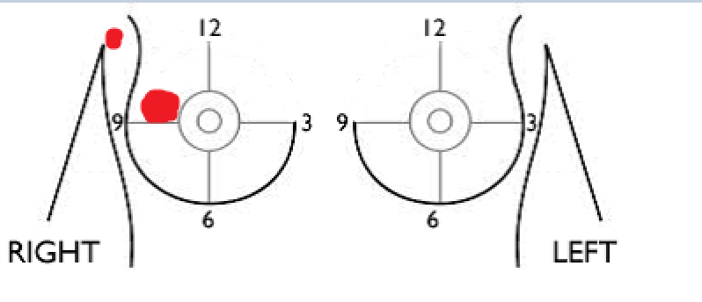
Diagnostic examinations

CBC: Hgb 120 Hct 0.3 WBC 9.0 Platelet 350
Na 142 K 3.6 Crea 71 Alb 38 Ca 2.34
PT 99% activity, INR 1.4 PTT normal
Chest X-ray: No cardiomegaly, No pulmonary opacities/nodules
Mammogram, left: BI RADS 1
Core needle biopsy: Invasive ductal carcinoma, no special type, Grade 2, right breast

