**OS 217 Oncology Module**

**Cancer of Unknown Primary**

**GENERAL DATA:**

62/Male from Quezon City

Married with 1 child

**Chief Complaint:** Left neck mass

**History of Present Illness:**

7 months prior to consult, patient noted a slow-growing, painless left neck mass, around the size of a marble. There was no dysphagia, hoarseness, difficulty of breathing, skin involvement, compressive symptoms, fever, cough or weight loss. No consult was done.

In the interim, there was gradual increase in the size of the mass. There is still no dysphagia, hoarseness, difficulty of breathing, fever, cough or weight loss. No consult was done since patient said he did not feel any pain nor discomfort from the mass.

1 month prior to consult, patient consulted a general practitioner, where unrecalled antibiotics were prescribed which the patient took for 7 days. No relief of symptoms was noted.

Due to persistent increase in the size of the mass, patient decided to consult PGH for further management.

**Review of Symptoms:**

(+) Undocumented febrile episodes

(+) weight loss

(-) night sweats

(+) decreased appetite

No dyspnea, chest pain, dysphagia, edema, colds, cough

**Past Medical History:**

* Left knee arthroscopic surgery, tubullovillous adenoma (1981)
* s/p PTB Category 1 treatment for 6 months (May-November 2016)

**Family History:**

* Colon cancer – Cousin

**Personal and Social History:**

* 40 pack-year smoking history; Patient quit smoking 3 years ago
* 6-12 beers per day
* Denies illicit drug use
* No IV drug addiction
* Works as a mechanic
* No prior history of chemotherapy or radiation therapy

**Physical Examination:**

* General survey: Awake, alert, comfortable at room air
* Head and Neck: Anicteric sclerae, pink palpebral conjunctivae, (+) conglomerated, hard fixed lateral neck masses on the left, measuring 3 x 2 cm.
* Oral Cavity: moist mucosa, no ulcers, masses, erythema, no dental caries
* Chest: Equal chest expansion, Clear breath sounds
* Cardiac: Adynamic precordium, Distinct S1 and S2, no S3, regular rhythm, no murmur
* Abdomen: Flabby abdomen, normoactive bowel sounds, soft, nontender no guarding
* Extremities: Full and equal pulses, CRT<2s, no upper extremity edema, no bipedal edema
* Cranial nerves intact, No sensory and motor deficits

***“PET-CT scan and work-up was requested. Patient then underwent Direct laryngoscopy and nasal endoscopy, left palatine and lingual tonsillectomy, BOT biopsies, left neck node dissection of levels II-IV.”***

**Review of Diagnostics:**

PET-CT scan done 6/14/21:

* Hypermetabolic enlarged jugulodigastric lymph node (level II), 3.9 x 2.5 cm in maximum diameter
* Maximum SUV of 15.9

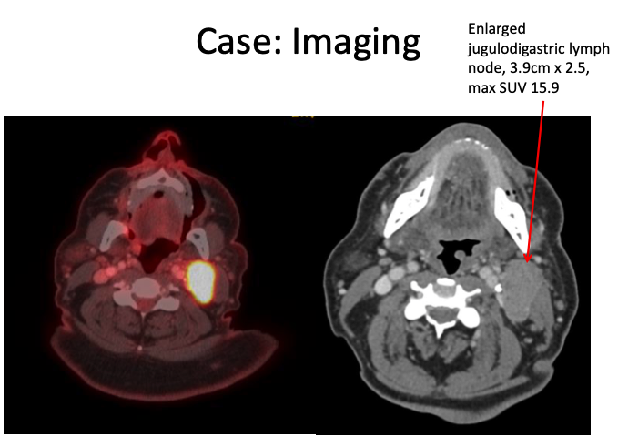

CBC 6/15/21:

* WBC 20.6, N 80, L 10, M 0.06, E 0.03, B 0.01
* Hgb 117, normocytic, normochromic, PC 472
* Uric acid 4.67 mg/dL N, alb 3.8

**Case: Pathology**

* s/p Direct laryngoscopy and nasal endoscopy, left palatine and lingual tonsillectomy, BOT biopsies, left neck node dissection of levels II-IV (1/37 +) (8/1/21)
* **Pathology for positive level IIA node:**
  + **Squamous cell carcinoma, poorly differentiated**
  + **No ECE**
  + **p16 positive**
  + **EBV negative**
* Primary areas of clinical concern all negative for tumor