OS 217 ONCOLOGY MODULE – BRAIN METASTASIS
CASE

OP, 68 year-old male from Lipa, Batangas

Chief complaint: seizure

History of Present Illness

6 months prior to admission, the patient noted an incidental lung nodule with spiculated borders on chest x-ray. Patient sought consult at a local hospital, where chest CT scan was done, which revealed a 2.6 x 2.5 x 2.0 cm (CC x W x AP) mass in the apicoposterior segment of the left upper lobe. Tissue correlation was suggested. A biopsy of the mass revealed lung adenocarcinoma. He was initially staged as IA3 (T1cN0M0). He was then referred to PGH for further management, but patient was lost to follow-up due to the pandemic.

3 days prior to admission, the patient sought consult at the Adult Neurology clinic for generalized seizures lasting for 30 seconds. He also complained of occasional headache, generalized weakness of 1 weeks duration and easy fatiguability. He also had occasional productive cough with whitish sputum. No febrile episodes were documented. He was advised to undergo a cranial CT scan, but patient opted to go home against medical advice.

Few hours prior to admission, the patient was noted to have another seizure episode lasting for more than 30 seconds, and was brought to the PGH ER.

Review of systems

(-) loss of consciousness, fever
(-) abdominal pain, changes in bowel habits, GI bleeding
(+) low back pain, right pelvic pain

Past Medical History

Patient was diagnosed with hypertension and has been on Losartan 50 mg OD for the past 8 years.
No previous hospitalizations or surgeries.

Family Medical History

Father was known to have DM and hypertension.

Personal and Social History

Patient is a 15 pack year smoker. Patient reports moderate alcohol intake. Patient used to work as a miner for 20 years.

Physical Examination

General surgery: drowsy but arousable
Prior to admission, patient is able to care for himself, but is unable to carry on normal activity or do active work.

Vital signs:
BP 90/60 HR 80 RR 18 Temp 37.1
Wt 48kg Ht 167cm

Pink conjunctivae, anicteric sclerae, no palpable neck lymphadenpathy or engorged neck veins
Equal chest expansion, decreased breast sounds on the left apex
Distinct heart sounds, normal rate, regular rhythm
Abdomen flat, soft, non-tender, no palpable mass. No hepatosplenomegaly noted.
Full and equal peripheral pulses, no edema. Pink nail beds, no jaundice.

Neurologic PE:
3/3 EBRTL
Full EOMs
Intact V1-V3
No facial palsy
Gross hearing intact
Normal gag reflex
Tongue midline
5/5 all extremities
No sensory deficits

Laboratory Examinations at ER

CBC: Hgb 76 (L) Hct 0.21 (L) WBC 11.03 (N 68 L26 B5 E1) Plt 333
Na 140 K 3.2 (L) Alb 14 (L) Ca 2.35 mmol/L Crea 89 ALT 24 AST 23 ALP 245 (H)
PT 99% activity INR 1.34 PTT normal

Chest X-ray Findings:
- Left upper lobe mass measuring 4.5 x 4.0 cm
- Left lower lobe pulmonary nodules (at least two), likely metastatic
- Left hilar lymphadenopathy
- Cardiomegaly
- Atherosclerotic aorta

Cranial CT Scan
Unenhanced CT reveals a several hypodense area of vasogenic edema in the right frontal lobe with two scattered rounded dense images, After injection of intravenous contrast medium, these enhance significantly, becoming apparent multiple other smaller similar images in both hemispheres.
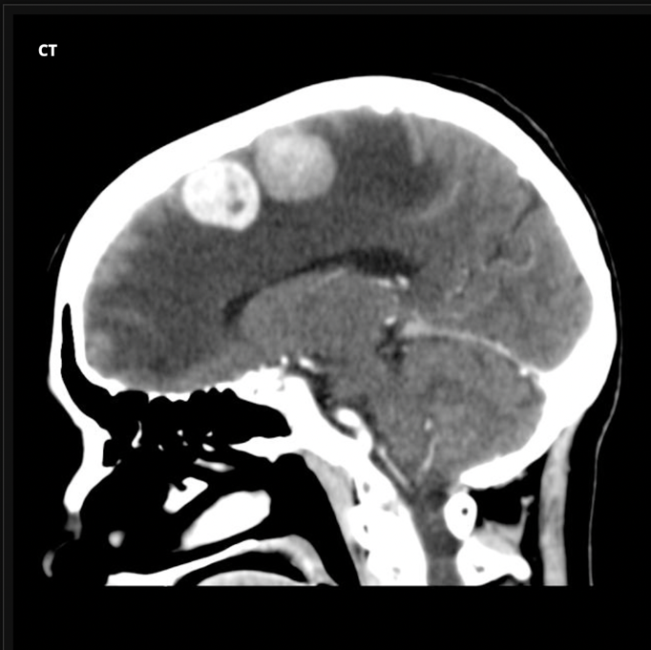
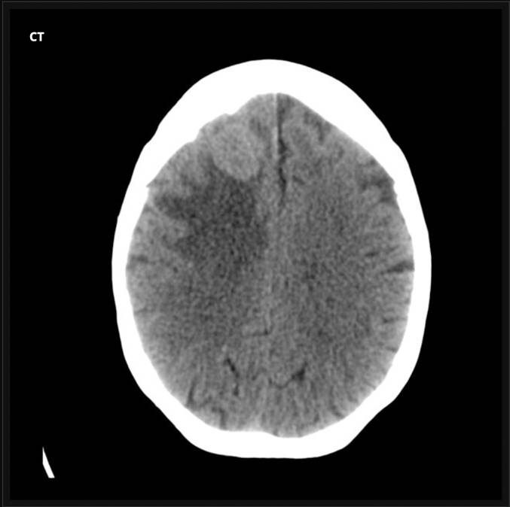

Old Diagnostics

Chest CT scan
Lung mass biopsy results: Adenocarcinoma

