**University of the Philippines - Manila**

**Philippine General Hospital**

**OBGYN 251: Integrated Clerkship II in Obstetrics and Gynecology**

Case Protocol: Hypertension in Pregnancy

**Learning Objectives:**

1. To present the history and physical examination findings of a pregnant patient with hypertension
2. To formulate a working impression on the given history and physical examination
3. To read and interpret laboratory and diagnostic findings
4. To discuss the importance of the laboratory tests
5. To differentiate the different hypertensive disorders in pregnancy
6. To discuss the signs, symptoms, and effects of hypertension in pregnancy
7. To provide an appropriate plan of management for the patient

**General Data:**

SL, a 28 G2P1 (1001), Roman Catholic, single, from Quezon City

**Chief Complaint:**

Headache

**Past Medical History:**

Diagnosed hypertensive at 19 6/7 weeks age of gestation, currently maintained on Methyldopa 500 mg BID, good compliance but without BP monitoring

**Family Medical History:**

(+) stroke – father

**Personal and Social History:**

College graduate, works as a receptionist

**Menstrual History:**

She had her menarche at 12 years old. Her menses regularly lasting around 3-5 days, consuming 2-3 moderate to fully soaked pads per day. She experiences dysmenorrhea

She was sure of her last menstrual period

**Sexual History:**

First coitus at 22 years old

2 sexual partners, both nonpromiscuous, lives with current partner

No prior use of OCP, injectable progesterone or IUD

No history of sexually transmitted disease

**Obstetric History:**

AOG: 37 2/7 weeks

Obstetric Score: Gravida 2 Para 1 (1001)

G1: 2018 FT SVD at Fabella, M, AGA, no fetomaternal complications  
G2 current pregnancy

Prenatal check up x2 c/o lying in center

**History of Present Condition:**

1 week prior to consult, the patient experienced persistent headache in the frontal area severity 8/10 but no neurologic deficits. She notes no hypogastric pain, good fetal movement.

2 days prior, she noted right upper quadrant pain, 4/10 in severity, and still with persistent headache, but no consult was done. No hypogastric pain, no watery/bloody vaginal discharge, but with good fetal movement

Persistence of the pain prompted consult at the admitting section

**Review of Systems:**

**General**: (-) fever, weakness, weight loss, pallor

**HEENT**: (+) headache, no BOV, tinnitus, otalgia, dysphagia, dysphagia, colds, nausea, vomiting

**Pulmonary**: (-) dyspnea, cough

**CVD**: (-) chest pain, palpitations, easy fatigability, orthopnea, edema

**GI**: (-) constipation, diarrhea, jaundice, hematochezia, melena

**GU**: (-) dysuria, hematuria, urinary incontinence

**Neurological**: no deficits

**Endocrine:** change in heat/cold intolerance

**Extremities:** No edema

No watery/bloody vaginal discharge

No decrease in fetal movement

**Physical Examination:**

**Vital Signs:** Temperature 36.7o C, blood pressure: 170/110, heart rate: 92 beats per minute, 98% O2 saturation, respiratory rate: 18 breaths per minute

**Height:**  150 cm **Weight:** 72 kg **BMI:** 32

**General:** Patient is awake, conversant, and not in cardiorespiratory distress

**HEENT:** Anicteric sclerae, pink palpebral conjunctivae, (-) cervical lymphadenopathy, (-) neck vein engorgement, (-) anterior neck mass,

**Heart and Lungs**: Adynamic precordium, distinct heart sounds, normal rate and regular rhythm, equal chest expansion, clear breath sounds

**Abdominal:** fundic height of 25 cm, EFW 2400 grams, FHT 150 bpm LLQ, cephalic

**Extremities:** Full, equal, pulses, pink nail beds, CRT<2s, (-) cyanosis, (-) edema,

***Pelvic/Internal Exam:***

**Internal Exam:** the cervix is 1-2 cms, 50% effaced, soft, posterior, cephalic station -1, intact BOW

Course:

The patient was admitted

Work up was done

IV hydralazine was given, initially 5 mg x3, 10 mg x2, but the BP was noted to be at 180/100

The patient was experiencing nausea, dyspnea, and aura

She was given IV and IM Magnesium sulfate.

The patient eventually underwent Cesarean section for deteriorating maternal status

Diagnostics

Urine albumin +2

Urine protein 72 mg/dL

Urine creatinine 73 mg/dL

CBC

Hgb 111

Hct 0.31

WBC 9 (Neut 72 Lymph 33)

Platelet 101

Serum Chemistry

LDH 323

AST 12 IU/L

ALT 15 IU/L

Crea 1.101 mg/dL

Baseline trace

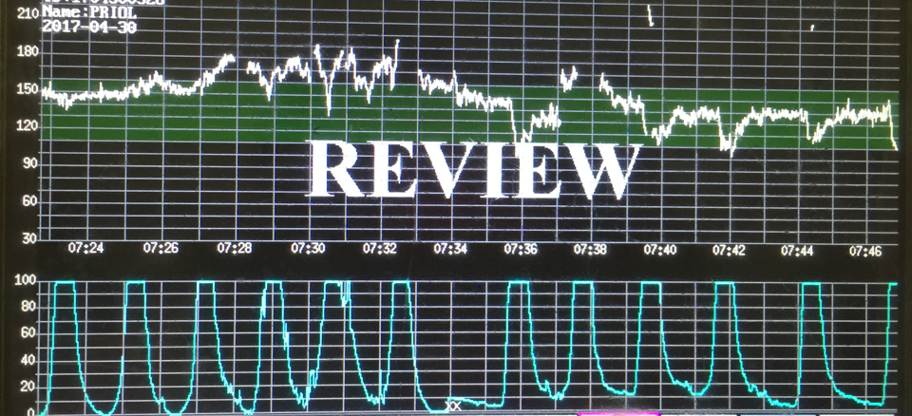

**Pediatric Outcome:**

**Full term, 2390 g, AGA, 37 weeks by pediatric aging, live birth**

**Delivered via primary low segment caesarean section**