**University of the Philippines - Manila**

**Philippine General Hospital**

**OBGYN 251: Integrated Clerkship II in Obstetrics and Gynecology**

Case Protocol: Malignant Ovarian New Growth

**Learning Objectives:**

1. To present the history and physical examination findings of a patient with ovarian new growth
2. To formulate a working impression based on the given history and physical examination findings
3. To read and interpret laboratory and diagnostic findings and to discuss its importance in managing similar cases
4. To define malignant ovarian new growth, its risk factors, and clinical presentation, and compare it to the index case
5. To provide an appropriate plan of management for the index case

**General Data:**

MS is a 57 year old Gravida 1 Para 1 (1001) from Makati. She is a married Roman Catholic who currently works as a city hall volunteer.

**Chief Complaint:**

Abdominal enlargement

**Past Medical History:**

No known comorbidities

No previous hospitalizations nor surgeries

**Family Medical History:**

The patient’s older sister died of breast cancer at the age of 60. No history of hypertension, diabetes mellitus, bronchial asthma, allergies, thyroid/blood/kidney disorders in the family.

**Personal and Social History:**

College graduate, currently working as a a city hall volunteer

(-) Vices

Coitarche at 19 years old with 1 lifetime sexual partner

(+) OCP use for 1 year (1993)

**Menstrual History:**

The patient had her menarche at 14 years of age, occurring monthly, lasting for 4 to 5 days, and soaking an average of 2 to 3 pads per day. She notes no symptoms of dysmenorrhea. She had her menopause at 47 years old.

**Obstetric History:**

Obstetric Score: Gravida 1 Para 1 (1001)

|  |  |  |  |  |  |  |  |  |
| --- | --- | --- | --- | --- | --- | --- | --- | --- |
|  | Date | AOG | Mode | Place | Weight | Sex | Status | Complic. |
| G1 | 2000 | FT | SVD | Ospital ng Makati | AGA | F | Alive | None |

**History of Present Illness:**

3 months prior to consult, noted onset of abdominal discomfort described as “parang kinakabag.” No consult done nor medications taken.

1 month prior to consult, there was note of persistence of symptoms, now with associated abdominal enlargement, weight loss, anorexia, and early satiety, prompting consult at the OPD where the patient was assessed as a case of abdominopelvic mass, to consider ovarian new growth, rule out malignancy. She was advised surgical management.

**Review of Systems:**

**General**: (-) fever

**HEENT**: (-) BOV, tinnitus, otalgia, dysphagia, dysphagia, colds, nausea, vomiting

**Pulmonary**: (-) dyspnea, cough

**CVD**: (-) chest pain, palpitations, easy fatigability, orthopnea, edema

**GU**: (-) dysuria, hematuria, frequency, dribbling

**GI**: (-) constipation, diarrhea, jaundice, hematochezia, melena

**Neurological**: (-) numbness, seizure, paresthesia, dizziness

**Endocrine:** (-) polydipsia, polyuria, polyphagia, change in heat/cold intolerance

**Physical Examination:**

**Vital Signs**

120/70

69 beats per minute

20 breaths per minute

37.1o C

99% O2 saturation

**Anthropometrics**

157 cm

60 kg

24.3 kg/m2

**General:** Awake, alert, conversant, not in cardiorespiratory distress

**Head and neck:** Anicteric sclerae, pink palpebral conjunctivae, (-) cervical lymphadenopathy, (-) neck vein engorgement, (-) anterior neck mass

**Chest**: Adynamic precordium, distinct heart sounds, normal rate and regular rhythm, equal chest expansion, clear breath sounds, (-) breast masses or tenderness

**Abdomen:** Normoactive bowel sounds, abdominal girth of 96 cm, (+) fluid wave, (+) 27 x 30 cm abdominopelvic mass, predominantly cystic with multiple irregular solid areas located at the inferior area of the mass, slightly movable, tender on deep palpation

**Extremities:** Full and equal pulses, pink nail beds, capillary refill time < 2 seconds, (-) cyanosis, (+) grade 1 bipedal edema

**Pelvic exam**

**Speculum exam:** Normal external genitalia, pink smooth vagina, cervix is pink and smooth, (-) discharge

**Internal exam:** Smooth parous vagina, cervix is 2.5 x 2.5 cm smooth, corpus and adnexa difficult to assess due to AP mass

**Rectovaginal exam:** Good sphincteric tone, intact rectal vault, posterior pole of AP mass not palpable at cul de sac

|  |  |  |  |
| --- | --- | --- | --- |
| **Laboratory Results (On Admission)** | | | |
| **Complete Blood Count** | | **Coagulation Studies** | |
| Hemoglobin | 141 g/L | PT-Ref | 12.6 secs |
| Hematocrit | 0.41 | PT-Time | 13.6 secs |
| WBC | 9.00 | PT-% | 89% |
| Platelet | 399 | PT-INR | 1.09 |
|  |  | APTT-Ref | 30.38 secs |
|  |  | APTT-Time | 30.8 secs |
| **Urinalysis** | | **Other labs** | |
| RBC | 2 | CA-125 | 120.8 U/mL (NV: less than 35) |
| WBC | 1 |
| EC | 2 | Blood type | O positive |
| Bacteria | 5 | ECG | Regular sinus rhythm, normal axis, nonspecific ST-T wave changes |
| Mucus Thread | 3 |
| **Serum Chemistry** | | | |
| BUN | 2.7 mmol/L | Sodium | 137 mmol/L |
| Creatinine | 52 umol/L | Potassium | 4.1 mmol/L |
| AST | 20 U/L | Chloride | 98 mmol/L |
| ALT | 13 IU/L | Calcium | 2.35 mmol/L |
| Albumin | 37 g/L |  |  |

|  |
| --- |
| **Transvaginal Ultrasound** |
| The uterus is anteverted with smooth contour and homogeneous echopattern measuring 8.3 x 4.4 x 4.3 cm. The cervix measures 3.3 x 2.5 x 2.3 cm with homogeneous stroma and distinct endocervical canal.  The endometrium is hyperechoic measuring 1.3 cm with linear midline echo. The endometrial-myometrial junction is regular.  Both ovaries are not visualized.  Occupying the abdominopelvic cavity is a multilocular solid mass, predominantly cystic, measuring 22.8 x 22.3 x 15.5 cm (volume: 4121 cc) with mixed echo fluid within. There are multiple solid areas, largest measuring 5.5 x 5.0 x 3.5 cm. The capsule measures 0.2 cm and the septum measures 0.2 cm.  The liver parenchyma is homogeneous  The bilateral renal calyces are not dilated.  There is no free fluid in the abdominopelvic cavity.  On Color flow and power Doppler, there is moderate internal vascularity on the solid areas of the mass and scattered septal flow (Color score = 3).  **Impression:**  Normal-sized uterus  Thickened endometrium, rule out endometrial pathology  Abdominopelvic mass consider ovarian new growth, probably malignant by IOTA LR2: 72.2% (Cut-off: 10%) |

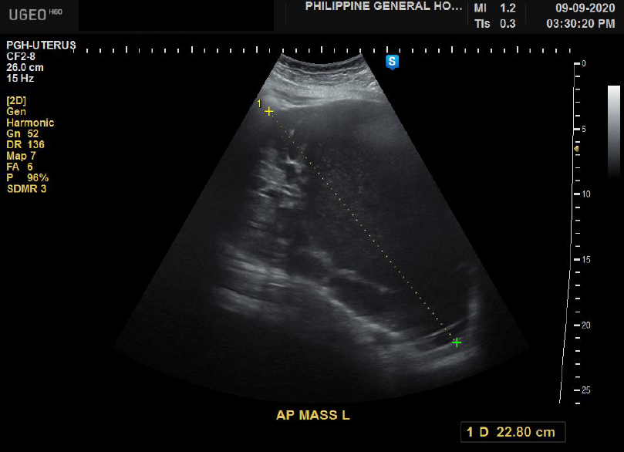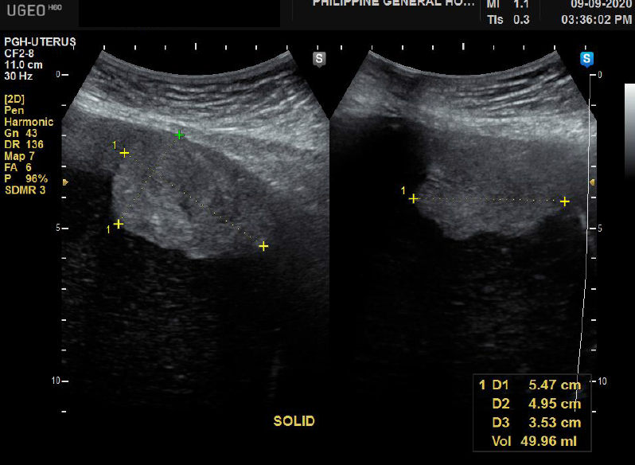

|  |
| --- |
| **Whole abdominal ultrasound** |
| **Impression:**  Large complex abdominopelvic mass with suspicious features, likely arising from right ovary:  A 22.3 x 23.0 x 13.8 cm predominantly cystic complex abdominopelvic mass with a few vascular thick separations, minimally vascular solid components at its inferior aspect and floating debris is seen arising from the right adnexal region. The said mass displaces the bowel loops superiorly and peripherally. No normal looking right ovary is seen.  Mild pelvocaliectasia, right, consider distal ureteral compression  Simple left renal cysts  Unremarkable study of liver, gallbladder, pancreas, spleen, aorta, paraaortic regions, urinary bladder, uterus, left ovary |

|  |
| --- |
| **Endometrial biopsy** |
| **Final histopathologic diagnosis:**  Endometrial hyperplasia without signs of atypia |

**Assessment:**

Ovarian new growth, right, probably malignant

Thickened endometrium, rule out endometrial pathology

Gravida 1 Para 1 (1001)

**Course in the Wards**

Hospital Day 0 (Admission): Admitted under OBGYN General Service. Baseline labs taken, with results as shown above. Referred to General Medicine for preoperative clearance.

Hospital Day 1: Patient placed on soft diet. Cleared by General Medicine service.

Hospital Day 2: Status post exploratory laparotomy, peritoneal fluid cytology, total hysterectomy with bilateral salpingo-oophorectomy, bilateral pelvic node dissection, paraaortic lymph node sampling, infracolic omentectomy, and random peritoneal biopsy under combined spinal and epidural anesthesia. Patient tolerated procedure well.

Hospital Day 3: Patient was monitored for any post-operative complications.

Hospital Day 4: Surgical site was cleaned and dressed. Cleared for discharge and advised follow up once with histopathology report.

**Gross Pictures**

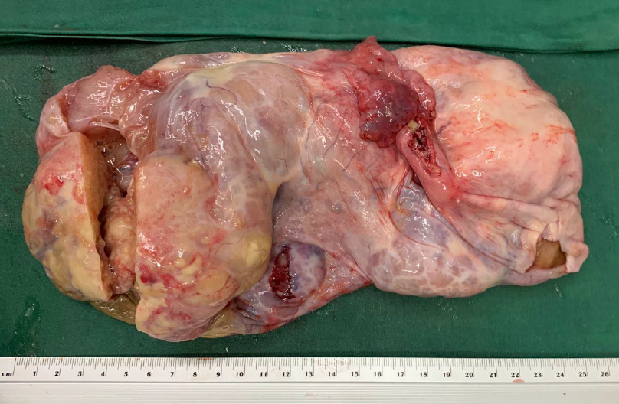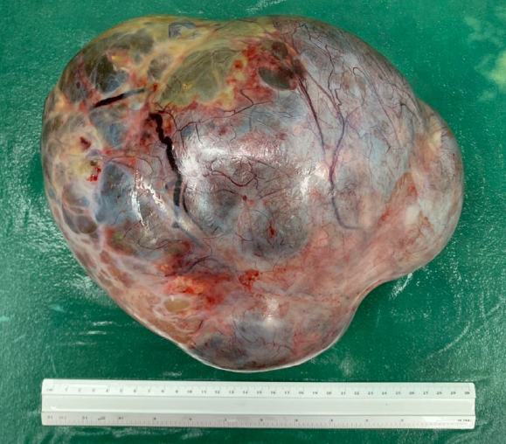

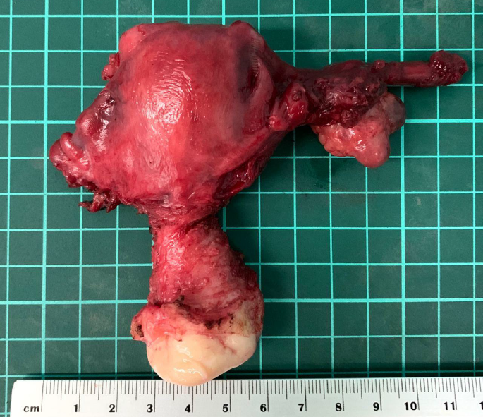

**Final Histopathologic Report**

High grade carcinoma, compatible with serous carcinoma

Pleural fluid: scattered inflammatory and reactive mesothelial cells. No malignant cells seen.

No definite lymphovascular space invasion identified. Other specimens negative for tumor.

**Guide Questions:**

1. What are the pertinent points in the history and physical examination of the patient that led to the primary working impression?
2. Are there other points in the history and physical examination that you would want to elicit?
3. Are there any significant laboratory/diagnostic test results? What is/are their significance? Are there any other laboratory/diagnostic tests you would order for the patient?
4. What is malignant ovarian new growth? How is it diagnosed? What are its risk factors?
5. What are the signs and symptoms that you should look out for in a patient with a malignant ovarian new growth?
6. What is the complete diagnosis for this patient? How will you manage her?