**University of the Philippines - Manila**

**College of Medicine & Philippine General Hospital**

**Department of Obstetrics and Gynecology**

**OB-GYN 251: Clinical Clerkship in Obstetrics and Gynecology**

**PRETERM PRELABOR RUPTURE OF MEMBRANES**

**Learning Objectives**

1. To discuss an index case of preterm prelabor rupture of membranes.
2. To think of differential diagnoses of pregnant women presenting with watery vaginal discharge.
3. To rationalize the different methods of detecting amniotic fluid leakage.
4. To enumerate the risk factors, screening, complications and prevention of preterm labor.
5. To explain the pathophysiology of preterm prelabor rupture of membranes and its complications.
6. To point out the different antimicrobial therapies for GBS prophylaxis, antenatal corticosteroids for fetal lung maturity, and magnesium sulfate for neuroprotection.
7. To discuss expectant management vs. induction of labor and its appropriateness for the periviable and viable pregnancies.

**General Data**

CT

16 year old

Gravida 1 Para 0

Single

Roman Catholic

Cavite

**Chief Complaint**

Watery vaginal discharge

**Past Medical History**

No hypertension

No diabetes mellitus

No bronchial asthma

No previous surgery

No food or medication allergy

**Family Medical History**

No hypertension

No diabetes mellitus

No bronchial asthma

No cancer

No liver/lung/kidney disease

**Personal and Social History**

Non smoker

Non-alcoholic drinker

No illicit drug use

High school student (grade 11)

Living with parents and 2 siblings

**Sexual History**

First coitus at 15 years old with 16 year old partner

1 non promiscuous sexual partner

No history of sexually transmitted disease

No dyspareunia, no postcoital bleeding

No history of COC use

**Menstrual History**

Menarche at 13 years old

Regular monthly interval

Lasting 5 days

4 pads per day

No dysmenorrhea

LAST NORMAL MENSTRUAL PERIOD: March 21, 2020 (sure of menses)

EDD: December 26, 2020

**Time of Admission:** November 2, 2020, 8 AM

**Obstetric History**

This is her first pregnancy

**Antenatal History**

She had 3 prenatal check-ups c/o Teen Mom Clinic.

First consult at 13 1/7 weeks AOG (June 21, 2020)

Prenatal Labs

|  |  |
| --- | --- |
| HbsAg | Nonreactive |
| VDRL/RPR | Nonreactive |
| ICC ELISA | Nonreactive |
| IgG Rubella | Noreactive |
| Blood type | O+ |
| 75g OGTT (at 28 weeks) | FBS 88  1st hr 108  2nd 90.4 |

Transvaginal ultrasound (June 21, 2020)

*Impression:*

*Single live intrauterine pregnancy, 13 weeks and 1 days by BPD, 12 4/7 weeks by FL*

*Placenta anterior grade 0, Normal amniotic fluid*

*Sonographic estimated fetal weight is appropriate for gestational age*

Consulted at the OB Admitting section for labor pains on her 30 6/7 wks AOG by LMP

IE during this time: cervix is closed

Labs sent: unremarkable CBC, urinalysis: RBC 0/hpf , WBC 20/hpf , EC 2/hpf, bacteria 90/hpf, mucus threads: 200/hpf

IPM: Category I trace – Reactive after resuscitation; cervical length done: 2.5cm

Sent home with Cefuroxime 500mg/capsule, 1 capsule BID for 7 days for which she was compliant.

**History of Present Illness**

5 hours prior to admission, experienced watery vaginal discharge associated with occasional labor pains (1-2x per hour) and good fetal movements.

**Review of Systems**

No fever, cough, colds, anosmia, body malaise, anorexia, loss of appetite

No headache, dizziness, blurring of vision

No vomiting, diarrhea, constipation

No difficulty of breathing, orthopnea

No epigastric pain

No hypogastric pain, dysuria, frequency of urination

No facial edema

(+) Vaginal pruritus and whitish vaginal discharge

Physical Examination

|  |  |
| --- | --- |
| *General Survey* | Conscious, coherent, not in distress |
| *Vital Signs* | BP 100/60 HR 86 RR 20 Temp 36.6 99% O2 Sat |
| *Anthropometrics* | Height 151 cm Weight 59.5 kg |
| *HEENT* | Anicteric sclera, pink palpebral conjunctiva,  (-) anterior neck masses, (-) cervical lymphadenopathies |
| *Heart and Lungs* | Adynamic precordium, distinct heart sounds, normal rate and regular rhythm, equal chest expansion, clear breath sounds |
| *Extremities* | Full and equal pulses, pink nail beds, (-) edema, CRT < 2 secs. |

|  |  |
| --- | --- |
| **Abdominal Examination** | |
| Fundic Height | Presentation |
| 27 cm | cephalic |
| EFW | Heart tones |
| 1.4 - 1.6 kg | 150s LLQ |
| Palpable contractions | |

|  |
| --- |
| **Speculum Examination** |
| (+) curd-like discharge on the vaginal sidewalls  (+) pooling of clear amniotic fluid on posterior vaginal fornix  (+) egress of clear amniotic fluid on withdrawal of the speculum |

|  |
| --- |
| **Internal Examination** |
| With excoriations on the vulvar area, smooth nulliparous vagina, cervix 2cms dilated, 30% effaced, posterior, station -3, bag of waters not appreciated |

**Admitting Impression:**

Gravida1 Para 0

Pregnancy uterine 32 weeks and 2 days age of gestation by amenorrhea, cephalic in preterm labor

Preterm prelabor rupture of membranes for 5 hours

Vulvovaginal candidiasis

Young Primigravid

Biometry on Admission

|  |  |  |  |  |
| --- | --- | --- | --- | --- |
| **Presentation** | **Cephalic** | | **Number of fetus** | **Singleton** |
| BIOMETRY: | | | | |
| Fetal heart activity | | 149 beats per minute | | |
| Biparietal diameter | | 7.4 cm | 29 4/7 | weeks |
| Occipito-frontal diameter | | 9.7 cm |  |  |
| Cephalic index | | 76% |  |  |
| Head circumference | | 27.5 cm | 30 | weeks |
| Femoral length | | 5.4 cm | 28 5/7 | weeks |
| Abdominal circumference | | 25.7 cm | 29 6/7 | weeks |
| Estimated fetal weight | | 1405 grams | 10th to 90th percentile: 1150-1750 grams AGA | |
| Placental location and grade | | Anterior, high-lying, grade II | | |

|  |  |  |  |
| --- | --- | --- | --- |
| **BIOPHYSICAL PROFILE** | **Score** | | **6/8** |
| Fetal Tone | 1 | | 2 |
| Fetal Movement | 3 | | 2 |
| Fetal Breathing | 1 | | 2 |
| Amniotic Fluid Index (AFI)  **(1.3 cm)** | - | - | - |
| 1.3 cm | - |

***Impression:***

Single live intrauterine pregnancy, in cephalic presentation, with good cardiac and somatic activities

29 4/7 weeks by composite sonar aging

Placenta is anterior, high-lying, grade II

Biophysical profile score is 6/8 with oligohydramnios

Sonographic estimated fetal weight is APPROPRIATE FOR GESTATIONAL AGE

Intrapartal Monitoring

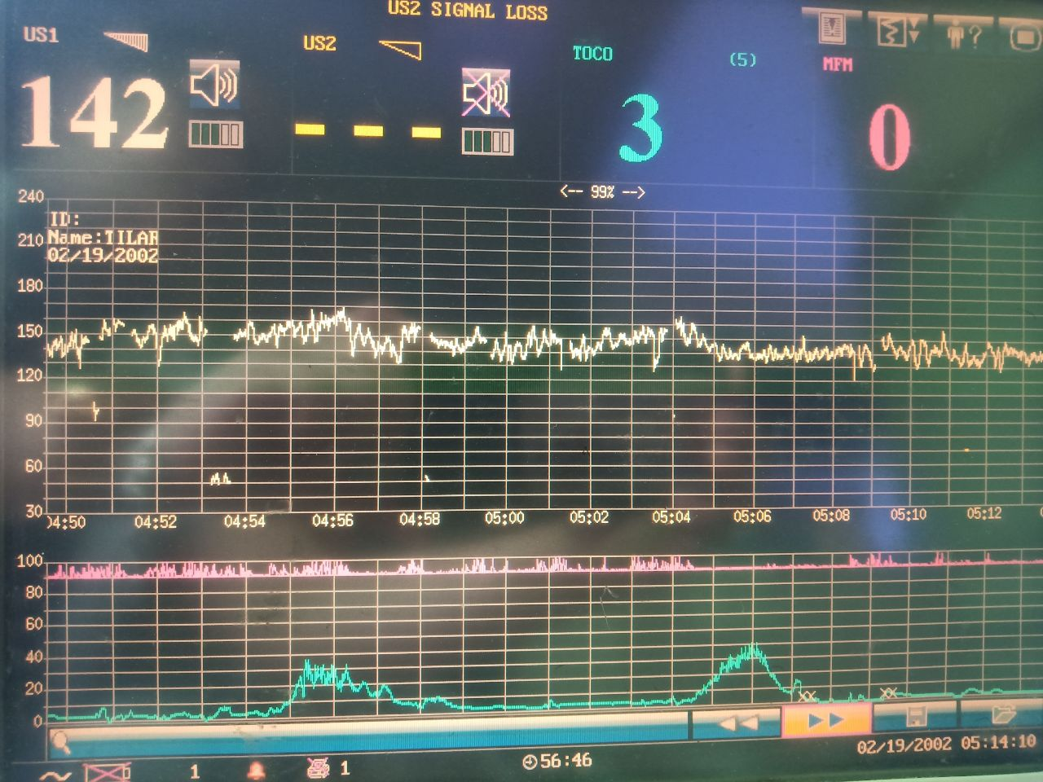

CBC

|  |  |
| --- | --- |
| **CBC** | **Result** |
| WBC | 13.90 |
| RBC | 4.27 |
| Hemoglobin | 117 |
| Hematocrit | 0.36 |
| MCV | 83.6 |
| MCH | 27.5 |
| MCHC | 328 |
| RDW | 13.7 |
| Platelet count | 257 |
| Neutrophil | 0.67 |
| Lymphocyte | 0.20 |
| Monocyte | 0.05 |
| Eosinophil | 0.08 |
| Basophil | 0.00 |

Urine culture

No growth after 2 days

**Guide Questions**

1. What are the salient features?
2. What are the differential diagnoses of pregnant women presenting with watery vaginal discharge?
3. What are the different methods of detecting amniotic fluid leakage?
4. What are the risk factors, screening, complications and prevention of preterm labor?
5. What is the pathophysiology of preterm prelabor rupture of membranes and its complications?
6. What are the different antimicrobials give to prevent GBS infection?
7. What are antenatal corticosteroids and their role? What agents are being given and dose/schedule?
8. What is the role of magnesium sulfate, upto when is this being given?
9. Please discuss expectant management vs. induction of labor and its appropriateness for the periviable and viable pregnancies.