Module 2
LIVING SYSTEMS FROM THE BIOLOGICAL PERSPECTIVE

Zenaida G. Baoanan

2.1 INTRODUCTION

Whatever course you are taking, you encounter the word “system” in almost all of your subjects. In fact everything that you come into contact with your day-to-day life is essentially either a system or a component of a system but you are perhaps not just conscious about it. Computer Science majors are maybe more familiar with an automated, computerized information system. Social Science students delve into political systems, and communication systems for those coming from Art Sciences.

Though many “types of systems” appear to be quite different, there are common principles, philosophies and theories that apply remarkably well to virtually all kinds of systems, that is consisting of three kinds of things: elements or structures, interconnections or interactions that hold the elements together, and a function or purpose that produce their own pattern or behavior over time (Meadows, 2008). World views on Living Systems have evolved from oral traditions, to the creation of written word, up to the present day environmental consciousness in Module 1 (Prespectives on Living Systems). Apparently, biological principles play important role in understanding the living systems that encompass all the microorganisms, plants, and animals including our own human race. Take for example the “law of specialization”, one of the important systems principles first observed in the field of biology explaining that the more highly adapted an organism is to a specific environment, the more difficult it is for the organism to adapt to a different environment. This probably explains why we often find our comfort zone and we get this nostalgic feeling of “There is no place like home”. Computer Sytem analysts likewise realize that if they optimize a computerized system to take maximum advantage of a specific CPU, programming language, and database management system, they are likely to have great trouble adapting that system to run on a different CPU or with a different database management system (Yourdon, 2006). Needless to say, it is important to understand the fundamentals of systems thinking to help us build and sustain stable, reliable systems that will function well in the complex society where we belong.

This module further leads you into the realm of biology to appreciate the systems of living things. More importantly, you must also have a hint on what keeps a human society stable and what leads to its collapse.

2.2. LEARNING OUTCOMES:

At the end of this module, students should be able to:
    - differentiate living from nonliving system
    - distinguish the basic characteristics of living systems
    - critique how living systems are organized and sustained
    - value the importance of living systems

2.3. READING ACTIVITY
Read pages 1-34 of the book “Thinking in Systems: A Primer by Donella H. Meadows (2008) which can be retrieved from http://wtf.tw/ref/meadows.pdf

Guide questions:

- What is a system?
- What differentiates living from nonliving systems?
- How are living systems sustained?

2.4. DISCUSSION ON PROPERTIES OF LIVING SYSTEMS

When a living creature dies, it loses its “system-ness” according to Meadow (2008). She added that, “the multiple interrelations that held it together no longer function, and it dissipates, although its material remains part of a larger food-web system”. Any other system for that matter will collapse or lose its system-ness when all the parts are gone or are no longer functioning.
To differentiate whether a system is living or not, there are certain attributes or properties that can be observed. This section specifically tackles the characteristics of living systems from biological perspective.

a. Living systems are organized into hierarchies with progressive specialization of functions and complexity emerging from lower level to higher levels of organization also known as emergent properties.

Oftentimes, the biological level of organization (See Reece et al., 2016; Starr et al., 2016) starts with atoms being the fundamental units of all substances, living or not. Atoms join other atoms to form molecules. In today’s natural world, only living things make the “molecules of life”, which are lipids, proteins, DNA, RNA, and complex carbohydrates organized into organelles, which are membrane enclosed structure that perform specific functions to form the cells. The cell is the “basic unit of life”. Some cells live and reproduce independently while other specific types are organized as tissues. The organized array of tissues carrying out specific tasks is known as organ. The set of interacting organs (organ system) make up the organism. An organism is an individual that consists of one (unicellular) or more cells (multicellular). Groups of interbreeding individuals of the same type or species living in a given area constitute the population. All populations occupying a given area form a community. The community and the non-living environment function together as an ecological system or ecosystem, the first unit that is complete because it has all the components necessary for survival (Odum and Barrett, 2005). The most inclusive level encompassing all regions of Earth’s crust, waters, and atmosphere in which organisms live is designated as the biosphere or ecosphere.

The eleven ecological levels-of-organization of living systems (also called biosystems) from cell to ecosphere is shown in Figure 1.

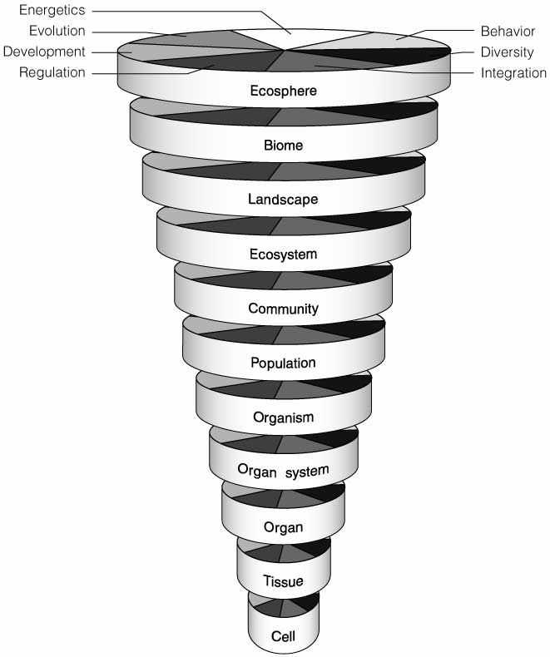

Figure 1. Eleven ecological levels-of-organization hierarchy with the seven transcending processes or functions as depicted by Barrett and colleagues in 1997 (cited in Odum and Barrett, 2005).

While each level in the ecological hierarchy exists in physical space and time, it is expected to have unique emergent and collective properties with increasing complexity brought about by internal dynamic interactions and exchanges with their environments. Yet there are seven basic functions (also known as transcending factors depicted as vertical components in Fig. 1) that operate at all levels including energetics, behavior, development, evolution, diversity, integration, and regulation.

Energetics is a study involving energy and matter conversion. Living systems need specific types of matter-energy in adequate amounts to keep it stable. The energy flow in living systems is explained further in Module 3 (Productivity in Living Systems). Other than material cycles and energy flows that involve interactions between living and nonliving components in a system, there are interactions that are intraspecific (i.e. within the level of population) as you will encounter in Module 5 (Population dynamics). Different patterns of behavior and development can be inferred at each level of organization with examples provided in Module 4 (Cycles and patterns). Development at the level of ecosystem is known as ecosystem development or succession, an often-predictable way or pattern by which plant and animal communities develop following disturbances (Odum and Barrett, 2005). Evolution plays an important role in bringing about diversity as explained in Module 6 (Changes in populations over time). Patterns of diversity can be seen at the genetic, species, and ecosystem levels (See Module 8: Biodiversity). The intricate processes of integration and regulation that bring separate components or subsystems into a unified and stable unit are unraveled in Module 7 (Ecosystems as complex systems).

b. Living systems are open systems with purposes and goals.

Another important property of a living system is that it continues indefinitely within the natural cycles to attain sustainability (Figure 2).
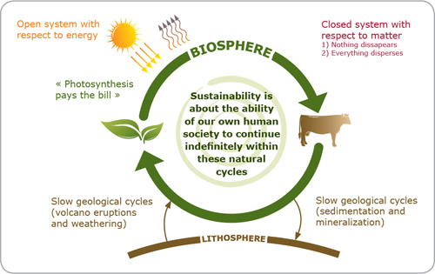

Figure 3. Model system depicting the sustainability theory (http://www.naturalstep.org/en/the-science-behind-our-approach)

The sun-driven process of photosynthesis acted upon by the plants generates the net increases in material quality on Earth almost entirely. This makes a living system an “open” system because during photosynthesis, plants convert energy from sunlight (input) to chemical energy (stored in food molecules such as sugars), which is used by plants to do work. This energy is then transferred to the higher trophic levels (consumers) and is eventually lost from the ecosystem as heat (output). The cycling of matter from plant to animals through consumption and the breakdown of these matter back to its elemental form through decomposition mostly driven by mircoorganisms to become utilized again by the plants somehow make the living system a relatively closed system. Unutilized decomposed materials become slowly deposited through sedimentation and mineralization and become available again through slow geological cycles such as volcanic eruptions and weathering. This natural cycle is also known as biogeochemical cycles as will be discussed further in Module 3.

The living system forms a “feedback mechanism” with the purpose or goal of keeping this cycle in control. For instance, an increase in the population of grazers will exert increase in grazing pressures on plants. This will lead to the decrease in the quality and quantity of the plants that eventually causes starvation and decrease in the population of grazers to alleviate the grazing pressure. This is known as “negative feedback”.

A “positive feedback” happens when humans depart from this natural cycle. For example, grazing becomes unregulated because the humans who own these grazers get a reward or profit by increasing the number of grazers (a positive feedback) that they raise and sell. The grazing pressure continues until all the plants are used up and there is no more food available for the grazers. This is a hypothetical example to explain the “tragedy of the commons”, an economic theory related to sustainability. The “commons” is taken to mean any shared and unregulated resource such as water, fish stocks, trees and so on. Failure of the human society to continue indefinitely within these natural cycles due to greed or self-interest will eventually lead to the collapse of the human system. This can be understood further in Module 7 (Ecosystems as complex systems) and Module 8 (Biodiversity) as relevant issues concerning environmental health and society are being tackled. In finding ways to mitigate chaos or collapse of the human system, you will need to read Module 9 (Sustaining living systems) and Module 10 (Health and wellness as ecosystem services).

The natural system with its self-organizing capacity will persist without humans, but humans cannot live without it. After all, we only have one Earth to live in, why don’t we save it?

2.5. LEARNING ACTIVITY

In the first few meetings, you were asked to watch the series of lectures of Donella Meadows in youtube. Having in mind the key concepts on Systems Thinking by Meadows, you will be watching the video, “In a World of Systems” illustrated and narrated by David Macaulay (Retrieved from https://www.youtube.com/watch?v=A_BtS008J0k).

Activity: Testing your comprehension
Length of video: 9:22
Estimated Time to Finish Task: 30 minutes
Discussion: 40 minutes

After watching the video, you will be asked to form a pair or group to discuss and come up with answers to the following:
- What types of systems were mentioned in the video?
- Which of these systems are living? non-living?
- Develop a model that will depict any type of system that was mentioned in the video. Make sure that you are able to show the elements or structures and the interconnections. Guided by your models, you should be able to explain how the system is organized to achieve its purpose.

2.6 SCORING RUBRIC FOR THE ACTIVITY

Categories | Yes  (2 pts) | Partly  (1 pt) | No  (0 pt) | Remarks
Comprehension
1. Discussion reflects a good perception of key
ideas from the module and resources
2. Discussion connects the topic to related ideas
and concepts
Presentation of Models
1. Models are clearly and concisely represented
2. Models are neat and properly labeled
Etiquette
1. The group responds to their peers' questions
courteously
2. The group displays openness to consider
suggestions from peers
Communication Skills
1. Presentation and discussion is presented in correct, academic language
2. Answers contain minimal grammatical errors
Sub-total

2.7. SELF-ASSESSMENT:

After studying the module resources and accomplishing the learning task for this module, check whether you are able to do the following:
    - differentiate living from nonliving system
    - distinguish the basic characteristics of living systems
    - understand how living systems are organized and sustained
    - appreciate the importance of living systems

2.8. REFERENCES

Meadows, D. H. (2008). Thinking in Systems: A Primer. UK: Sustainability Institute. Retrieved from http://wtf.tw/ref/meadows.pdf

Odum, E.P and G.W. Barrett. 2005. Fundamentals of Ecology. 5th ed. Singapore: Brooks/Cole, Thomson Learning Asia. 598p.

Reece, J. B., Taylor, M. R., Simon, E. J., Dickey, J. L., Hogan, K., & Campbell, N. A. (2015). Campbell Biology: Concepts & Connections (8th ed.). Harlow, England: Pearson Education.

Starr, C., Evers, C. A., & Starr, L. (2016). Biology: Today and Tomorrow (5th ed.). United States of America: Cengage Learning.

The Science Behind our Approach: The Natural Step. Retrieved from http://www.naturalstep.org/en/the-science-behind-our-approach

Yourdon, E. (2006). Chapter 2: The Nature of Systems. Retrieved from http://jjakiela.prz.edu.pl/SysNature.pdf

